Example Metrics and Targets Disclosure
Small Specialist Investment Vehicle

Introduction
This document has been prepared as a hypothetical example of disclosing the Metrics and Targets criteria for inclusion in an entity’s Annual Report. This example has been prepared by the Department of Finance's Climate Action in Government Operations Unit to support Commonwealth entities participating in Tranche 1 of the Commonwealth Climate Disclosure (CCD) Initiative in FY2024-25. The example disclosure can also be used by other entities opting into Tranche 1.
The example disclosure has been prepared for a fictional Commonwealth entity, the Bushfire Recovery Investment Corporation, which is notionally a small corporate Commonwealth entity and Specialist Investment Vehicle governed by an independent board. This document demonstrates a possible approach entities could take when preparing their climate disclosure. It is tailored for entities at the start of their climate risk maturity journey.
The example climate disclosure should be considered in conjunction with the Year 1 Commonwealth Climate Disclosure (CCD) Requirements and Resource Management Guide (RMG) 136 when preparing an entity’s FY2024-25 Annual Report.
Note: Commonwealth entities are encouraged to disclose more detail and progress than outlined in this example climate disclosure where they have the opportunity to do so.
Note: the example below has assumed the entity has voluntarily opted in to the APS Net Zero 2030 target. Another approach for a corporate Commonwealth entity (CCE) would be to set their own target.

Tip: Guidance on how to use this example is identified throughout in these boxes.

Appendix F: Climate Statement

Example Metrics and Targets Climate Disclosure

APS Net Zero 2030 Target
We are committed to leading climate action within the public sector and have voluntarily committed to the Government’s APS Net Zero by 2030 target. See the APS Net Zero Target Factsheet for details including scope, emissions sources and timeframes. We have not deviated from the approach in this factsheet.
Our approach to reducing emissions is detailed in our publicly available in our Emissions Reduction Plan and we will report our progress annually through our climate disclosure. This plan was approved by the Board who will also monitor its ongoing performance through regular Board meetings.
This year we made progress against our plan including:

Emissions reporting
APS Net Zero 2030 is the Government’s policy for the Australian Public Service (APS) to reduce its greenhouse gas emissions to net zero by 2030 and transparently report on its emissions. As part of the Net Zero in Government Operations Strategy and the reporting requirements under section 516A of the Environment Protection and Biodiversity Conservation Act 1999, corporate Commonwealth entities such as the Bushfire Recovery Investment Corporation (BRIC) are required to report on their operational greenhouse gas (GHG) emissions.
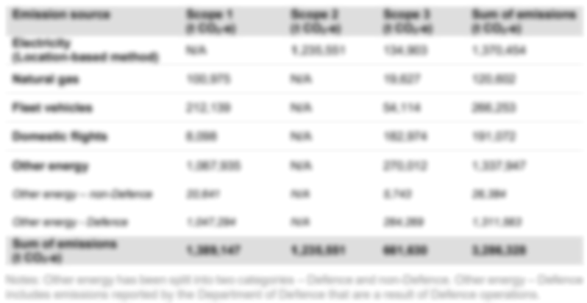
Table 1 2024-25 Greenhouse gas emissions inventory using the location-based accounting method
Greenhouse gas emissions inventory as per the APS Net Zero Emissions Reporting Framework

Commonwealth Climate Disclosure Index
Tip: Where information is provided across different sections of an annual report and/or external publications, it is recommended that an index is used to ensure readers to see that all requirements have been addressed. The index can also be used to respond to any disclosure gaps within the annual report.
Core Requirement | Overview | Disclosed
M0 | Objective of category | Achieved through M1
M1(b) | Information on greenhouse gases in accordance with M3 | Achieved through M3
M1(c) | Information on targets and progress towards targets in accordance with M5-9. | As per the APS Net Zero Factsheet on the Department of Finance’s website.
M3(a) | Greenhouse gas emissions generated in tonnes CO₂e | As per section ‘Emissions reporting’ on page X.
M3(b) | Greenhouse gas emissions approach, inputs, assumptions and methodologies. | As per the Australian Public Service Net Zero Emissions Reporting Framework on the Department of Finance website
M3(e) | Scope 2 and 3 greenhouse gas emissions using location-based and market-based for electricity-related greenhouse gas emissions. | As per section ‘Emissions reporting’ on page X.
M3(f) | Confirmation of the scope 3 emissions categories included. | As per the Australian Public Service Net Zero Emissions Reporting Framework on the Department of Finance website
M5 | Quantitative and qualitative climate-related targets it has set to monitor progress towards these targets | As per the APS Net Zero Factsheet on the Department of Finance’s website and our publicly available Emissions Reduction Plan.
M6 | Information about its approach to setting and reviewing each target identified in M5 | As per the APS Net Zero Factsheet on the Department of Finance’s website.
M8 | Scope of target including greenhouse gases included, scope of emissions sources included | As per the APS Net Zero Factsheet on the Department of Finance’s website.
M9 | In preparing M5-8 disclosures, disclose information on the APS Net Zero 2030 target and sub-targets | As per the APS Net Zero Factsheet on the Department of Finance’s website. The targets and measures relevant to our entity as part of the Net Zero in Government Operations Strategy are set out in our publicly available Emissions Reduction Plan.

Document control
Version number | Date of issue | Brief description of change
1 | 28/03/2025 | Initial publication
2 | XX/04/2025 | Minor amendment – update of table 1 title

The Regional Investment Corporation’s Emissions Reduction Plan has been used as an example of how to cross-reference publicly available information.

