Example Metrics and Targets Disclosure
Large non-corporate Commonwealth entity

Introduction
This document has been prepared as a hypothetical example of disclosing the Metrics and Targets criteria in an entity’s Annual Report. This example has been prepared by the Department of Finance’s Climate Action in Government Operations Unit to support Commonwealth entities participating in Tranche 1 of the Commonwealth Climate Disclosure (CCD) Initiative in FY2024-25. The example disclosure can also be used by other entities opting into Tranche 1.
The example disclosure has been prepared for a fictional Commonwealth entity, the Resilient Infrastructure Agency, which is presented as a large non-corporate Commonwealth entity. It demonstrates a possible approach entities could take when preparing their climate disclosure. It is tailored for entities at the start of their climate risk maturity journey.
This example Metrics and Targets disclosure should be considered in conjunction with the CCD Year 1 Requirements and Resource Management Guide (RMG) 135 when preparing an entity’s FY2024-25 Annual Report.
Note: Commonwealth entities are encouraged to disclose more detail and progress than outlined in this example climate disclosure where they have the opportunity to do so.

Tip: Guidance on how to use this example is identified throughout in these boxes.
The following section provides an example of the Metrics and Targets component of the Commonwealth Climate Disclosure for the fictional entity, the Resilient Infrastructure Agency, which would be included as an Appendix in the entity's Annual Report.
The example demonstrates how to leverage information that would be within the body of an annual report and how to cross-reference information, including:
- Externally available information. This example uses real documents from Commonwealth entities which are identified through footnotes (such as Department of Finance’s Emissions Reduction Plan).
An index is recommended when cross-referencing information outside of the climate disclosure to enable readers to connect to all relevant information.

Appendix C: Climate Statement

Example Metrics and Targets Climate Disclosure
APS Net Zero 2030 is the Government’s policy for the Australian Public Service (APS) to reduce its greenhouse gas emissions to net zero by 2030, and transparently report on its emissions. As part of the Net Zero in Government Operations Strategy and the reporting requirements under section 516A of the Environment Protection and Biodiversity Conservation Act 1999, Commonwealth entity’s such as the Resilient Infrastructure Agency are required to report on their operational greenhouse gas (GHG) emissions.
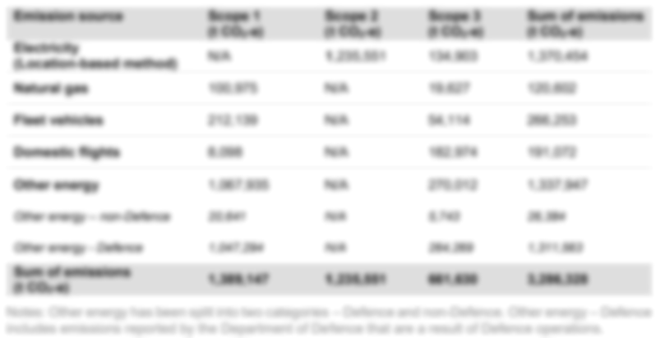
Emissions Reporting

Greenhouse gas emissions inventory as per the
APS Net Zero Emissions Reporting Framework

Table 1: 2024-25 Greenhouse gas emissions inventory using the location-based accounting method
APS Net Zero 2030 Target
We are committed to leading climate action within the public sector and contributing to the APS Net Zero 2030 target. See the APS Net Zero Target Factsheet for details including scope, emissions sources and timeframes. We have not deviated from the approach in this factsheet.
Our approach to reducing emissions is detailed in our publicly available Emissions Reduction Plan, which reports on our entity’s progress annually. This plan was approved by the Board who will also monitor its ongoing performance through regular board meetings. This year we made progress against our plan including:

Commonwealth Climate Disclosure Index
\
Tip: Where information is provided across different sections of an annual report and/or external publications, it is recommended that an index is used to ensure readers to see that all requirements have been addressed. The index can also be used to respond to any disclosure gaps within the annual report.

Criteria | Requirement summary | Response and cross-reference
M0 | Objective of category | Achieved through M1
M1(b) | Information on greenhouse gases in accordance with M3 | Achieved through M3
M1(c) | Information on targets and progress towards targets in accordance with M5-9. | As per the APS Net Zero Factsheet on the Department of Finance’s website. on the Department of Finance’s website.
M3(a) | Greenhouse gas emissions generated in tonnes CO₂e | As per the Emissions Reporting section in Appendix C ‘Climate Statement’ on page X.
M3(b) | Greenhouse gas emissions approach, inputs, assumptions and methodologies. | As per the Australian Public Service Net Zero Emissions Reporting Framework on the Department of Finance website
M3(e) | Scope 2 and 3 greenhouse gas emissions using location-based and market-based for electricity-related greenhouse gas emissions. | As per the Emissions Reporting section in Appendix C ‘Climate Statement’ on page X.
M3(f) | Confirmation of the scope 3 emissions categories included. | As per the Australian Public Service Net Zero Emissions Reporting Framework on the Department of Finance website
M5 | Quantitative and qualitative climate-related targets it has set to monitor progress towards these targets | As per the APS Net Zero Factsheet on the Department of Finance’s website and our publicly available Emissions Reduction Plan.
M6 | Information about its approach to setting and reviewing each target identified in M5 | As per the APS Net Zero Factsheet on the Department of Finance’s website. on the Department of Finance’s website.
M8 | Scope of target including greenhouse gases included, scope of emissions sources included | As per the APS Net Zero Factsheet on the Department of Finance’s website.
M9 | In preparing M5-8 disclosures, disclose information on the APS Net Zero 2030 target and sub-targets | As per the APS Net Zero Factsheet on the Department of Finance’s website. The targets and measures relevant to our entity as part of the Net Zero in Government Operations Strategy are set out in our publicly available Emissions Reduction Plan.

Version number | Date of issue | Brief description of change
1 | 07/04/2025 | Initial publication

As the RIA is fictional and does not have an Emissions Reduction Plan, the Department of Finance’s 2024-25 Emissions Reduction Plan has been used as an example of how to reference external public facing documents within a climate disclosure.

