# Example Governance Disclosure

Large non-corporate Commonwealth entity

## Introduction

This document has been prepared as a hypothetical example of disclosing the Governance criteria for inclusion in an entity’s Annual Report. This example has been prepared by the Department of Finance's Climate Action in Government Operations Unit to support Commonwealth entities participating in Tranche 1 of the [Commonwealth Climate Disclosure (CCD) Initiative](https://www.finance.gov.au/government/climate-action-government-operations/commonwealth-climate-disclosure-policy) in FY2024-25. The example disclosure can also be used by other entities opting into Tranche 1.

The example disclosure has been prepared for **a fictional Commonwealth entity**, the Resilient Infrastructure Agency, which is presented as a large non-corporate Commonwealth entity. It demonstrates a possible approach entities could take when preparing their climate disclosure. It is tailored for entities at the start of their climate risk maturity journey.

This example governance disclosure should be considered in conjunction with the [CCD Year 1 Requirements](https://www.finance.gov.au/government/climate-action-government-operations/commonwealth-climate-disclosure-requirements) and either Resource Management Guide (RMG) [135](https://www.finance.gov.au/government/managing-commonwealth-resources/annual-reports-non-corporate-commonwealth-entities-rmg-135) or [136](https://www.finance.gov.au/government/managing-commonwealth-resources/annual-reports-corporate-commonwealth-entities-rmg-136) when preparing an entity’s FY2024-25 Annual Report.

Note: Commonwealth entities are encouraged to disclose more detail and progress than outlined in this example climate disclosure where they have the opportunity to do so.

|  |
| --- |
| **Tip:** Guidance on how to use this example is identified throughout in these boxes.  The following section provides an example of the Governance component of the Commonwealth Climate Disclosure of the fictional entity, the Resilient Infrastructure Agency, which would be included as an Appendix in the entity's Annual Report (refer to example Contents section on page 7 for where this would fit in the annual report structure).  This example demonstrates how to leverage information that would be within the body of an annual report and how to cross-reference information, including:   * information with the body of the annual report (example extracts of annual report included from page 6 onwards) * externally available information. This uses real documents from Commonwealth entities which have been identified through footnotes, such as Department of Finance’s Corporate Plan.   An index is recommended when cross-referencing information outside of the climate disclosure to enable readers to connect to all relevant information. |

# 

# Appendix C: Climate Statement

## Example governance disclosure

Commonwealth Climate Disclosure is the Government’s policy for Commonwealth entities to publicly disclose their exposure to climate risks and opportunities, as well as their actions to manage them, delivering transparent and consistent climate disclosures to the Australian public.

Under the policy, non-corporate Commonwealth entities are required to complete climate disclosures. As the Resilient Infrastructure Agency (RIA) meets the thresholds of Tranche 1 in the [CCD Policy Architecture](https://www.finance.gov.au/government/climate-action-government-operations/commonwealth-climate-disclosure-policy), we are required to start including climate-related disclosures in our Annual Report from FY2024-25. This climate statement has been prepared in accordance with the [Year 1 Reporting Provisions](https://www.finance.gov.au/government/climate-action-government-operations/commonwealth-climate-disclosure-requirements) for Tranche 1 entities.

Governance

Effective governance is crucial to enabling our CEO, as our accountable authority, to oversee our agency’s management of climate-related risks and opportunities. With a comprehensive governance framework already in place, we use existing policies and procedures to manage all our enterprise risks, including the risks and opportunities relating to climate change. Through embedding climate risk in existing frameworks, we are delivering on our obligations under The [Australian Government’s Approach to Climate Risk and Opportunity Management in the Public Sector 2024-2026](https://www.dcceew.gov.au/climate-change/publications/climate-risk-opportunity-management-program-resources). Refer to the Corporate Governance section (Page X) and the Enterprise Risk Management section (Page X) for further information on our agency-wide approach to governance, risk management, related policies and procedures and the roles and responsibilities of our executive committees.

Climate risk management is a priority in our agency, with climate change identified as one of the four key challenges influencing our operating environment in our [Corporate Plan](https://www.finance.gov.au/sites/default/files/2024-08/2024-25%20_Corporate_Plan.pdf)[1]. Our strategy to reduce emissions aligns with the [APS Net Zero in Government Operations Strategy](https://www.finance.gov.au/government/climate-action-government-operations/aps-net-zero-emissions-2030) and is set out in our publicly available [Emissions Reduction Plan](https://www.infrastructure.gov.au/department/media/publications/emissions-reduction-plan-2024)*[2]*.

Our approach to climate governance

Our climate governance is underpinned by our agency’s Risk Management Framework and Risk Management Policy, established in accordance with our Accountable Authorities Instructions, the [Commonwealth Risk Management Policy (2023)](https://www.finance.gov.au/government/comcover/risk-services/management/commonwealth-risk-management-policy), and the [*Public Governance, Performance and Accountability Act 2013*](https://www.legislation.gov.au/C2013A00123/latest/text) (PGPA Act). Our Risk Management Framework (Framework) has been established to ensure alignment with Section 16 of the PGPA Act, which requires our CEO to establish and maintain internal systems for oversight and management of risk. Climate-related risk is addressed in the framework as a specialist risk category.

The CEO oversees the agency’s strategy and risk management processes, including making decisions in relation to climate-related risks and opportunities. The CEO also oversees the setting of targets related to climate-related risks and opportunities, as set out in our recently published [Emissions Reduction Plan](https://www.infrastructure.gov.au/department/media/publications/emissions-reduction-plan-2024), and monitors progress towards those targets.

The CEO and Executive Committee work closely with the Audit and Risk Committee[3] and the newly established Climate Risk Sub-Committee to ensure our climate risk management practices align with the Climate Risk and Opportunity Management Program’s (CROMP) tools and resources. This process ensures climate-related risks and opportunities are appropriately identified, assessed, prioritised and managed across our agency. This year we have added climate risk to our due diligence process for major projects (within the site selection checklist). This ensures the Executive Committee can consider climate-related risks and opportunities at the earliest opportunity within a major project’s lifecycle.

The roles and responsibilities of our executive team and committees are detailed in Figure 2 Executive Management Structure and the Corporate Governancesection of the Annual Report on Page X. In addition to these roles, climate risk is also managed in the agency through the governance structure summarised in Figure 1, and the roles and responsibilities outlined in Table 2.

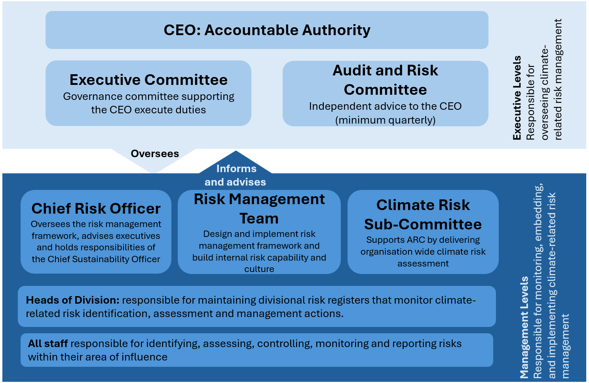Figure 2 Our Climate Risk Governance Structure

Table 2 - Climate Risk Roles and Responsibilities

|  |  |
| --- | --- |
| Role | Responsibility |
| Chief Risk Officer (CRO): | Responsible for overseeing the risk management framework and governance as well as advising the CEO and Executive Committee, including through their role on the Audit and Risk Committee. Executes the agency’s obligations under the Commonwealth Climate Disclosure Initiative and CROMP and contributes to the department’s implementation of the Net Zero in Government Operations Strategy (currently led by our Business Enabling Services Division). The CRO also functions as the Chief Sustainability Officer, the appointment of which is encouraged in the Net Zero in Government Operations Strategy. |
| Climate Risk Sub-committee | Cross-functional working group responsible for delivering the agency’s organisation-wide climate risk assessment using CROMP tools and resources and providing in-house climate risk expertise across the agency. |
| Risk Management team | Responsible for designing, building, and implementing our risk management framework, developing capability internally to manage risk, promoting positive risk culture and supporting the Climate Risk Sub-committee through the CROMP process. |

Climate risk capability

The [Commonwealth Risk Management Policy](https://www.finance.gov.au/government/comcover/risk-services/management/commonwealth-risk-management-policy) requires that Commonwealth entities have an appropriate level of risk management capability. To ensure our agency is equipped with the in-house capability to manage climate-related risks, we have mandated that all members of the Risk Management Team complete the first two [Climate Risk and Opportunity Management Program (CROMP) training modules](https://www.apsacademy.gov.au/courses/program-cromp-climate-risk-and-opportunity-management-program), and that members of the Climate Risk Sub-Committee complete all three CROMP training modules. We also encourage participation in the [Net Zero in Government Operations GovTEAMS](https://www.finance.gov.au/government/climate-action-government-operations/aps-net-zero-emissions-2030) community and the completion of the [Foundations of Net Zero in Government Operations training module](https://www.apsacademy.gov.au/courses/foundations-net-zero-government-operations).

The Climate Risk Sub-Committee ensures that staff and executives in the agency possess the skills and expertise necessary for climate risk management through climate risk and opportunity assessments. The Sub-Committee will communicate any skills gaps identified in these assessments to the CEO via the quarterly Audit and Risk Committee meeting for further action.

Commonwealth Climate Disclosure Index

|  |
| --- |
| **Tip:** Where information is provided across different sections of an annual report and/or external publications, it is recommended that an index is used to ensure readers to see that all requirements have been achieved. The index can also be used to respond to any disclosure gaps within the annual report. |

|  |  |  |
| --- | --- | --- |
| Core Requirement | Overview | Disclosed |
| G1(a) | ID Accountable Authority | Chief Executive Officer |
| G1(a)i | Responsibilities of Accountable Authority | Corporate Governance section, page X-Y; Our approach to climate governance section, page X; Figure 1 Our Climate Risk Governance Structure, page X |
| G1(a)ii | Skills and Competencies | Climate risk capability section, page X |
| G1(b)iii | Informing accountable authority | Appendix C – Climate Statement Table 2, page X  CEO informed on risks through quarterly ARC meetings with serious risks escalated on an as needs basis |
| G1(a)iv | Strategy and Risk Management | Our approach to climate governance section, page X |
| G1(a)v | Setting Targets | Our approach to climate governance, para 2, page X; Emissions Reduction Plan, available online at <https://www.infrastructure.gov.au/department/media/publications/emissions-reduction-plan-2024> |
| G1(a)vi | Risk Oversight | Enterprise Risk Management section, pages X-Y; Our approach to climate governance section, pages X-Y |
| G1(b) | Controls and procedures | Enterprise Risk Management section, pages X-Y; Our approach to climate governance section, pages X-Y |
| G2(a) | Regard to CROMP Approach | Governance section, page X |
| G2(b) | Alignment with other policies | Governance section, page X |

Annual Report

2024-25 Financial Year

Resilient Infrastructure Agency

|  |
| --- |
| **Note:** This annual report has been developed to demonstrate how to cross reference standard annual report content to avoid duplication and length within a climate disclosure. It also showcases where a climate disclosure could fit within the annual report. |

Contents

### Introduction

Letter of transmittal

2024-25 snapshot

### Section 1: Overview

Agency overview

Purpose and vision

### Section 2: Our Performance

Annual performance statement

Performance framework

Performance results

### Section 3: Organisational Management

Corporate governance

Enterprise Risk Management

People Management

Financial resource management

### Section 4: Financial Statements

Financial Statements

### Section 5: Appendices

Appendix A – List of requirements

Appendix B – Glossary

Appendix C – Climate Statement

|  |
| --- |
| **Tip:** this contents page is included to demonstrate how existing information within the body of your annual report can be leveraged when producing a climate disclosure. The sections that address the Governance criteria are identified in yellow and included below. Where criteria are addressed by cross-referencing the body of the annual report or an external publication, this can be summarised in an index to ensure readers can easily access relevant information and see that all criteria have been addressed by the entity. |

Section 3: Organisational Management

|  |
| --- |
| **Tip:** The following sections provide examples of extracts from the Annual Report of the fictional entity, the Resilient Infrastructure Agency, that have been referred to in the climate disclosure in Appendix C. The aim of this section is to highlight how entities can leverage content already included within an annual report to meet climate disclosure obligations. |

Corporate Governance

### Agency Executive Management Structure

Figure 2 Executive Management Structure

### Executive Roles and Responsibilities

* **Chief Executive Officer:** Responsible for supporting the Minister for Infrastructure in the delivery of portfolio responsibilities and development of strategic policy advice. The Chief Executive Officer (CEO) provides strategic oversight, leadership and management of the agency, ensuring there is collaborative implementation and delivery of government policy and programs and a whole-of-government approach to services delivery. The CEO also manages key stakeholder relationships and contributes to the stewardship of the APS.
* **Deputy Chief Executive, Project Delivery:** Responsible for the delivery of the pipeline of Resilient Infrastructure projects under the agency’s responsibility oversight and management of project design and delivery.
* **Deputy Chief Executive, Innovation and Technology:** Responsible for developing and delivering the agency’s information and communications technology (ICT), digital capability and innovation.
* **Chief Operating Officer:** Responsible for the agency’s corporate functions including finance, human resources, audit, legal and procurement.

### Executive Committees

##### Executive Committee

The Executive Committee (EC) is the agency’s most senior governance committee. It supports the CEO to undertake her duties under the [*Public Governance, Performance and Accountability Act 2013*](https://www.legislation.gov.au/C2013A00123/latest/text) (PGPA Act) and section 57 of the [*Public Service Act 1999*](https://www8.austlii.edu.au/cgi-bin/viewdb/au/legis/cth/consol_act/psa1999152/). The committee’s focus is on the overall strategic direction and priorities of the agency, as well as providing oversight of the agency’s financial and operational performance. It allocates resources, resolves major issues, oversees the management of enterprise risks, and ensures the agency meets accountability and regulatory requirements. It also provides direction on key organisation matters raised by sub-committees.

##### Audit and Risk Committee

The Audit and Risk Committee (ARC) provides independent advice to the CEO, as the Accountable Authority, on the appropriateness of the agency’s financial reporting, performance reporting, system of risk oversight and management, and system of internal control, consistent with subsection 17(2) of the [*Public Governance and Accountability Rule 2014*](https://www.legislation.gov.au/Series/F2014L00911) (PGPA Rule).

The ARC functions in accordance with section 17 of the PGPA Rule. The [Committee Charter](https://www.servicesaustralia.gov.au/audit-and-risk-committee-charter?context=22)[4] details its purpose and responsibilities.

The ARC is composed of five members: the Chief Operating Officer (COO), two Deputy Chief Executives, and two additional members with relevant expertise. These members provide a balance of perspectives to ensure robust governance practices.

The ARC supports the CEO by reviewing and providing advice on key areas such as financial reporting, performance reporting, risk management and internal controls and systems.

Additionally, the ARC ensures that the agency’s risk management processes are aligned with the Commonwealth Risk Management Policy and the PGPA Act, establishing a cohesive and consistent approach to identifying and managing risks.

##### Climate Risk Sub-committee

The ARC is supported by the newly established Climate Risk Sub-committee (CRSC). The purpose of the CRSC is to support the ARC by delivering an organisation-wide climate risk and opportunity assessment and provide advice on how the assessment results can be embedded within the agency’s approach to risk management.

Enterprise Risk Management

Effective risk management plays a key role in shaping the Resilient Infrastructure Agency’s strategic direction and successfully delivering on its purpose of fostering sustainable development and infrastructure growth to enhance the nation’s economic and social well-being. Our Risk Management Framework is prepared in accordance with the Commonwealth Risk Management Policy and the PGPA Act to establish a common approach to identifying and managing risk. The CEO, as the Accountable Authority, endorses this framework.

Deputy CEOs are accountable to the CEO and responsible for managing risks within the agency. All staff actively contribute to risk management within their area of responsibility to identify, assess, manage, monitor and report risks.

The Executive Committee sets the direction for risk management and oversees how risks are managed. The Chief Risk Officer supports the CEO and proves strategy advice to the executive. Together they promote positive risk behaviours to drive the improvement of risk management across the agency, ensuring a positive risk management culture is embedded within the agency.

The Audit and Risk Committee provides independent advice to the CEO on the appropriateness of the agency’s systems of risk oversight and management.

During FY2023–24, we increased our risk management maturity by establishing a new Climate Risk Sub-committee to deliver on our first climate risk and opportunity assessment.

Risks are identified, assessed, managed, monitored and reported in accordance with the framework. Our agency manages 10 enterprise risks across 7 risk categories. Enterprise risks are owned and managed by the executive and are defined as “risks with the greatest potential to affect the agency’s achievement of its mission and strategic objectives.”

Table 1 - Key Agency Risks

|  |  |
| --- | --- |
| Risk category | Key risks |
| Health and safety | Staff wellbeing and safety |
| Security | Physical security risk; Cyber security risk |
| Reputation | Reputational damage risk; Fraud |
| Project delivery | Project delivery cost; Timeframes to deliver projects |
| Workforce | Workforce attraction and retention |
| Community engagement | Community engagement and  Community satisfaction |
| Assets | Resilience and maintenance |

Oversight of the agency’s risks, associated controls and treatment strategies is managed through quarterly reporting to the Executive and the Audit and Risk Committee.

## Document control

|  |  |  |
| --- | --- | --- |
| Version number | Date of issue | Brief description of change |
| 1 | 31/01/2025 | Initial publication |

1. As the RIA is fictional and does not have a Corporate Plan, the Department of Finance’s 2024-25 Corporate Plan has been used as an example on how to reference external public facing documents within a climate disclosure.
2. As the RIA is fictional and does not have an [Emissions Reduction Plan](https://www.infrastructure.gov.au/department/media/publications/emissions-reduction-plan-2024), the Department of Infrastructure, Transport, Regional Development, Communications and the Arts has been used as an example on how to reference a publicly available Emissions Reduction Plan.
3.
4. As the RIA is a fictional entity, the [Audit and Risk Committee Charter](https://www.servicesaustralia.gov.au/audit-and-risk-committee-charter?context=22) published by Services Australia is included as an example on how to cross reference external publications.