Example Governance Disclosure
Small Specialist Investment Vehicle

Introduction
This document has been prepared as a hypothetical example of disclosing the Governance criteria for inclusion in an entity’s Annual Report. This example has been prepared by the Department of Finance's Climate Action in Government Operations Unit to support Commonwealth entities participating in Tranche 1 of the Commonwealth Climate Disclosure (CCD) Initiative in FY2024-25. The example disclosure can also be used by other entities opting into Tranche 1.
The example disclosure has been prepared for a fictional Commonwealth entity, the Bushfire Recovery Investment Corporation, which is notionally a small corporate Commonwealth Entity and Special Investment Vehicle governed by an independent board. This document demonstrates a possible approach entities could take when preparing their climate disclosure. It is tailored for entities at the start of their climate risk maturity journey.
The example climate disclosure should be considered in conjunction with the Year 1 CCD Requirements and Resource Management Guide (RMG) 136 when preparing an entity’s FY2024-25 Annual Report.
Note: Commonwealth entities are encouraged to disclose more detail and progress than outlined in this example climate disclosure where they have the opportunity to do so.
Tip: Guidance on how to use this example is identified throughout in these boxes.

Appendix F: Climate Statement

Example Governance Climate Disclosure
Commonwealth Climate Disclosure is the Government’s policy for Commonwealth entities to publicly disclose their exposure to climate risks and opportunities, as well as their actions to manage them, delivering transparent and consistent climate disclosures to the Australian public.
Under the policy, non-corporate Commonwealth entities are required to complete climate disclosures. As a specialist investment vehicle (SIV) the Bushire Recovery Investment Corporation (BRIC) meets the thresholds of Tranche 1 in the CCD Policy Architecture, is required to start including climate-related disclosures in our Annual Report from FY2024-25. This climate statement has been prepared in accordance with the Year 1 Reporting Provisions.
The criteria have been addressed through the body of our annual report, our Emissions Reduction Plan, Corporate Plan, and the information within this Climate Statement. An index has been included at the end of this appendix to enable readers to easily access
cross-referenced information and provide additional details, where relevant.

Governance
Climate risk and opportunity management is embedded within our existing governance and risk management policies and procedures (see the annual report Governance section on page 8). The roles and responsibilities delegated from the Board (accountable authority) and executive levels, down to the operational level are detailed below in Figure 1.
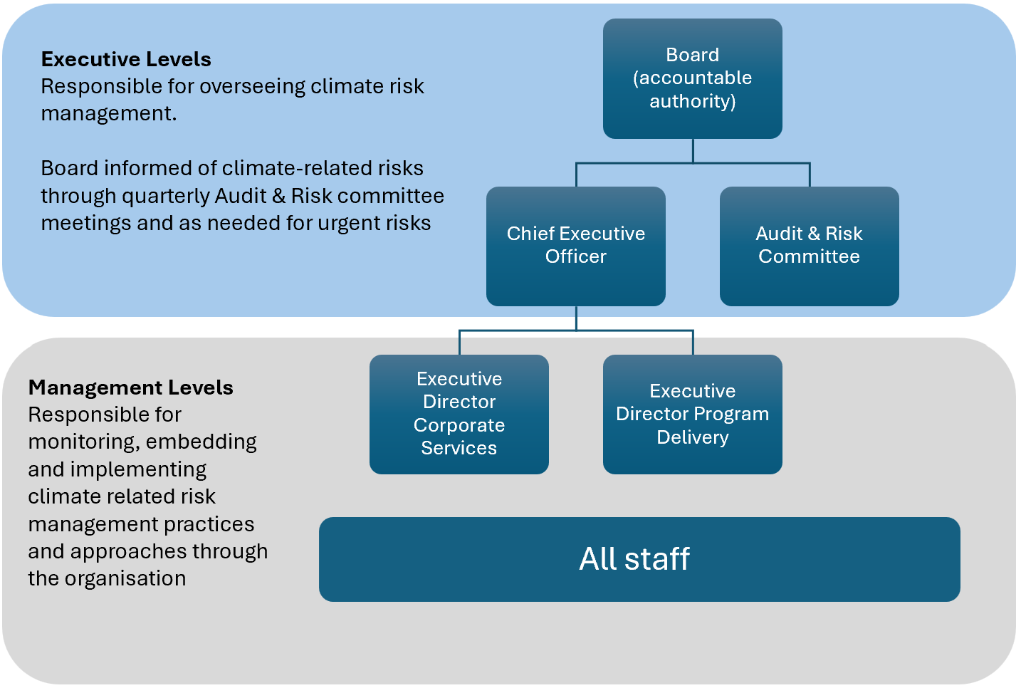
Figure 1 Climate Governance Structure
Criteria | Requirement summary | Response and cross-reference
G1(a) | The Accountable authority responsible for oversight of climate-related risks and  opportunities | The BRIC Board (see Our Board on page 8)
G1(a)i | How the accountable authority's responsibilities for climate risks are reflected in terms of reference, mandates, or policies. | The Board’s role, as detailed in the Board Charter, includes oversight of the enterprise risk framework, Risk Appetite Statement, and compliance with the PGPA Act, PGPA Rules, BRIC Act and BRIC Operating Mandate.
G1(a)ii | How the accountable authority ensures skills to oversee climate strategies are available or developed | The Board's self-evaluation and skills matrix review did not identify any relevant skills gaps. In FY2024-25, climate-related skills will be added to our learning and development survey to identify our staff training needs. Where needed, the free climate-related resources on the APS Academy will be used to build internal capability.
G1(a)iii | How and how often the accountable authority is informed about climate risks and opportunities | Figure 1 Climate Governance Structure within Appendix F: Climate Statement on page 3.
G1(a)iv | How the accountable authority considers climate risks in strategy, risk management, and major transaction decisions | Our CEO and Board are responsible for ensuring the framework in place to manage risk is embedded in our aligned policies and plans, including our Corporate Plan, Emissions Reduction Plan and integrated risk management approach. This includes managing climate-risk in major transaction decisions.  Our loan guidelines and eligibility criteria also consider climate-related risks and opportunities. This includes the requirement for all businesses applying for a loans to complete a screening climate risk and opportunity checklist and have a bushfire management plan in place. Our risk management approach is detailed in the Governance and Approach to risk, fraud and corruption sections starting on page 7.
G1(a)v | How the accountable authority sets and monitors climate-related targets | See Other reporting requirements on page 9.
G1(a)vi | How the accountable authority deputises risk oversight to a specific management-level position or management level committee | The Board work closely with the Audit and Risk Committee to seek advice and assurance on risk reporting and controls. The CEO is responsible for embedding a positive risk culture throughout the organisation and Executive Directors the day-to-day management of risk throughout the business.  The roles, responsibilities and membership of the Audit and Risk Committee are detailed within this Charter^{iii}. The climate risk management hierarchy is set out in Figure 1 Climate Governance Structure of the Climate Statement.
G1(b) | How management oversees governance processes, controls, and procedures for climate-related risks and opportunities | The Board oversees the risk framework while the Executive Leadership Team (CEO and Executive Directors) are responsible for the managing the governance processes, controls, and procedures for climate-related risks and opportunities. This includes maintaining a positive risk culture and the day-to-day risk management. Details can be found in the Governance section from page 7.
G2(a) | Entity consideration of The Australian Government’s Approach to Climate Risk and Opportunity Management in the Public Sector 2024-2026 | Climate risk and opportunity management has been integrated into existing processes and procedures. Our approach aligns with the expectations that we are identifying and managing climate risks and opportunities, as outlined in The Australian Government’s Approach to Climate Risk and Opportunity Management in the Public Sector 2024-2026.
G2(b) | Consideration of the Net Zero in Government Operations Strategy and Commonwealth Risk Management Policy | Optional for corporate Commonwealth entities. See the Commonwealth Risk Management Policy in the Approach to risk, fraud and corruption on page 7.

Annual Report

2024-25 Financial Year

Bushire Recovery Investment Corporation
Note: This annual report has been developed to demonstrate how to cross reference standard annual report content to avoid duplication and length within a climate disclosure. It also showcases where a climate disclosure could fit within the annual report.

Contents

Introduction
Letter of transmittal
Introduction from Accountable Authority
2024-25 snapshot

Organisational Overview
Agency overview
Purpose and vision

Governance
Our Board
Approach to risk, fraud and corruption
Legislative and government policy events
Other reporting requirements

Other performance statements
Statement of preparation
Overview of performance

Financial Statements
Independent auditor’s report
Statement of Accountable Authority

Appendices
Appendix A: Accountable Authority
Appendix B: Audit Committee
Appendix C: Management and human resources
Appendix D: Executive remuneration
Appendix E: Compliance Index
Appendix F: Climate Statement

Tip: this contents page is included to demonstrate how existing information within the body of your annual report can be leveraged when producing a climate disclosure. The sections that address the Governance criteria are identified in yellow and included below. Criteria addressed by cross-referencing the body of the annual report or an external publication are summarised in an index. This ensure readers can easily access relevant information and see that all criteria have been addressed.

Introduction

Agency overview
The Bushfire Recovery Investment Corporation (BRIC) was established on 1 July 2019 and operates under the Bushfire Recovery Investment Corporation Act 2020 (Cth) (BRIC Act) and the Bushfire Recovery Investment Corporation Operating Mandate Direction 2020. The BRIC is governed by an independent board appointed by, and accountable to, two responsible Ministers. In FY2024-25, the responsible Ministers were Senator the Hon. Swanson, Minister for the Environment and Senator the Hon. Knope, Minister for Finance.

About our organisation
BRIC is a corporate Commonwealth entity and a specialist investment vehicle within the Commonwealth Investment Framework that delivers Government policy through concessional loans.
We support bushfire-affected areas during times of disaster and business disruption and invest in recovery for a stronger and more resilient future. We specialise in concessional loans to businesses in areas impacted by bushfires with a focus on community rebuilding and recovery. We work alongside commercial lenders to offer these loans, and in recognition of the ecological damage caused by fires, we also offer loans to support recovery actions for native species, ecological communities, and natural assets. We manage the return of loan funds back to the Australian Government on a cost-neutral basis, an investment that benefits the Government, industry, regional communities, and borrowers.
Our customers are small businesses who are in financial need post-disaster, but viable in the long term. Concessional loans support customers by freeing up their cashflow to invest in rebuilding businesses, manage cost pressures while recovering, and increase spending into their local markets.

Figure 2 BRIC Organisational Chart

Governance
Our governance framework provides the context in which the BRIC operates to achieve its objectives and effectively manage risk and key stakeholder relationships. It includes:
- the legislative foundation provided by the BRIC Act and Operating Mandate, various subordinate instruments, and relevant sections of the Public Governance, Performance and Accountability Act 2013 (Cth) (PGPA Act)
- two responsible Ministers
- an independent Board that has an established induction program, annual training program, and conducts annual reviews of its performance
- an Audit and Risk Committee that ensures the Board receives appropriate advice and assurance on financial and performance reporting, systems of risk oversight and management, and systems of internal control
- a Board-endorsed and owned Policy Framework that demonstrates coverage, application and integration of BRIC policies within an overarching framework, and outlines ownership and accountability for the artefacts within the framework.

Our Board
The BRIC Board is the Accountable Authority as defined under section 12 of the PGPA Act. The Board decides BRIC’s objectives, strategic direction and ensures that it fulfils its statutory functions. In accordance with the BRIC Act and the Board’s Charter, the Board must meet at least 4 times per year. In the reporting period FY2024-25 it met on 4 occasions and attended to 7 matters out of session. The Board provided leadership across several areas including:
- BRIC’s performance against its plans and objectives
- oversight of the direction, budget, and delivery of the insourced operating model
- the strategic direction and approval of BRIC’s submission to the Statutory Review of the BRIC Act
- oversight of credit risk in the loan portfolio
- approval of Board policy frameworks
- interest rate reviews
- Board governance matters including the annual review of the Board’s Charter, skills matrix and Board performance
- working closely with the Audit and Risk Committee on its advice and assurance in relation to financial and performance reporting, risk including climate-related risk, and internal controls.

Approach to risk, fraud and corruption
As the Accountable Authority, the Board has put in place a system of risk management and oversight which includes the determination of risk appetite and tolerance. The Board also takes all reasonable measures to prevent, detect and respond to fraud and corruption. We have an Audit and Risk Committee that proactively manages risk, fraud and corruption and ensures our controls are aligned with industry standards and government policies, including the:
- 2021 industry standard AS8001: Fraud and Corruption Control
- Commonwealth Risk Management Policy 2023
- Australian Government Investigation Standards 2022
- Commonwealth Fraud and Corruption Control Framework (2024).
The Committee met three times during the year, attended to one matter out of session, and oversaw BRIC’s financial and performance reporting, its systems of risk oversight and management, and systems of internal control. Appendix 2 provides further details of the Audit and Risk Committee membership.
The evolution of risk management practices has seen the BRIC shift from reactive risk management practices to an integrated and customised process of continual review, evaluation and environmental scanning. This approach means we take reasonable steps to ensure we are managing potential enterprise risks through regular reviews of our risk management practices. During the year we undertook a full review of the enterprise risk management framework to ensure that it continues to be fit for purpose.

Other reporting requirements
APS Net Zero 2030 is the Government’s policy for the Australian Public Service (APS) to reduce its greenhouse gas emissions to net zero by 2030, and transparently report on its emissions. As part of the Net Zero in Government Operations Strategy and the reporting requirements under section 516A of the Environment Protection and Biodiversity Conservation Act 1999, corporate Commonwealth entities such as BRIC are required to report on their operational greenhouse gas (GHG) emissions. BRIC has also voluntarily opted-in to the APS Net Zero 2030 target in full and produced an Emissions Reduction Plan^{i} setting out our actions to contribute to this target. This plan was approved by the Board who will also monitor its ongoing performance through regular Board meetings.
We remained committed to Environmental, Social and Governance (ESG) principles in
FY2023-24. In alignment with the Australian Government's transition to a circular economy by 2030, we developed a Waste Management Strategy to reduce waste and improve recycling practices, contributing to sustainable and effective outcomes for BRIC.
Throughout the last year, our Reconciliation Action Plan (RAP) Committee made significant progress in the development of BRIC’s first Reflect RAP. At the time of reporting, our RAP was in the final stages of approval, awaiting endorsement by Reconciliation Australia. We also commissioned a RAP artist to develop an artwork to support our reconciliation story.

As the BRIC is fictional, the Regional Investment Corporation’s Emissions Reduction Plan (ERP) has been included as an example on how to cross-reference external publications.
As the BRIC is fictional, the Department of Finance’s Corporate Plan has been included used as an example on how to cross-reference external publications.
The Regional Investment Corporations Board Charter has been used as an example of how to leverage and cross-reference publicly available information. Document control Version number Date of issue Brief description of change 1 17/02/2025 Initial publication

