Dr Steven Kennedy PSM
Secretary
The Treasury
Langton Crescent
PARKES ACT 2600

Dear Dr Kennedy
COMPLIANCE ADVICE ON THE PROPOSED
tax cuts Campaign extension
The Independent Communications Committee (the Committee) considers proposed advertising campaigns with expenditure expected to be $250,000 or more, and provides independent advice to the relevant Chief Executive.
On 17 June 2024, the Committee considered the Tax Cuts campaign extension being developed by the Department of the Treasury. As part of its consideration of this campaign, the Committee met with your officers and reviewed the following supporting documentation:
- communication strategy
- communications research
- draft media strategy and indicative media plan overview
- a statement against Principles 1 to 4 of the Australian Government Guidelines on Information and Advertising Campaigns by non-corporate Commonwealth entities (Guidelines).
The Committee is satisfied that the campaign is relevant to government responsibilities (Principle 1), and that the campaign is being developed in line with Principles 2 to 4 of the Guidelines. The Committee has concluded the proposed Tax Cuts campaign extension is capable of complying with Principles 1 to 4 of the Guidelines, noting this view has been formed at the communication strategy stage and the Committee has not considered the advertising materials.
As legal and procurement matters relating to the campaign are not considered by this Committee, you will need to seek advice and assurance from your entity with respect to compliance with Principle 5 of the Guidelines.
This letter will be published on the Department of Finance website after the campaign is launched.
Any additional phases of the campaign will require separate consideration by the Committee.
Yours sincerely
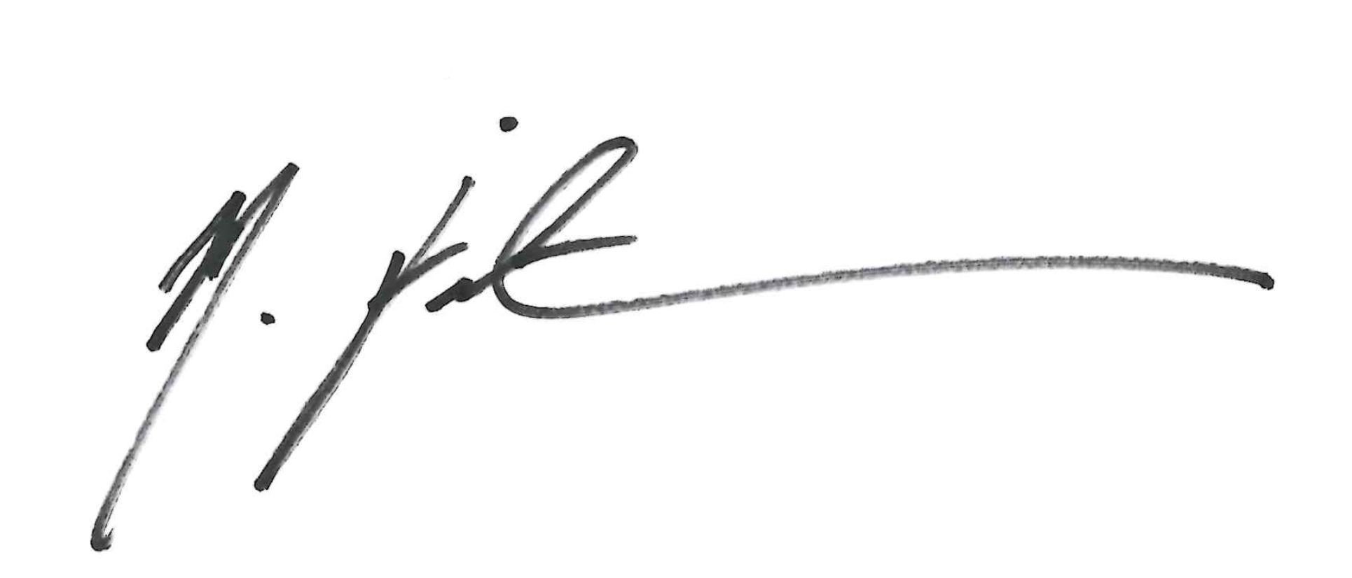

Meredith Fairweather
Chair
Independent Communications Committee

21 June 2024

