Jan Adams AO PSM
Secretary
Department of Foreign Affairs and Trade
RG Casey Building, John McEwen Crescent
Barton ACT 0221 Australia

Dear Ms Adams
COMPLIANCE ADVICE ON THE SMARTRAVELLER CAMPAIGN
The Independent Communications Committee (the Committee) considers proposed advertising campaigns with expenditure expected to be $250,000 or more, and provides independent advice to the relevant Chief Executive.
On 17 June 2024, the Committee considered the Smartraveller campaign being developed by the Department of Foreign Affairs and Trade. As part of its consideration of this campaign, the Committee met with your officers and reviewed the following supporting documentation:
- communication strategy
- developmental and evaluation communications research
- draft media strategy and indicative media plan overview
- a statement against Principles 1 to 4 of the Australian Government Guidelines on Information and Advertising Campaigns by non-corporate Commonwealth entities (Guidelines).
The Committee is satisfied that the campaign is relevant to government responsibilities (Principle 1), and that the campaign is being developed in line with Principles 2 to 4 of the Guidelines. The Committee has concluded the proposed Smartraveller campaign is capable of complying with Principles 1 to 4 of the Guidelines, noting this view has been formed at the communication strategy stage and the Committee has not considered the advertising materials.
As legal and procurement matters relating to the campaign are not considered by this Committee, you will need to seek advice and assurance from your entity with respect to compliance with Principle 5 of the Guidelines.
This letter will be published on the Department of Finance website after the campaign is launched.
Any additional phases of the campaign will require separate consideration by the Committee.
Yours sincerely
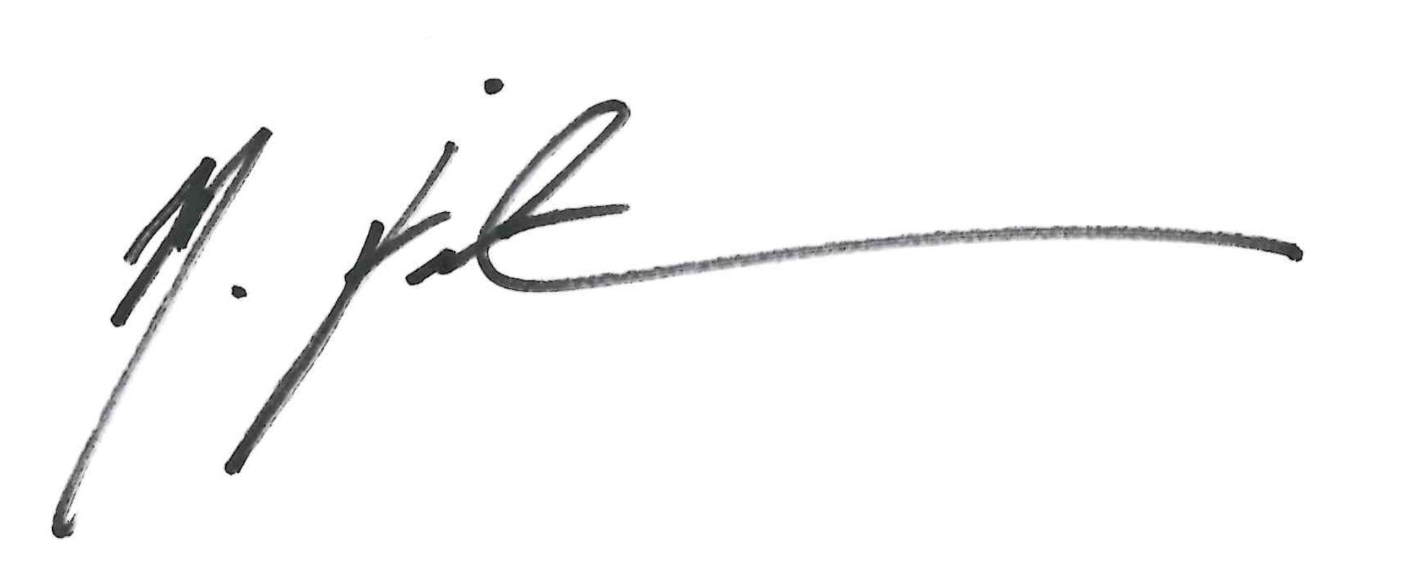

Meredith Fairweather
Chair
Independent Communications Committee

17 June 2024

