Independent Parliamentary Expenses Authority

Entity resources and planned performance

Independent Parliamentary Expenses Authority

Section 1: Entity overview and resources 181

1.1 Strategic direction statement 181

1.2 Entity resource statement 182

1.3 Budget measures 184

Section 2: Outcomes and planned performance 185

2.1 Budgeted expenses and performance for Outcome 1 186

Section 3: Budgeted financial statements 190

3.1 Budgeted financial statements 190

3.2. Budgeted financial statements tables 191

# 

# Independent Parliamentary Expenses Authority

## Section 1: Entity overview and resources

### 1.1 Strategic direction statement

The Independent Parliamentary Expenses Authority (IPEA) was established by the *Independent Parliamentary Expenses Authority Act 2017* (IPEA Act).

IPEA’s purpose is to foster trust in the use of public resources through independent advice, administration, reporting and assurance of work resources for parliamentarians and travel resources for their staff.

As an organisation, IPEA strives to achieve its purpose by delivering its primary functions, which relate to advice, education reporting and assurance. These functions include:

* providing personal advice to members of parliament (parliamentarians) on their work resources
* providing personal advice to persons employed under the Members of Parliament (Staff) Act 1984 (MOP(S) staff) on their travel resources
* monitoring parliamentarians’ and MOP(S) staff travel expenses and allowances and other related expenditure
* administering travel expenses and allowances, and other related expenditure, including the processing of these claims
* reporting publicly on work expenses
* conducting assurance activities, including audits, on work expenses claims.

Consistent with its primary functions, IPEA’s activities seek to:

* deliver services relating to the administration of travel resources, which includes providing advice, education and claims processing in respect of travel expenses and allowances
* provide independent reporting and assurance in respect of parliamentarians’ work resources and the travel resources of their staff.

### 1.2 Entity resource statement

Table 1.1 shows the total resourcing from all sources available to the entity for its operations and to deliver programs and services on behalf of the government.

The table summarises how resources will be applied by outcome (government strategic policy objectives) and by administered (on behalf of the government or the public) and departmental (for the entity’s operations) classification.

For more detailed information on special accounts and special appropriations, please refer to the *Budget Paper No. 4 – Agency Resourcing*.

Information in this table is presented on a resourcing (that is, appropriations/cash available) basis, whilst the Budgeted expenses by Outcome 1 tables in Section 2 and the financial statements in Section 3 are presented on an accrual basis. Amounts presented below are consistent with amounts presented in the Appropriation Bills themselves.

**Table 1.1: Independent Parliamentary Expenses Authority resource statement – Budget estimates for 2024-25 as at Budget May 2024**



Prepared on a resourcing (i.e. appropriations available) basis.

All figures shown above are GST exclusive - these may not match figures in the cash flow statement.

(a) Appropriation Bill (No. 1) 2024-2025

### 1.3 Budget measures

Budget measures in Part 1 relating to IPEA are detailed in the Budget Paper No. 2 and are summarised below.

Table 1.2: Independent Parliamentary Expenses Authority 2024-25 Budget measures

**Part 1: Measures announced since the 2023-24 Mid-Year Economic and Fiscal Outlook (MYEFO)**

Prepared on a Government Finance Statistics (Underlying Cash) basis. Figures displayed as a negative (‑) represent a decrease in funds and a positive (+) represent an increase in funds.

1. The lead entity for measure titled *Finance Portfolio - additional resourcing* is the Department of Finance. The full measure description and package details appear in the Budget Paper No. 2 under the Finance portfolio.
2. The measure titled *Savings from external labour - extension* is Cross Portfolio. The full measure description and package details appear in Budget Paper No. 2 under Cross Portfolio.

## Section 2: Outcomes and planned performance

Government outcomes are the intended results, impacts or consequences of actions by the government on the Australian community. Commonwealth programs are the primary vehicle by which government entities achieve the intended results of their outcome statements. Entities are required to identify the programs which contribute to government outcomes over the Budget and forward years.

Each outcome is described below together with its related programs. The following provides detailed information on expenses for each outcome and program, further broken down by funding source.

|  |
| --- |
| **Note:**  Performance reporting requirements in the Portfolio Budget Statements are part of the Commonwealth performance framework established by the *Public Governance, Performance and Accountability Act 2013*. It is anticipated that the performance measure described in Portfolio Budget Statements will be read with broader information provided in an entity’s corporate plans and annual performance statements – included in Annual Reports – to provide a complete picture of an entity’s planned and actual performance.  The most recent corporate plan for the Independent Parliamentary Expenses Authority can be found at: [Publications | Independent Parliamentary Expenses Authority (ipea.gov.au)](https://www.ipea.gov.au/publications).  The most recent annual performance statement can be found at: [Publications | Independent Parliamentary Expenses Authority (ipea.gov.au)](https://www.ipea.gov.au/publications) in IPEA’s Annual Report |

### 2.1 Budgeted expenses and performance for Outcome 1

|  |
| --- |
| Outcome 1: Support for current and former parliamentarians and others as required by the Australian Government through the delivery of, independent oversight and advice on, work resources and travel resources. |

#### Linked programs

| Department of Finance |
| --- |
| **Programs**   * Program 3.1 – Ministerial and Parliamentary Services |
| Contribution to Outcome 1 made by linked programs  IPEA administers and advises on travel related work expenses, and provides independent oversight of the work expenses administered by the Department of Finance for current and former parliamentarians and their staff. |

##### Budgeted expenses for Outcome 1

This table shows how much the entity intends to spend (on an accrual basis) on achieving the outcome, broken down by program, as well as by Administered and Departmental funding sources.

Table 2.1.1: Budgeted expenses for Outcome 1



Table continues on next page

1. Expenses not requiring appropriation in the Budget year are made up of audit fees.

Note: Departmental appropriation splits and totals are indicative estimates and may change in the course of the budget year as government priorities change.

Table 2.1.3: Performance measures for Outcome 1

Table 2.1.3 details the performance measures for each program associated with Outcome 1. It is used by entities to describe the results they plan to achieve and the related key activities, as detailed in the current corporate plan, the context in which these activities are delivered, and how the performance of these activities will be measured. Where relevant, details of the 2024-25 Budget measures that have created new programs or materially changed existing programs are provided.

| Outcome 1 – Support for current and former parliamentarians and others as required by the Australian Government through the delivery of, independent oversight and advice on, work resources and travel resources. | | |
| --- | --- | --- |
| **Program 1.1 – Independent Parliamentary Expenses Authority – Travel Oversight and Reporting.**  IPEA provides services to parliamentarians and their staff and publicly reports on their expenditure. | | |
| Key Activities | For current and former parliamentarians and their staff:   * Deliver services relating to the administration of travel resources. This includes providing advice and claims processing in respect of travel expenses and allowances. * Provide independent reporting and assurance in respect of parliamentarians’ work resources* and the travel resources of their staff. | |
| Year | Performance measures | Expected Performance Results |
| Current Year  2023‑24 | Travel — Advice  Provide accurate and timely advice to  parliamentarians and MOP(S) staff on travel and related expenses.  Travel — Education  Provide education sessions to  parliamentarians and MOP(S) staff on travel and related expenses.  Travel — Claims  Accurate and timely processing of claims for travel expenses and allowances relating to parliamentarians and MOP(S) staff.  Data and Reporting  Increasing transparency through the  compilation of reports detailing the  work resources of current and former  parliamentarians and the travel resources of MOP(S) staff. | **Met** – Advice is provided in accordance with IPEA’s published service level standards, which include measurements for quality and timeliness.  **Met** – Education sessions are provided in accordance with the published service  level standards.  **Partially met** – IPEA’s ability to meet its service level standards, and fully measure and report on its travel claims performance, has been impacted by Parliamentary Expenses Management Systems’ (PEMS) functionality limitations and technical issues.  **Met** – Reports relating to work expenses for parliamentarians and their staff are  prepared and provided as per IPEA’s  published service level standards. |

Table continues on next page

Table 2.1.3: Performance measures for Outcome 1 (continued)

| **Program 1.1 – Independent Parliamentary Expenses Authority – Travel Oversight and Reporting.**  IPEA provides services to parliamentarians and their staff and publicly reports on their expenditure. | | |
| --- | --- | --- |
| Year | Performance measures | Expected Performance Results |
| Current Year  2023‑24 | Audit and Assurance  Conducting assurance activities on the work resources of parliamentarians and the travel resources of MOP(S) staff. | **Met** – All parliamentarians’ offices are subject to one or more forms of assurance activity during the financial year in accordance with IPEA’s published service level standards and procedures (protocols and factsheets). |
| Year | Performance measures | Planned Performance Results |
| Budget Year  2024‑25 | Provision and delivery of independent advice, administration, reporting on, and assurance of, work resources* for parliamentarians and travel resources for their staff.  Advice  Provide accurate and timely advice to parliamentarians and their staff on travel resources.  Education  Educate parliamentarians and their staff on travel resources.  Claims Administration  Administer accurately and in a timely manner the processing of parliamentarians’ and their staff claims for travel resources.  Reporting  Increase transparency through the compilation of reports on parliamentarians’ work resources and the travel resources of their staff.  Assurance & Audit  Conduct assurance activities on parliamentarians’ work resources and the travel resources of their staff. | IPEA achieves 80% of targets in respect of its performance measures.  Advice is provided in accordance with its service level standards, and performance targets in respect of advice are achieved.  Education is provided in accordance with its service level standards, and performance targets in respect of education are achieved.  Claims for travel expenses and allowances are processed in accordance with their service level standards, and performance targets in respect of claims processing are achieved.  Performance targets for reporting on work and travel resources are achieved.  All parliamentarians’ offices are the subject of at least one assurance activity in the reporting period. |
| Forward Estimates  2025‑28 | As per 2024‑25 | As per 2024-25 |
| Material changes to Program 1.1 resulting from 2024‑25 Budget Measures: Nil | | |

Parliamentarians’ “work resources” include the resources provided to them under the Parliamentary Business Resources legislative framework including their travel resources.

## Section 3: Budgeted financial statements

Section 3 presents budgeted financial statements which provide a comprehensive snapshot of entity finances for the 2024-25 budget year, including the impact of budget measures and resourcing on financial statements.

### 3.1 Budgeted financial statements

#### 3.1.1 Differences between entity resourcing and financial statements

No material differences exist between entity resourcing and the financial statements.

#### 3.1.2 Explanatory notes and analysis of budgeted financial statements

Departmental

IPEA is budgeting for a break-even result for 2024-25 and across the forward estimates. The expected actual operating result in 2023-24 is an operating deficit of $0.95 million due to additional costs and anticipated savings yet to be realised from the implementation of the Parliamentary Expense Management System (PEMS).

Expenses and revenue from government decrease in 2025-26 and beyond reflecting the effect of anticipated savings from the Parliamentary Expenses Management System (PEMS) measure published in the 2017-18 Portfolio Additional Estimates Statements (PAES).

Administered

In the schedule of budgeted income and expenses, the administered supplier expenses reflect estimated work and travel expenses for current and former parliamentarians and MOP(S) staff.

### **3.2.** **Budgeted financial statements tables**

Table 3.1: Comprehensive income statement (showing net cost of services) for the period ended 30 June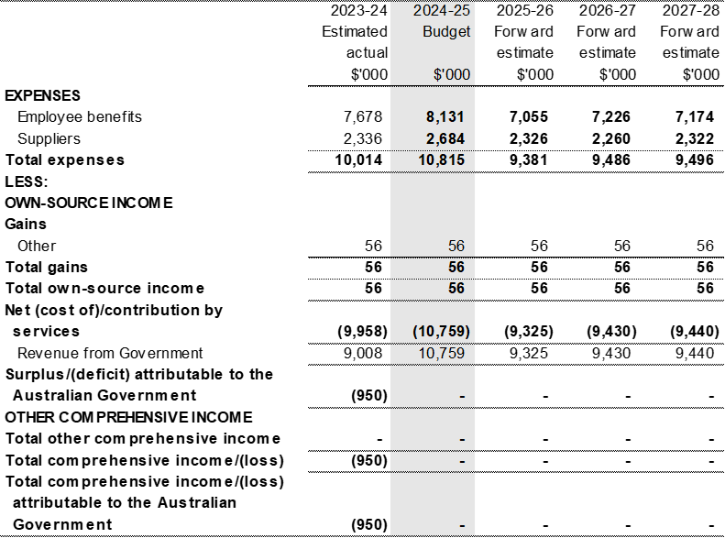

Prepared on Australian Accounting Standards basis.

**Note: Impact of net cash appropriation arrangements**

Table 3.2: Budgeted departmental balance sheet (as at 30 June)



Prepared on Australian Accounting Standards basis.

*’Equity’ is the residual interest in assets after deduction of liabilities.

Table 3.3: Departmental statement of changes in equity – summary of movement (Budget year 2024-25)



Prepared on Australian Accounting Standards basis.

Table 3.4: Budgeted departmental statement of cash flows (for the period ended 30 June)



Prepared on Australian Accounting Standards basis.

Table 3.5: Departmental capital budget statement (for the period ended 30 June)

IPEA has no budgeted capital expenditure.

Table 3.6: Statement of departmental asset movements (Budget year 2024-25)

IPEA has no budgeted non-financial asset.

Table 3.7: Schedule of budgeted income and expenses administered on behalf of Government (for the period ended 30 June)



Prepared on Australian Accounting Standards basis.

Table 3.8: Schedule of budgeted assets and liabilities administered on behalf of Government (as at 30 June)



Prepared on Australian Accounting Standards basis.

Table 3.9: Schedule of budgeted administered cash flows (for the period ended 30 June)



Prepared on Australian Accounting Standards basis.**Table 3.10: Schedule of administered capital budget statement (for the period ended 30 June)**

IPEA has no budgeted capital expenditure on behalf of government.

Table 3.11: Statement of administered asset movements (for the period ended 30 June)

IPEA has no budgeted non-financial assets administered on behalf of government.