PORTFOLIO SUPPLEMENTARY ADDITIONAL ESTIMATES STATEMENTS 2023–24

Appropriation Bill (No. 5) 2023–2024  
and  
Appropriation Bill (No. 6) 2023–2024

Finance Portfolio

Explanations of supplementary Additional Estimates 2023–24

© Commonwealth of Australia 2024

ISBN 978-1-925205-58-9 (Print); 978-1-925205-59-6 (Online)

This publication is available for your use under a [Creative Commons Attribution 4.0 International](https://creativecommons.org/licenses/by/4.0/) licence, with the exception of the Commonwealth Coat of Arms, the logo, photographs, images, signatures and where otherwise stated. The full licence terms are available from [http://creativecommons.org/licenses/by/4.0/](https://creativecommons.org/licenses/by/4.0/).

CC by_grey

Use of material under a [Creative Commons Attribution 4.0](https://creativecommons.org/licenses/by/4.0/) International licence requires you to attribute the work to the creator (but not in any way that suggests that Department of Finance endorses you or your use of the work).

**Australian Government Department of Finance material used 'as supplied'**

Provided you have not modified or transformed Finance material in any way including, for example, by changing the Finance text; calculating percentage changes; graphing or charting data; or deriving new statistics from published Finance statistics – then Finance prefers the following attribution:

*Source: The Australian Government* *Department of Finance*

**Derivative material**

If you have modified or transformed Finance material, or derived new material from those of the Finance in any way, then Finance prefers the following attribution:

*Based on The Australian Government Department of Finance data*

**Use of the Coat of Arms**

The terms under which the Coat of Arms can be used are set out on the Department of the Prime Minister and Cabinet website (see [www.pmc.gov.au/honours-and-symbols/commonwealth-coat-arms](https://www.pmc.gov.au/honours-and-symbols/commonwealth-coat-arms))

**Other Uses**

Inquiries regarding this licence and any other use of this document are welcome at:

Copyright Coordinator

Department of Finance

One Canberra Avenue, FORREST ACT 2603

Email: publications@finance.gov.au

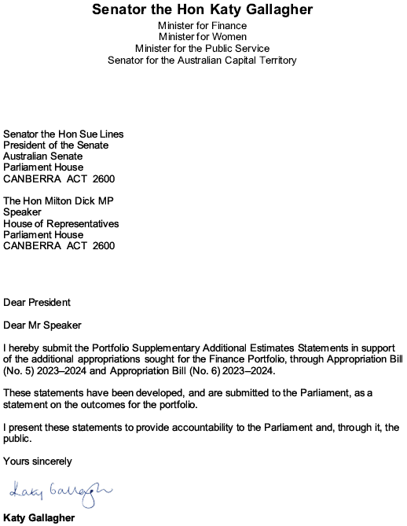

Abbreviations and conventions

The following notations may be used:

NEC/nec not elsewhere classified

‑ nil

.. not zero, but rounded to zero

na not applicable (unless otherwise specified)

nfp not for publication

$m $ million

Figures in tables and in the text may be rounded. Figures in text are generally rounded to one decimal place, whereas figures in tables are generally rounded to the nearest thousand. Discrepancies in tables between totals and sums of components are due to rounding.

Enquiries

Should you have any enquiries regarding this publication please contact Chief Financial Officer in the Department of Finance (02) 6215 2222.

A copy of this document can be located on the Australian Government Budget website at: [www.budget.gov.au](http://www.budget.gov.au/).

User guide  
to the  
Portfolio Supplementary Additional Estimates   
Statements

User guide

The purpose of the 2023–24 Portfolio Supplementary Additional Estimates Statements (PSAES) is to inform Senators, Members of Parliament and the public of the proposed allocation of additional resources to government outcomes by entities within the portfolio.

The PSAES facilitate understanding of the proposed appropriations in Appropriation Bill (No. 5) 2023–2024 and Appropriation Bill (No. 6) 2023–2024. In this sense the PSAES is declared by the Appropriation Acts to be a ‘relevant document’ to the interpretation of the Acts according to section 15AB of the *Acts Interpretation Act 1901*.

Appropriation Bill (No. 5) 2023–2024, which follows on from *Appropriation Act (No. 1)* tabled at Budget and *Appropriation Act (No. 3)* tabled at Additional Estimates, will provide additional expenditure authority for the ordinary annual services of government in respect of the 2023–24 financial year.

Appropriation Bill (No. 6) 2023–2024, which follows on from *Appropriation Act (No. 2)* tabled at Budget and *Appropriation Act (No. 4)* tabled at Additional Estimates, will provide additional expenditure authority in respect of the 2023–24 financial year for capital works and services, payments to or for the states, territories and local government authorities, and new administered outcomes not authorised in specific legislation.

Contents

Entity Supplementary Additional Estimates Statements xi

Department of Finance 3

Australian Electoral Commission 11

Entity Supplementary Additional Estimates Statements

Department of Finance

[Overview of additional appropriations 3](#_Toc165644491)

[Department of Finance measures table 4](#_Toc165644492)

[Supplementary additional estimates and variations 5](#_Toc165644493)

# Department of Finance

## Overview of additional appropriations

The Department of Finance is receiving additional appropriation in 2023-24 due to the 2024-25 Budget Measure titled ‘Future Made in Australia – Investing in Innovation, Science and Digital Capabilities’.

### Department of Finance measures table

Table 1.1 summarises new Government measures taken since the 2023–24 Additional Estimates. The table is split into receipt and payment measures, with the affected program identified.

Table 1.1: Department of Finance 2023–24 Supplementary additional estimates measures



Prepared on a Government Financial Statistics (Underlying Cash) basis. Figures displayed as a negative (-) represent a decrease in funds and a positive (+) represent an increase in funds.

1. The measure *Future Made in Australia - Investing in Innovation, Science and Digital Capabilities* is Cross Portfolio. The full measure description and package details appear in 2024-25 Budget Paper No. 2 under Cross Portfolio.

### Supplementary additional estimates and variations

The following table details the changes to the resourcing for the Department of Finance at Supplementary Additional Estimates, by outcome. The following table details the estimates and variations resulting from new measures and any other variations (if applicable) since the 2023–24 Additional Estimates in Appropriation Bills (No. 5 and No. 6).

Table 1.2: Supplementary additional estimates and variations to outcomes from measures and other variations



Prepared on a resourcing (i.e. appropriations available) basis.

The following tables detail the Supplementary Additional Estimates sought for Department of Finance through Appropriation Bills (No. 5 and No. 6).

Table 1.3: Appropriation Bill (No. 5) 2023–2024



Table continues on next page

**Table 1.3 - Appropriation Bill (No. 5) 2023-2024 (continued)**



**Note 1:** 2022–23 available appropriation is included to allow a comparison of this year's appropriation with what was made available for use in the previous year.

Table 1.4: Appropriation Bill (No. 6) 2023–2024

Finance has not sought any Additional Estimates through Appropriation Bill (No. 6).

# Australian Electoral Commission

[Overview of additional appropriations 11](#_Toc165645751)

[Entity measures table 12](#_Toc165645752)

[Supplementary additional estimates and variations 12](#_Toc165645753)

# Australian Electoral Commission

## Overview of additional appropriations

The Australian Electoral Commission is receiving an increase in funding in 2023-24. This funding is related to the additional costs incurred for the delivery of the 2022 federal election and the Aston and Fadden by-elections.

### Australian Electoral Commission measures table

Table 1.1 summarises new Government measures taken since the 2023–24 Additional Estimates. The table is split into receipt and payment measures, with the affected program identified.

Table 1.1: Australian Electoral Commission 2023–24 Supplementary additional estimates measures

The Australian Electoral Commission did not receive any supplementary additional estimate measures.

### Supplementary additional estimates and variations

The following table details the changes to the resourcing for the Australian Electoral Commission at Supplementary Additional Estimates, by outcome. The following table details the estimates and variations resulting from new measures and any other variations (if applicable) since the 2023–24 Additional Estimates in Appropriation Bills (No. 5 and No. 6).

Table 1.2: Supplementary additional estimates and variations to outcomes from measures and other variations



Prepared on a resourcing (i.e. appropriations available) basis.

The following tables detail the Supplementary Additional Estimates sought for the Australian Electoral Commission through Appropriation Bills (No. 5 and No. 6).

Table 1.3: Appropriation Bill (No. 5) 2023–2024



**Note 1:** 2022–23 available appropriation is included to allow a comparison of this year's appropriation with what was made available for use in the previous year.

Table 1.4: Appropriation Bill (No. 6) 2023–2024

The Australian Electoral Commission has not sought any Additional Estimates through Appropriation Bill (No. 6).