National Data Sharing Work Program factsheet

In July 2021 National Cabinet signed the Intergovernmental Agreement on Data Sharing (IGA). The IGA is an agreement by the Australian Government and all state and territory governments to share data across jurisdictions as a default position, where it can be done securely, safely, lawfully and ethically.

The IGA is implemented through the Data and Digital Ministers Meeting (DDMM) and is supported by the National Data Sharing Work Program (Work Program). The mechanism to establish the Work Program is set out in the IGA. The Work Program implements the IGA by embedding it in data sharing practices.

The Work Program also aims to; build trust and relationships, uplift capacity, and capability in the Australian data ecosystem; and develop robust, reusable data products. The Work Program seeks to uplift the national data sharing system by:
- focusing national effort on specific time-limited priority policy areas to deliver collaborative, inter-jurisdictional projects; and
- driving broader data sharing system reforms.
Operating in six-monthly sprints, the Work Program builds towards a future data sharing ‘end-state’ through specific, time-limited projects. The end state maps the goals for a well-functioning data sharing system, as agreed by Data and Digital Ministers on 25 March 2022 (Attachment A). It includes:
- Streamlined and consistent data access and transfer mechanisms. New systems are developed with common technical building blocks and interoperability considered. Data sharing governance and management maturity is more consistent across jurisdictions.
- Increased visibility of initiatives and best practice informs decisions for investment in data sharing capabilities. There is national alignment on ICT investment for data sharing.
- Consistency in approval pathways for system-wide approaches to be agreed and implemented. There are appropriate and consistent approvals required for subject specific data access or sharing requests.

- Value of data to other jurisdictions is quantifiable. Investment decisions are informed by evidence of data value (social, economic). Data sharing is an enabler to maximise public benefit, data standards, quality and national interoperability.
- Visibility of jurisdictions’ data sharing approaches drive alignment and trust; custodians make more informed decisions with better information. All jurisdictions have confidence there will be no adverse consequences to themselves, agencies or data subjects when sharing data.

Portfolio based Work Program projects must be endorsed by a minimum of one relevant Commonwealth portfolio minister and relevant portfolio ministers from at least two states and/or territories (Attachment B). The Work Program is evaluated following each sprint, to identify opportunities for improvement and refinement.

The IGA was evaluated in September 2023, two years after commencement. Following that review, DDMM agreed Work Program sprints be limited to approximately four projects, and data sharing system reform projects with outstanding deliverables will be carried forward to the following sprint, subject to agreement of project leads, noting some pieces of work required additional time to achieve results. Ministers also agreed future Work Programs should have a targeted scope and prioritise projects with resourcing.

The Work Program has facilitated projects in priority data sharing areas such as Closing the Gap Target 9B, Family, Domestic and Sexual violence, Veterans’ health, and the Australian National Data Integration Infrastructure (ANDII) to support the National Disability Data Asset (NDDA).

More information on DDMM and its sub-groups can be found in the Data and Digital Ministers Meeting factsheet.

Attachment A
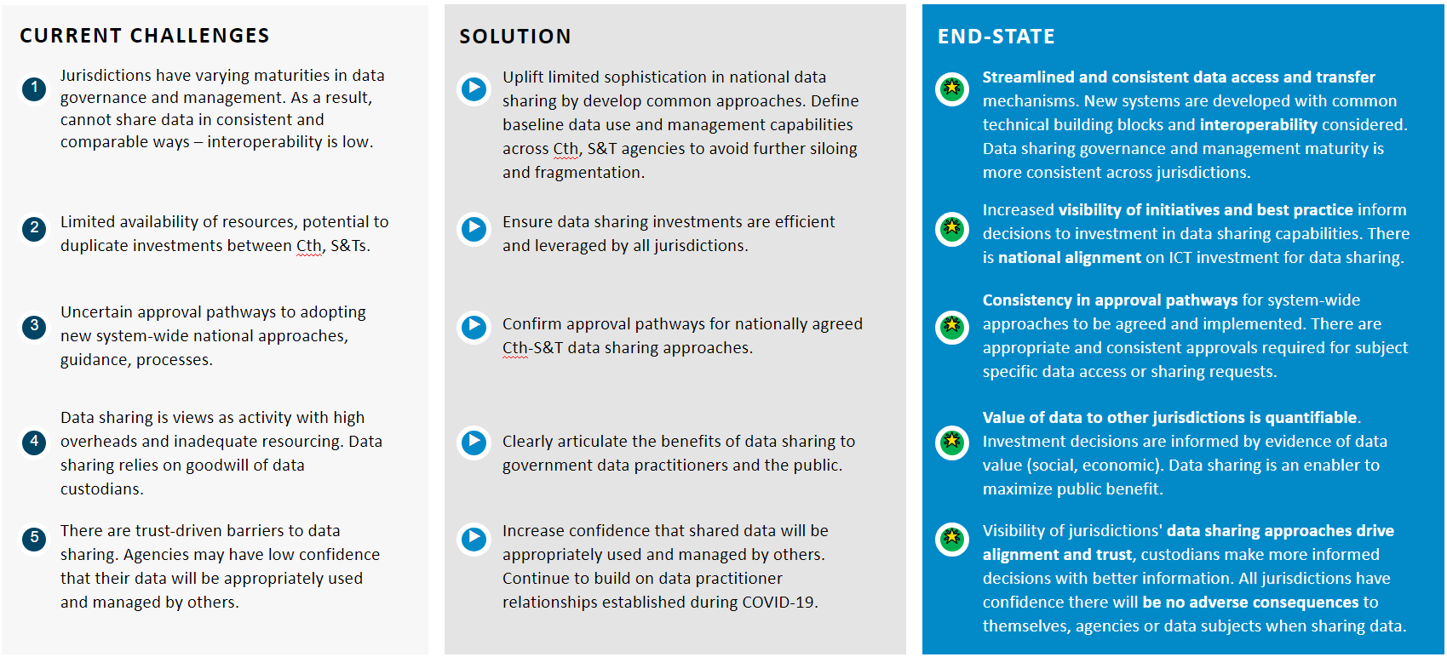
The ‘end-state’ maps current challenges, proposed solutions, and desired outcomes to ensure projects build towards long-term objectives.

Attachment B
National Data Sharing Work Program Gateways

