**Intergovernmental Agreement on Data Sharing factsheet**

**Overview**

The [Intergovernmental Agreement on Data Sharing (IGA)](https://www.finance.gov.au/government/public-data/data-and-digital-ministers-meeting/intergovernmental-agreement-data-sharing) was signed by National Cabinet on 9 July 2021 and reviewed by Data and Digital Ministers in September 2023. **The IGA commits all jurisdictions to share public sector data by default, where it can be done securely, safely, lawfully and ethically.** The IGA is implemented through the [Data and Digital Ministers Meeting (DDMM)](https://www.finance.gov.au/government/public-data/data-and-digital-ministers-meeting/terms-reference) and is supported by the National Data Sharing Work Program.

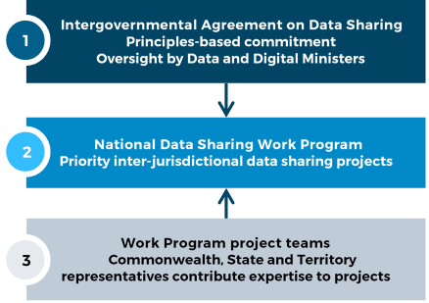

**The IGA does:**

* recognise data as a shared national asset and aims to maximise the value of data to deliver outstanding policies and services for Australians.
* expect that governments will share data with each other for the design, development, and delivery of policies, programs and services, and other activities in the public interest.

**The IGA does not:**

* change or override any existing data sharing agreements or legislation. It commits all parties to apply their best endeavours to share data across governments, including being responsive to requests and giving clear reasons for refusals.

**Applying the IGA**

The IGA can be applied to cross-jurisdictional data sharing work. It can be used by data practitioners to help increase the volume and value of data sharing. Some ways to apply the IGA include:

* use best endeavours to share data by default. Review any policies, processes and systems to align with the IGA and its implementation.
* apply the guiding principles in the IGA to data sharing negotiations and incorporate relevant principles in data sharing agreements.
* initiate a data request and apply the schedules in the IGA which set out requirements for data requests (Schedule E) and what to consider when assessing a request (Schedule B).
* talk to data custodians in your organisation about your data sharing policies and transfer mechanisms to ensure you are well prepared to respond to new data requests.
* set up a central data request point in your organisation for other government officials to access, such as a portal, web form or email address.
* participate in projects under the National Data Sharing Work Program. Projects can be nominated through your jurisdictions’ DDMM Data & Analytics Working Group member. Please contact [ddmm@finance.gov.au](mailto:ddmm@finance.gov.au) for further information.

**Ensuring privacy and data security**

Data shared in accordance with the IGA must be in accordance with established privacy and security standards and policies, and within existing legislative conditions, including complaints handling processes.

For example, the Office of the Australian Information Commissioner (OAIC)’s [Data Breach Preparation and Response Guide](https://www.oaic.gov.au/__data/assets/pdf_file/0017/1691/data-breach-preparation-and-response.pdf) outlines how you can comply with the Australian Privacy Principles, and state and territory equivalents, and contains templates to help you prepare a data breach response plan.

Commonwealth entities must also comply with the [Protective Security Policy Framework](https://www.protectivesecurity.gov.au/). The framework contains 16 policies that set out the core requirements for Australian Government entities to protect their people, information and assets.

The IGA was reviewed in September 2023 and will be reviewed again in 2026. The 2023 review found that no changes to the IGA are needed.