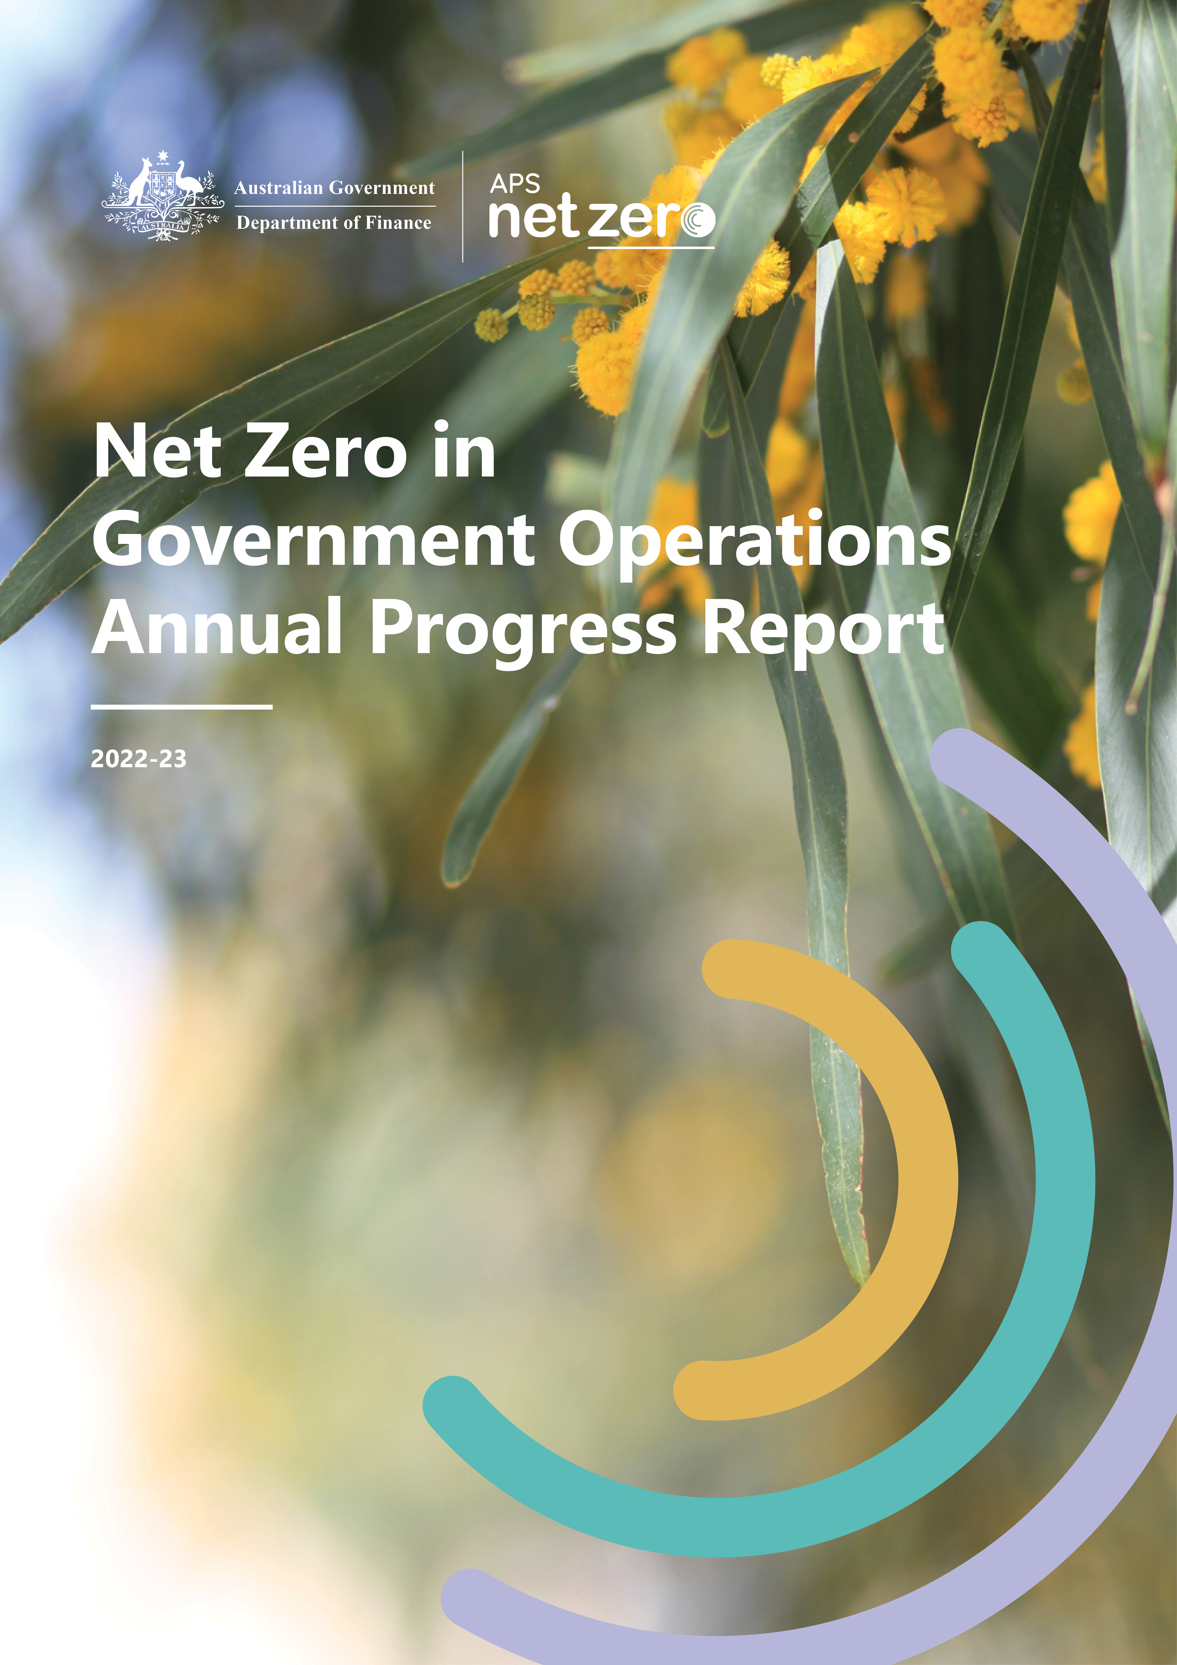

© Commonwealth of Australia 2023 Ownership of intellectual property rights unless otherwise noted, copyright (and any other intellectual property rights) in this publication is owned by the Commonwealth of Australia (referred to as the Commonwealth).
Creative Commons licence All material in this publication is licensed under a Creative Commons Attribution 4.0 International Licence except content supplied by third parties, logos and the Commonwealth Coat of Arms.
Inquiries about the licence and any use of this document should be emailed to apsnetzero@finance.gov.au.
ISSN: 2981-9539
Disclaimer: The Australian Government acting through the Department of Finance has exercised due care and skill in preparing and compiling the information and data in this publication. Notwithstanding, Finance, its employees and advisers disclaim all liability, including liability for negligence and for any loss, damage, injury, expense or cost incurred by any person as a result of accessing, using or relying on any of the information or data in this publication to the maximum extent permitted by law.

Executive Summary
The Net Zero in Government Operations Strategy includes two components: an emissions reduction target, and the reinstatement of public reporting on emissions from Australian Government operations.
The Net Zero in Government Operations Annual Progress Report presents an aggregated summary of entity greenhouse gas emissions at a whole-of-Australian-Government level, as per the Strategy. As 2022-23 was the first year of publication, future Annual Progress Reports will be expanded to show progress towards achieving the Australian Public Service (APS) Net Zero by 2030 target in a transparent and consistent manner.
Australian Government entities have commenced emissions accounting in their 2022-23 annual reports. All non-corporate Commonwealth entities and corporate Commonwealth entities were required to report the emissions from their operations against the APS Net Zero Emissions Reporting Framework in their annual reports for 2022-23. Commonwealth companies were not required to report for the 2022-23 reporting period and will commence reporting in the 2023-24 reporting period.
Emission sources reported in 2022-23 are as follows:
- electricity
- natural gas
- fleet vehicles
- domestic flights
- other energy – non-Defence
- other energy – Defence.
Non-corporate Commonwealth entities (92) and corporate Commonwealth entities (66) emitted an approximate total of 3,286,328 tonnes of carbon dioxide equivalent (t CO₂-e) emissions in financial year 2022-23. The single largest source of CO₂-e emissions is from electricity consumption (1,370,454 t CO₂-e).

Australian Government Greenhouse Gas Emissions Inventory – Location-based method
Emission source | Scope 1  (t CO₂-e) | Scope 2  (t CO₂-e) | Scope 3  (t CO₂-e) | Sum of emissions  (t CO₂-e)
Electricity  (Location-based method) | N/A | 1,235,551 | 134,903 | 1,370,454
Natural gas | 100,975 | N/A | 19,627 | 120,602
Fleet vehicles | 212,139 | N/A | 54,114 | 266,253
Domestic flights | 8,098 | N/A | 182,974 | 191,072
Other energy | 1,067,935 | N/A | 270,012 | 1,337,947
Other energy – non-Defence | 20,641 | N/A | 5,743 | 26,384
Other energy - Defence | 1,047,294 | N/A | 264,269 | 1,311,563
Sum of emissions  (t CO₂-e) | 1,389,147 | 1,235,551 | 661,630 | 3,286,328

Australian Government Greenhouse Gas Emissions Inventory – Market-based method
Emission source | Scope 1  (t CO₂-e) | Scope 2  (t CO₂-e) | Scope 3  (t CO₂-e) | Sum of emissions  (t CO₂-e)
Electricity  (Market-based method) | N/A | 886,858 | 117,379 | 1,004,237
Natural gas | 100,975 | N/A | 19,627 | 120,602
Fleet vehicles | 212,139 | N/A | 54,114 | 266,253
Domestic flights | 8,098 | N/A | 182,974 | 191,072
Other energy | 1,067,935 | N/A | 270,012 | 1,337,947
Other energy – non-Defence | 20,641 | N/A | 5,743 | 26,384
Other energy – Defence | 1,047,294 | N/A | 264,269 | 1,311,563
Sum of emissions  (t CO₂-e) | 1,389,147 | 886,858 | 644,106 | 2,920,111
Notes:
- The market-based values above are calculated for the total of all entities, rather than calculated on an individual entity basis. This means the values presented in separate annual reports will not sum to the above values.
- Other energy has been split into two categories – Defence and non-Defence. Other energy – Defence includes emissions reported by the Department of Defence that are a result of Defence operations.


Contents
Executive Summary i
Contents iii
Index of Tables iv
Index of Figures iv
Introduction 1
Emission sources 1
Responsibilities and governance 4
2022-23 Results 5
Whole-of-Australian-Government emissions 5
Electricity 10
Natural gas 14
Fleet vehicles 15
Domestic flights 18
Other energy 19
Appendix A: Caveats 23
Annual report differences 23
Entity-specific caveats 23
Machinery of Government changes 24
Entities reporting to the National Greenhouse and Energy Reporting (NGER) Scheme 25
Appendix B: Methods 26
Emission calculations 26
Data post-processing 28
Time series consistency 28
Appendix C: Emission factors 29
Natural gas emission factors 29
Electricity emission factors 30
Fleet emission factors 31
Flights emission factors 32
Other energy tab 33
Appendix D: Energy content factors 36

Index of Tables
Table 1: Australian Government Greenhouse Gas Emissions Inventory – Location-based method 5
Table 2: Australian Government Greenhouse Gas Emissions Inventory – Market-based method 7
Table 3: Electricity emissions by state/territory and scope (location-based method) 11
Table 4: Electricity emissions and renewable percentages (market-based method) 12
Table 5: Natural gas emissions by state/territory and scope 14
Table 6: Fleet vehicle emissions by vehicle type, fuel type and scope 16
Table 7: Flight emissions 18
Table 8: Emissions reported as Other Energy, by source, fuel type and scope 19

Index of Figures
Figure 1: Polycarbonate solar panels on Questacon’s curved roof 3
Figure 2: Percentage of emission sources for each scope (location-based method) 6
Figure 3: Percentage of emissions by activity (location-based method) 6
Figure 4: Percentage of emission sources for each scope (market-based method) 7
Figure 5: Percentage of emissions by activity (market-based method) 8
Figure 6: Australian Tourism Exchange 9
Figure 7: Location-based and market-based emissions comparison 11
Figure 8: Percentage of natural gas emissions by state 14

Introduction
The Net Zero in Government Operations Strategy (the Strategy) includes an emissions reduction target and the reinstatement of public reporting on emissions from Australian Government operations. The Net Zero in Government Operations Annual Progress Report (the Annual Progress Report) presents an aggregate report of entity greenhouse gas emissions and will expand over time to show progress towards achieving the APS Net Zero by 2030 target.
Emissions reporting by entities will be integrated as an ongoing requirement under the Commonwealth Climate Disclosure reform.
The Department of Finance, supported by the Department of Climate Change, Energy, the Environment and Water, has developed an Emissions Reporting Framework that adapts existing greenhouse gas emissions related accounting frameworks to leverage best practice and has been designed to promote consistency of reporting across Commonwealth entities.
The Emissions Reporting Framework intends to provide a consistent basis for the recently reinstated public reporting of greenhouse gas emissions associated with government operations. Implementation of the Emissions Reporting Framework will involve a continuous improvement cycle in public reporting over time. This provides an opportunity to rebuild capability across the APS to measure, report and reduce emissions.
The data that underpins this Annual Progress Report is prepared by entities, and submitted for collation, calculation and analysis by the Department of Finance.

Emission sources
The Strategy sets out the emission sources and Australian Government entities that are required to report their emissions.
Data reported in the Annual Progress Report for 2022-23 will form an initial baseline for emissions associated with the following activities:
- electricity
- natural gas
- fleet vehicles
- domestic flights
- other energy – non-Defence
- other energy – Defence.
The initial baseline may change if additional sources are included in the future.
These emission sources can be categorised across scope 1, scope 2 and scope 3 emissions.
Scope 1 emissions reflect emissions from sources owned or controlled by Government, including the stationary combustion of fuels (boilers, generators) and transportation (vehicle fleet). In this report, scope 1 refers to natural gas use, fleet vehicles, domestic flights in owned and/or leased aircraft, and some other energy sources.
Scope 2 emissions are indirect emissions which occur because of the activities that generate electricity, which is consumed by an entity, but is generated outside that entity’s boundaries. These emissions are physically produced by the burning of fossil fuels by the generator of the electricity. In this Annual Progress Report, the only scope 2 emission source is electricity consumed.
Scope 3 emissions reflect other indirect emissions produced through Government activities. For 2022-23, scope 3 emission sources include domestic flights, and indirect emissions associated with the extraction, production and transportation of energy sources (natural gas, fleet vehicles and other energy sources) as well as the transmission and distribution losses associated with electricity use.

Case study: Department of Industry, Science and Resources
Questacon is a division of the Department of Industry, Science and Resources (DISR), and engages people in science, technology and innovation by providing fun and inspirational learning experiences. Questacon conducts activities at two locations: the National Science and Technology Centre in Parkes, and the Ian Potter Foundation Learning Centre in Deakin. It delivers travelling exhibitions and high-impact face-to-face STEM (science, technology, engineering and mathematics) programs to schools, teachers and communities in rural and remote Australia.
The case
To support the Australian Government’s climate change response and plan to achieve net zero through the transformation of Australian industries, Questacon delivers experiences that promote better understanding of climate change, energy, waste and environmental science. Questacon also actively manages its own impacts on the environment and contributes to national and United Nations Sustainability Goals by reducing emissions in line with APS Net Zero 2030 policies.
The approach
Questacon started its net zero journey in 2020 by measuring its 2019 emissions footprint based on the Climate Active Carbon Neutral Organisation standard. The emissions inventory listed all its scope 1, 2 and 3 emission sources, and was used to identify emissions reduction opportunities. A plan was established to deliver emissions reductions that were achievable within 2 to 5 years.
Using the footprint breakdown, Questacon worked with DISR’s Property Team and others to identify the first three opportunities to commence reducing Questacon’s emissions footprint by the end of 2024.
- Gas to electric transition
In 2020, DISR completed a review of building services which included a focus on Questacon’s gas infrastructure. The review noted that Questacon’s gas boilers were at the end of their useful economic life and required replacement. The boilers will be replaced with high efficiency electric heat pump technology. By also switching café gas appliances to electric, Questacon will be able to remove all gas infrastructure from the building which will improve safety and result in a 47% reduction of scope 1 emissions.
- Reduce refrigerant emissions
All refrigeration equipment leaks some gas. With the installation of new heat pump units, Questacon will be switching to a refrigerant gas with a much lower global warming potential than the gas that is currently being used. Questacon will also aim to minimise leakage with monitoring and regular maintenance. Use of a lower global warming potential gas will reduce Questacon’s scope 1 emissions by at least 27%.
- Increase on-site renewable energy
Questacon needed to replace the hail-damaged zinc roof sheets on its curved roofs. For approximately the same cost as zinc replacement, Questacon installed polycarbonate solar panels on cheaper steel roof sheets. The solar panels have increased Questacon’s solar generating capacity from 117kW to 175kW.
Looking ahead
Questacon is working with DISR and SG Fleet (DISR’s fleet management specialists) to transition fleet vehicles to electric. Questacon will continue to improve energy efficiency and environmental management at the centres and will be looking for ways to reduce travel-related emissions. Questacon is also implementing long-term plans and processes to further reduce emissions as well as developing offsets principles that will help with identification of offsets that support Questacon’s net zero aims.
Lessons learned
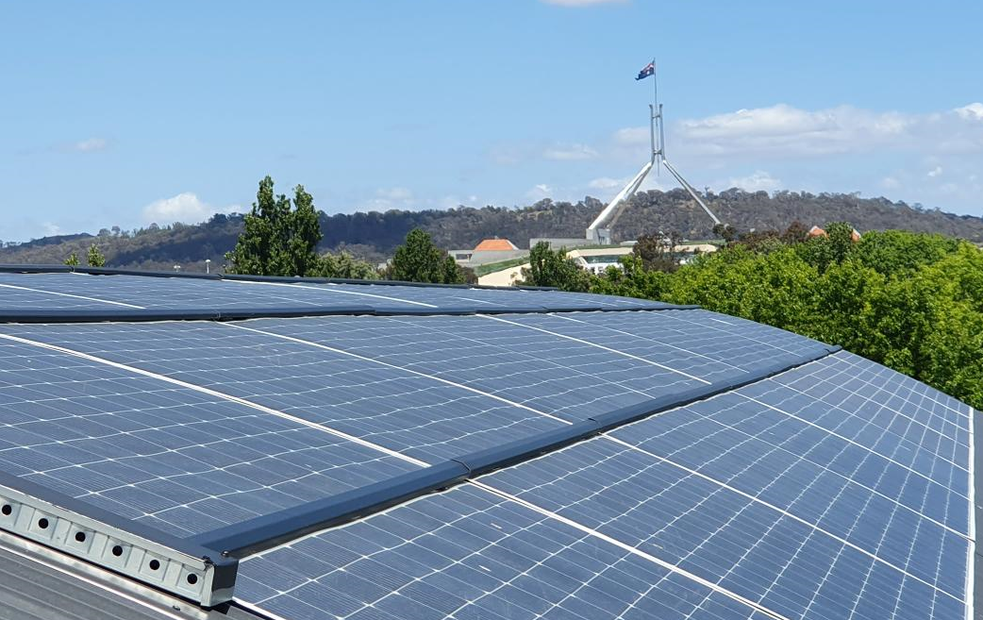
Achieving net zero requires a collective effort and it will not happen overnight. There are many emissions that are outside the direct control of Questacon, with heavy reliance on the actions of suppliers and contractors. However, it will be possible to exercise influence over scope 3 emissions by selecting low emissions goods and services where they become available.
Figure 1: Polycarbonate solar panels on Questacon’s curved roof

Responsibilities and governance
The Australian Government’s APS Net Zero by 2030 commitment requires Commonwealth entities to report their greenhouse gas emissions consistently to track progress to net zero emissions. As part of the reporting requirements under section 516A of the Environment Protection and Biodiversity Conservation Act 1999, and in line with the Strategy, all non-corporate and corporate Commonwealth entities were required to publicly report on the emissions from their operations in Australia or Australia’s external territories, commencing with public reporting of 2022-23 emissions in their annual reports. Commonwealth companies will commence reporting from 2023-24.
Entities are responsible for ensuring the data that is collected and collated to calculate their emissions is accurate and complete as possible. Entities are ultimately responsible for their own data and its verification.
The Department of Finance is responsible for final collation, ensuring the data meets adequate standards for use (data validation), analysing calculated emissions data from entities and producing and publishing the Annual Progress Report by the end of each calendar year.
Although best efforts have been made to report with accuracy, some factors are beyond the control of the Department of Finance and the individual entities reporting within this document. Entities may have to rely upon assumptions and estimates to calculate some emissions, although this is not encouraged. Many entities reported on their emissions in 2022-23 for the first time in a decade, with differing staff capability across entities to collect, verify and validate relevant data, supported by the Department of Finance.
Emissions reporting for 2022-23 has been disclosed in good faith, noting best efforts have been made to present accurate and complete data. Further efforts are underway to identify and disclose any uncertainty, inaccuracy or other issues – see Appendix A for further information. Processes are being developed to mitigate these issues in the future to the best extent possible.
In addition to identifying and mitigating inaccuracies, the Department of Finance practices continuous improvement in climate-related data reporting. The quality of data is expected to improve over time as emissions reporting matures, and as future expansions to the Emissions Reporting Framework are developed to capture data from additional scope 3 emission sources. The Department of Finance will continue to support further capability uplift across entities by providing advice, guidance, tools, case studies and training programs. The Climate Action in Government Operations website and GovTEAMS community include general information and guidance to assist entities.

2022-23 Results

Whole-of-Australian-Government emissions
Data within this report presents an aggregate summary of emissions reported by 158 non-corporate and corporate Commonwealth entities for the 2022-23 financial year.
Figure 2 and Figure 4 show the percentage of emissions for each scope (1, 2 and 3) by activity.
Figure 3 and Figure 5 show the percentage of emissions from their respective activities, including electricity, natural gas, fleet vehicles, domestic flights and other energy (further categorised as Defence and non-Defence).
Electricity emissions have been calculated with the location-based method (Figure 2 and Figure 3) and market-based method (Figure 4 and Figure 5), with further explanation of the calculation methods in the Electricity chapter.

Location-based emissions breakdown
Table 1: Australian Government Greenhouse Gas Emissions Inventory – Location-based method
Emission source | Scope 1  (t CO₂-e) | Scope 2  (t CO₂-e) | Scope 3  (t CO₂-e) | Sum of emissions  (t CO₂-e)
Electricity  (Location-based method) | N/A | 1,235,551 | 134,903 | 1,370,454
Natural gas | 100,975 | N/A | 19,627 | 120,602
Fleet vehicles | 212,139 | N/A | 54,114 | 266,253
Domestic flights | 8,098 | N/A | 182,974 | 191,072
Other energy | 1,067,935 | N/A | 270,012 | 1,337,947
Other energy – non-Defence | 20,641 | N/A | 5,743 | 26,384
Other energy - Defence | 1,047,294 | N/A | 264,269 | 1,311,563
Sum of emissions  (t CO₂-e) | 1,389,147 | 1,235,551 | 661,630 | 3,286,328
Notes: Other energy has been split into two categories – Defence and non-Defence. Other energy – Defence includes emissions reported by the Department of Defence that are a result of Defence operations.
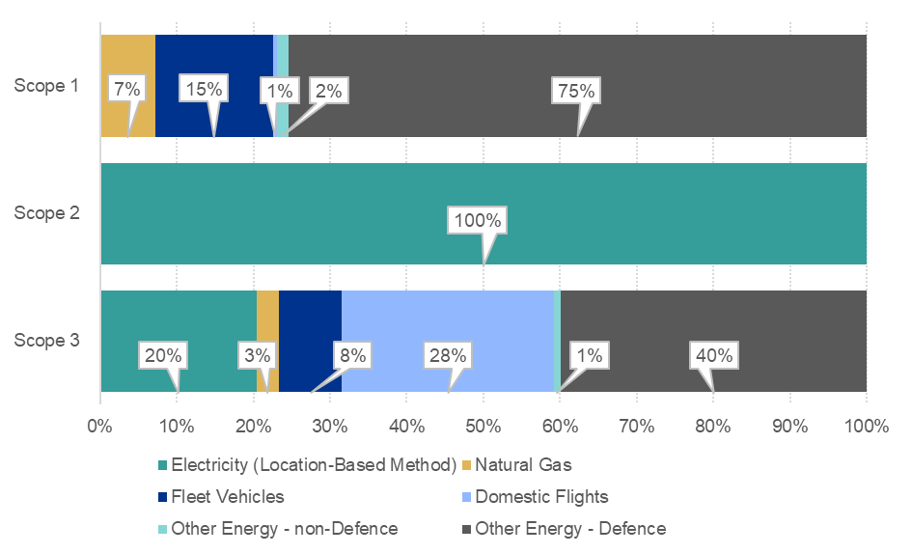
Figure 2: Percentage of emission sources for each scope (location-based method)

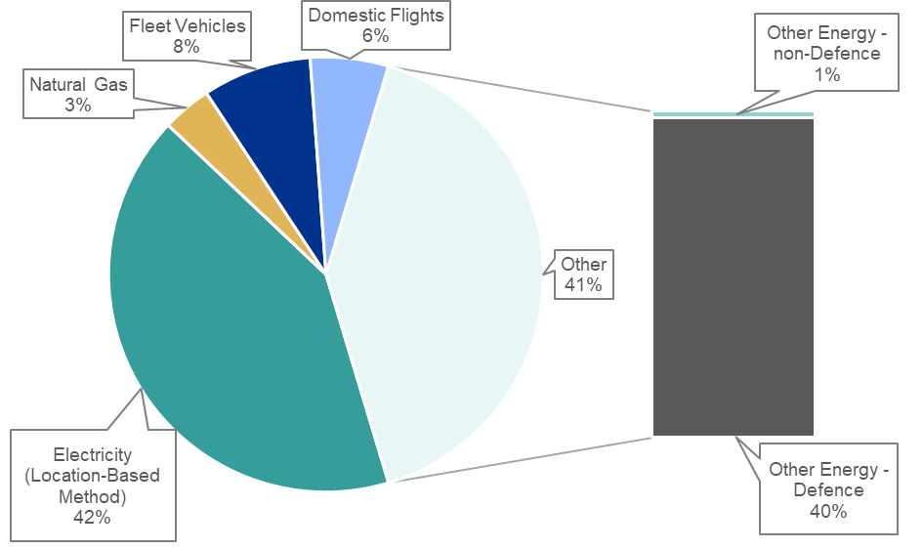
Figure 3: Percentage of emissions by activity (location-based method)

Market-based method emissions breakdown
Table 2: Australian Government Greenhouse Gas Emissions Inventory – Market-based method
Emission source | Scope 1  (t CO₂-e) | Scope 2  (t CO₂-e) | Scope 3  (t CO₂-e) | Sum of emissions  (t CO₂-e)
Electricity  (Market-based method) | N/A | 886,858 | 117,379 | 1,004,237
Natural gas | 100,975 | N/A | 19,627 | 120,602
Fleet vehicles | 212,139 | N/A | 54,114 | 266,253
Domestic flights | 8,098 | N/A | 182,974 | 191,072
Other energy | 1,067,935 | N/A | 270,012 | 1,337,947
Other energy – non-Defence | 20,641 | N/A | 5,743 | 26,384
Other energy – Defence | 1,047,294 | N/A | 264,269 | 1,311,563
Sum of emissions  (t CO₂-e) | 1,389,147 | 886,858 | 644,106 | 2,920,111
Notes: The market-based values above are calculated for the total of all entities, rather than calculated on an individual entity basis. This means the values presented in separate annual reports will not sum to the above values.

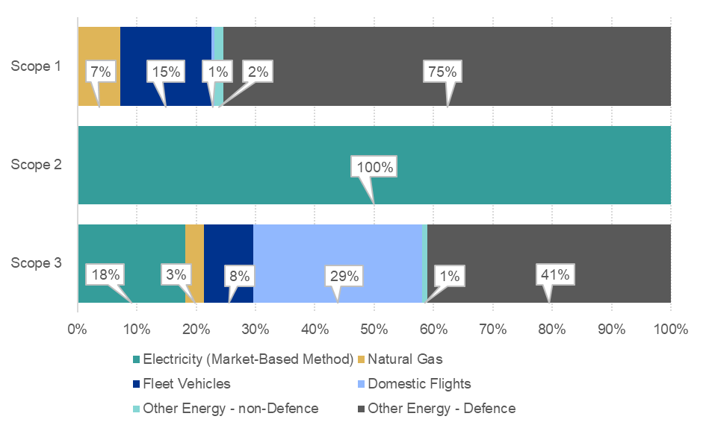
Figure 4: Percentage of emission sources for each scope (market-based method)

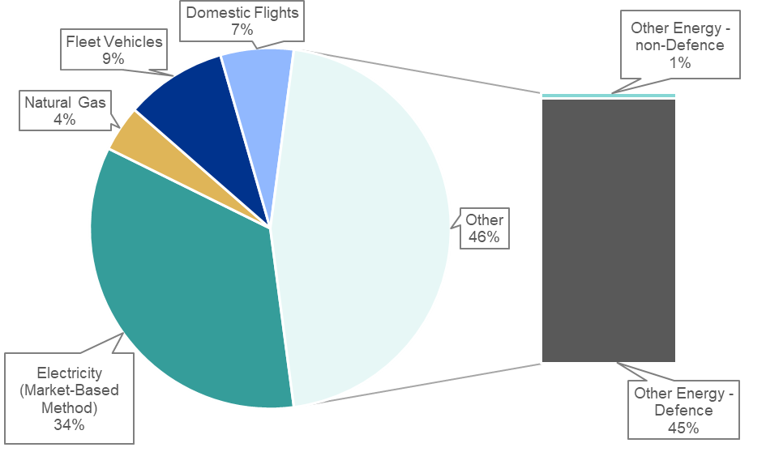
Figure 5: Percentage of emissions by activity (market-based method)

Case study: Tourism Australia
Tourism Australia is the Australian Government agency responsible for attracting international visitors to Australia, both for leisure and business events, all while fostering a competitive and sustainable tourism industry. In striving to achieve this goal, Tourism Australia places great importance on respecting and protecting the cultures, landscapes and wildlife that are integral to Australia’s appeal as a destination.
The case
Aligning to the organisation’s purpose, in 2023 Tourism Australia sought to certify its premiere trade event, the Australian Tourism Exchange (ATE), as a Climate Active Carbon Neutral event to lessen its impact on the environment. Held annually, the ATE is the Australian tourism industry’s largest annual business-to-business event with over 2000 local and foreign delegates in attendance from over 30 countries.
The approach
To achieve carbon neutrality for ATE23, Tourism Australia partnered with Rewild Agency to calculate the carbon footprint of the event and secure certification from Climate Active. Before the event, the two organisations worked together to model a preliminary carbon footprint, taking into consideration key emission sources such as attendee travel, catering, waste and electricity consumption. Attempts to reduce the event’s carbon footprint included:
- using 100% recyclable front and back graphic panels in seller booths
- partnering with Meet PAT on water filling stations
- minimising and/or eliminating the use of single-use plastics at catered events
- encouraging delegates to offset their flights to the Gold Coast.
After the event, Rewild Agency refined the preliminary footprint using real time data collected during the event to accurately measure the event footprint and create a post-event assessment, a requirement for Climate Active Carbon Neutral Event Certifications.
- Attendee travel: Tourism Australia estimated the total travel distance for the 2,500 delegates attending ATE. Tourism Australia concluded that 25% of delegates travelled regionally (within QLD), 48% nationally (within Australia) and 27% internationally.
- Catering: Menus for all catered meals were provided to Rewild to calculate the carbon footprint. This included daily breakfast, morning tea, lunch and afternoon tea, as well as canape service.
- Signage: 569 shell scheme exhibition booths were erected on the tradeshow floor using 100% recyclable front and back graphic panels. After the event, the graphic panels were recycled, and the booth shells returned.
- Waste: The Gold Coast Convention and Exhibition Centre provided Tourism Australia with a breakdown of all co-mix recycling, cardboard or paper, food and general waste created during the event.

Figure 6: Australian Tourism Exchange
In addition to those measures taken for ATE23, the below recommendations will be implemented for ATE24 to reduce the event’s carbon footprint:
- Reusing rigged state banners from ATE23
- Leveraging Melbourne Convention and Exhibition Centre's partnership with OzHarvest to reduce food waste
- Increasing provision of low carbon meals and plant-based dishes to 60% of all dishes
- Raising awareness of low carbon forms of transport and air travel schemes amongst delegates.
By adopting these strategies, Tourism Australia aims to lead the way for its industry.

Electricity
Electricity emissions include indirect emissions produced as a result of the burning of fossil fuels by the generator of the electricity (scope 2), and emissions associated with transmission and distribution losses from electricity use (scope 3). Electricity emissions have been calculated using the location-based method and market-based method.

Location-based vs. market-based electricity emissions calculation method
There are two methods for estimating electricity emissions: the location-based method and the market-based method. Reporting electricity emissions under both methods provides different perspectives of the emissions associated with an entity’s electricity usage.

Location-based method
The location-based method is a way to estimate an entity’s electricity emissions based on its geographical location. This method takes into account the intensity of emissions from electricity generation in the state or territory where the entity operates.
The key component of this method is the location-based scope 2 emission factors (see Appendix C). These are state-based emission factors derived from on-grid electricity generation, and they are calculated using the physical characteristics of the electricity grid. These factors are updated each financial year, reflecting the electricity generation within each state and territory. They also consider interstate electricity flows and the emissions attributable to those flows.
The location-based method calculates an average emission factor for all electricity consumed from the grid in a given state, territory or electricity grid. This method of reporting mirrors the emissions intensity of the grid where the electricity consumption takes place.
In Australia there are state-based emission factors, sourced from the National Greenhouse Accounts Factors, that are used to convert electricity consumption into an equivalent amount of emissions. The location-based method provides a snapshot of an entity’s electricity emissions in relation to its location and the emissions intensity of the electricity grid it depends on.
It is important to note that this method reflects the average emissions intensity of the electricity grid in the location where energy consumption occurs. However, it does not permit any claims of renewable electricity from grid-imported electricity usage. This means that even if an entity uses renewable energy sources or purchases GreenPower or large-scale generation certificates, this will not be reflected in the location-based method’s estimation of their emissions.

Market-based method
The market-based method is a strategy for estimating an entity’s electricity emissions based on its investments in different electricity products and markets. This includes both voluntary purchases of renewable electricity and mandatory schemes like the Renewable Energy Target.
This method provides a snapshot of an entity’s electricity emissions in the context of its renewable energy investments. It reflects the emissions intensity of various electricity products, markets and investments. A key component of this method is the use of a residual mix factor (see Appendix C), which allows for unique claims on the zero-emissions attribute of renewables without double-counting.
The market-based method assigns an emissions factor of zero to an entity’s investments in renewable electricity. It then uses a national residual mix factor, sourced from the National Greenhouse Accounts Factors, to calculate emissions from any remaining electricity consumption.
However, when entities consume electricity from the grid, they are using electricity generated from a variety of technologies in operation at the time of consumption, which may include non-renewable sources. While the market-based method allows entities to align their consumption with investments in renewable electricity, it does not imply that they are consuming electricity solely from renewable generators.
In 2022-23, the 158 entities reporting emitted an approximate aggregate sum of 1,370,454 t CO₂-e associated with electricity usage calculated by the location-based method, or 1,004,237 t CO₂-e, calculated by the market-based method (see Figure 7).
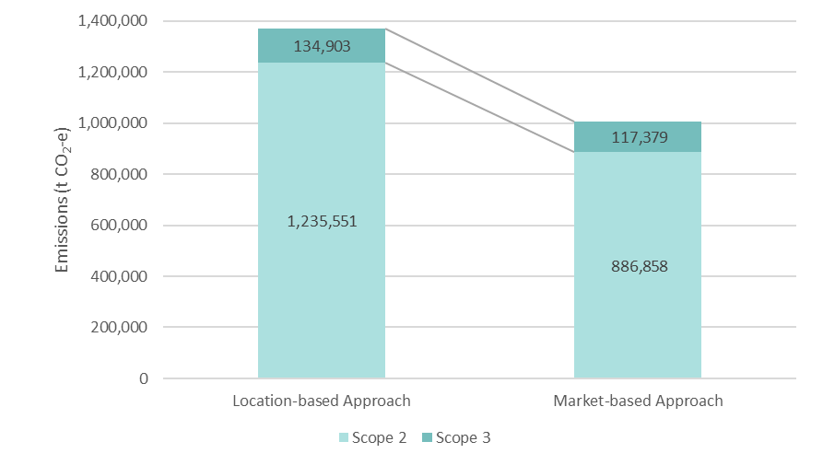
Figure 7: Location-based and market-based emissions comparison

Location-based electricity emissions
The location-based method allows emissions associated with electricity usage to be calculated by state (see Table 3).
Table 3: Electricity emissions by state/territory and scope (location-based method)
State/Territory | Electricity usage  (kWh) | Electricity usage  (GJ) | Scope 2 emissions  (t CO₂-e) | Scope 3 emissions  (t CO₂-e) | Sum of reported emissions  (t CO₂-e)
NSW | 455,272,013 | 1,639,329 | 332,781 | 27,384 | 360,165
ACT | 390,053,070 | 1,404,191 | 284,817 | 23,417 | 308,234
NT | 124,033,796 | 446,522 | 67,008 | 8,654 | 75,662
QLD | 277,943,464 | 1,000,596 | 204,283 | 41,100 | 245,383
SA | 113,825,604 | 409,772 | 28,755 | 9,077 | 37,832
TAS | 22,759,345 | 81,934 | 3,856 | 241 | 4,097
VIC | 287,792,624 | 1,037,284 | 245,880 | 20,433 | 266,313
WA | 117,108,439 | 421,590 | 68,171 | 4,597 | 72,768
Total | 1,788,788,355 | 6,441,218 | 1,235,551 | 134,903 | 1,370,454

Market-based electricity emissions
The market-based method does not allow for electricity emissions to be calculated for each state as it is based on the entire electricity grid and its renewable percentage without regard to state lines. For example, an entity in Sydney may purchase eligible large-scale generation certificates which are produced in South Australia, which are then considered voluntarily purchased renewable energy.
Renewable energy used by Commonwealth entities comes from voluntary and mandatory renewable energy sources representing a total renewable percentage of 41%. Voluntary sources are those where a decision has been made to purchase renewable energy, such as large-scale generation certificates purchased and retired (3%), purchased GreenPower (3%) or electricity consumed in the ACT (16%) where renewable energy is purchased by the ACT Government. The behind-the-grid on-site electricity produced and consumed by Commonwealth entities is currently unknown. The remaining renewable energy used by Commonwealth entities comes from the mandatory Large-scale Renewable Energy Target both in the ACT (4%) and outside (15%) (see Table 4).
Table 4: Electricity emissions and renewable percentages (market-based method)
Market-based approach | Electricity usage  (kWh) | Emissions  (t CO₂-e) | Renewable percentage of total
Large-scale generation certificates (LGCs) purchased and retired (kWh)  (including Power Purchase Agreements (PPAs)) | 59,453,989 | - | 3%
Greenpower | 53,836,029 | - | 3%
Jurisdictional renewables (LGCs surrendered) | 289,146,341 | - | 16%
Jurisdictional renewables (Large-scale Renewable Energy Target) (applied to ACT grid electricity) | 73,329,977 | - | 4%
Large-scale Renewable Energy Target (applied to grid electricity only) | 262,962,234 | - | 15%
Total renewable electricity from grid | 738,728,569 | - | 41%
Total non-renewable electricity from grid | 1,050,059,785 | 1,036,001
Total grid electricity | 1,788,788,354 | 1,004,237
Scope 2 | 927,325,525 | 886,858
Scope 3 | 122,734,261 | 117,379

Case study: Department of Agriculture, Fisheries and Forestry
The Department of Agriculture, Fisheries and Forestry (DAFF) is the Australian Government agency responsible for supporting and enhancing Australia’s agricultural, fisheries and forestry industries, helping to make them more productive and sustainable. The diverse roles and functions of the Department include biosecurity operations, trade and technical market access, world-class science and research, policy advice to government, program administration, client services to industry and regulation. This diversity in role and function is a challenge for the Department in reducing its greenhouse gas emissions. DAFF is committed to reducing its operational emissions in line with the APS Net Zero 2030 target while still achieving the objectives of industry growth, biosecurity and resilience as well as sustainability of agriculture, fisheries and forestry industries.
The case
A component of DAFF's leasing strategy is to occupy buildings that are more energy efficient. DAFF negotiates lease renewals to improve energy efficiency and increase National Australian Built Environment Rating System (NABERS) ratings where possible. In new leases, the Department implements Green Lease Schedules where applicable and seeks highly efficient buildings whenever possible. An example is DAFF’s recent consolidation from several older buildings in Canberra to Agriculture House. Agriculture House is a new building, fit for purpose for the Department. It features energy efficient technologies such as light-emitting diode lighting, double glazed windows and effective lighting and air conditioning controls to ensure energy efficient operation and limit unnecessary energy use after hours.
The approach
As part of lease negotiations, DAFF set a minimum agreed base building NABERS rating of 5 stars. This ensured all aspects of building and fit-out design considered energy efficiency wherever possible. By including this in upfront negotiations, it was seamless for the building owner to ensure all design aspects aligned to the target rating. The NABERS rating can be achieved when the building performance is assessed after a full 15 months of typical occupancy. At the time of this report, the estimated rating is tracking to achieve 5 stars. In the interim, an assessment was conducted of energy use after 6 months of occupancy at Agriculture House, compared to consumption at previous buildings. The data indicated that Agriculture House is twice as energy efficient (measured as energy used per square metre) than DAFF's previous offices combined. This has resulted in significant reduction of emissions by 1,379 t CO₂-e per year.
Looking ahead
DAFF is reviewing the strategy for its current lease portfolio and considering how leasing decisions can further support sustainability in its complex operational environments. Adopting a more sustainable approach to leasing and property management across its portfolio will generate financial and climate benefits both for the department, its landlords and building owners.
Lessons learned
Energy efficient technologies can generate large savings and decrease long-term emissions. DAFF continues to seek energy efficient options where possible and implement Green Lease Schedules in new lease agreements as required.

Natural gas
Natural gas includes emissions produced by combustion of natural gas (scope 1), and indirect emissions associated with the extraction, production and transportation of natural gas (scope 3).
In 2022-23, the 158 entities reporting emitted an approximate aggregate sum of 120,602 t CO₂-e associated with natural gas (see Figure 8 and Table 5).
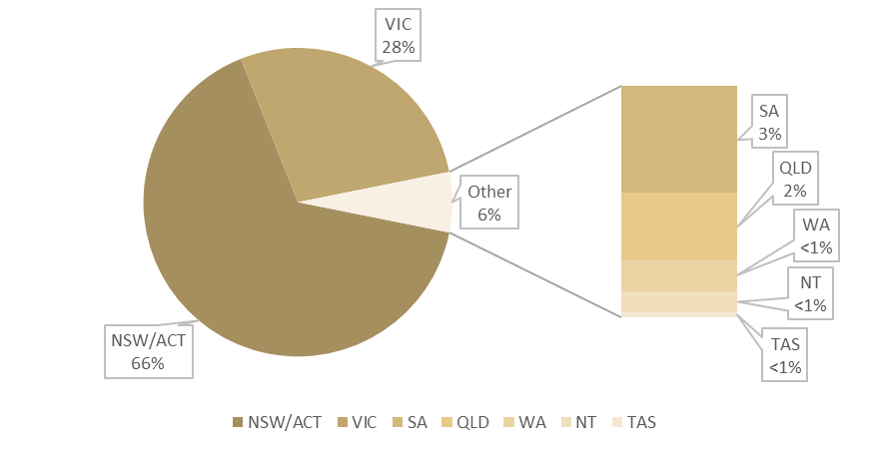
Figure 8: Percentage of natural gas emissions by state
Table 5: Natural gas emissions by state/territory and scope
State/Territory | Usage (GJ) | Scope 1 emissions  (t CO₂-e) | Scope 3 emissions  (t CO₂-e) | Sum of reported emissions  (t CO₂-e)
NSW/ACT¹ | 1,228,243 | 63,293 | 16,092 | 79,385
NT | 11,787 | 608 | 96 | 704
QLD | 36,356 | 1,874 | 316 | 2,190
SA | 56,245 | 2,899 | 602 | 3,501
TAS | 2,823 | 146 | 23 | 169
VIC | 605,217 | 31,187 | 2,421 | 33,608
WA | 18,769 | 968 | 77 | 1,045
Total | 1,959,440 | 100,975 | 19,627 | 120,602
¹ NSW and ACT use the same emission factors for natural gas. During data collection, natural gas was combined using an NSW/ACT option and cannot be separated in the results.

Case study: Australian National University
The Australian National University (ANU) is a tertiary institution with a strong research focus. Employing over 4000 staff, ANU provides a unique educational experience to over 22,000 international and domestic students from across Australia and 100 countries around the world. The main ANU campus is in Canberra, ACT.
The case
ANU is committed to effective climate action, with a current priority to reduce direct on-campus and energy emissions (scope 1 and 2), and indirect emissions from business travel and waste (partial scope 3). ANU is also developing its own in-setting projects for carbon removal.
The approach
A major program to reduce emissions on campus includes capital works projects to transition away from natural gas boilers in its current buildings. In 2023 winter, for the first time, four buildings were heated using electric heat pumps. The heat pumps replaced gas boilers, providing space and laboratory heating without relying on fossil fuels. This project has reduced ANU’s carbon footprint by 230 t CO₂-e per annum. Heat pumps operate at 250-300% of the energy efficiency of natural gas boilers, reducing the energy required to heat the buildings. ANU is deploying a range of heat pump technologies that are new in Australia within a retrofit capacity and have yet to be deployed at campus scale to date. Meeting the challenges requires innovation and a multidisciplinary approach to the design and implementation.
Looking ahead
Installation of heat pumps is an integral part of a long-term strategy to decarbonise the campus, as is efficiently managing the energy requirements across buildings. One innovative option being explored is establishing large-scale central electric hubs that redistribute thermal load across connected buildings. Central hubs can be a highly efficient and cost-effective degasification pathway. Linking buildings to a central plant powered by renewable electricity means energy can be transferred between buildings or stored for use at different times of the day. This strategy also supports capturing waste heat and redistributing it between buildings.
Lessons learned
There are technical challenges to consider when retrofitting buildings with heat pumps, including increased spatial requirements, power upgrades and the integration with other aged mechanical equipment in the buildings. While it is necessary for significant capital expenditure upfront, the system has a payback period of about 20 years. After the initial payback period, ongoing operational costs are likely to be significantly reduced due to lower energy requirements and efficiencies (dependent on future gas and electricity price predictions).
For more information visit the ANU Below Zero Program.

Fleet vehicles
Fleet vehicle emissions include emissions from the combustion of fuels used by Commonwealth entities in their vehicle fleets (scope 1), and indirect emissions associated with the extraction, production and transportation of the fuels (scope 3). Fleet vehicles included in this section are the Australian Government’s Commonwealth Fleet under the Whole of Government Vehicle Leasing and Fleet Management arrangement, in addition to other vehicles operated by the 158 different entities, such as cars, trucks, motorcycles, marine craft and other similar vehicles. Some Department of Defence vehicles are recorded here, whilst others are included in the Other Energy – Defence section.
In 2022-23, the 158 entities reporting emitted an approximate aggregate sum of 266,253 t CO₂-e associated with fleet vehicles. Emissions have been sorted by fuel type and vehicle type (Table 6).
Table 6: Fleet vehicle emissions by vehicle type, fuel type and scope
Vehicle type | Fuel type | Energy | Scope 1 emissions | Scope 3 emissions | Sum of reported emissions
 |  | (GJ) | (t CO2-e) | (t CO2-e) | (t CO2-e)
1.A.3.b Road transportation |  | 2,185,724 | 153,184 | 37,774 | 190,958
1.A.3.b.i Cars |  | 733,683 | 50,995 | 12,650 | 63,645
 | Diesel | 531,845 | 37,448 | 9,201 | 46,649
 | Ethanol mix (ethanol component) | 21,026 | 1,322 | 337 | 1,659
 | Gasoline | 180,537 | 12,208 | 3,106 | 15,314
 | Liquid Petroleum Gas (LPG) | 275 | 17 | 6 | 23
1.A.3.b.ii Light duty trucks |  | 774 | 53 | 14 | 67
 | Diesel | 168 | 12 | 3 | 15
 | Gasoline | 464 | 32 | 8 | 40
 | Liquid Petroleum Gas (LPG) | 142 | 9 | 3 | 12
1.A.3.b.iii Heavy duty trucks and buses |  | 1,451,011 | 102,117 | 25,104 | 127,221
 | Diesel | 1,450,355 | 102,072 | 25,092 | 127,164
 | Ethanol mix (ethanol component) | 86 | 6 | 2 | 8
 | Gasoline | 570 | 39 | 10 | 49
1.A.3.b.iv Motorcycles |  | 256 | 19 | 6 | 25
 | Ethanol mix (ethanol component) | 1 | 1 | 1 | 2
 | Gasoline | 255 | 18 | 5 | 23
1.A.3.d Water-borne navigation |  | 747,588 | 51,593 | 13,942 | 65,535
1.A.3.d.ii Domestic marine |  | 747,588 | 51,593 | 13,942 | 65,535
 | Other Biofuels | 169 | 1 | 0 | 1
 | Diesel | 739,338 | 51,045 | 13,803 | 64,848
 | Gasoline | 8,081 | 547 | 139 | 686
1.A.3.e Other transportation |  | 119,153 | 7,330 | 2,388 | 9,718
1.A.3.e.ii Other (off road vehicles) |  | 119,153 | 7,330 | 2,388 | 9,718
 | Diesel | 5,895 | 416 | 102 | 518
 | Gasoline | 637 | 44 | 11 | 55
 | Liquid Petroleum Gas (LPG) | 112,621 | 6,870 | 2,275 | 9,145
1.A.4 Other sectors |  | 436 | 32 | 10 | 42
1.A.4.c.ii Agriculture/Forestry/Fishing - Off road vehicles and other machinery |  | 406 | 29 | 8 | 37
 | Diesel | 395 | 28 | 7 | 35
 | Liquid Petroleum Gas (LPG) | 11 | 1 | 1 | 2
1.A.4.c.iii Agriculture/Forestry/Fishing - Mobile combustion |  | 30 | 3 | 2 | 5
 | Diesel | 9 | 1 | 1 | 2
 | Gasoline | 21 | 2 | 1 | 3
Total |  | 3,052,901 | 212,139 | 54,114 | 266,253

Case study: Services Australia
As the government’s primary service delivery agency that delivers Medicare, Centrelink and Child Support services to support individuals, families and communities, Services Australia supports Australians around the nation when they need it the most.
The case
In 2022, the Department of Finance updated the Whole-of-Australian-Government Fleet Vehicle Selection Policy to require the selection of low emission vehicles. The change in policy impacted Services Australia in particular, given the diverse portfolio of vehicles it maintains to meet the needs of clients across Australia, as well as the emergency support it provides in remote, regional and Australian offshore islands. In addition to maintaining a significant fleet of up to 450 vehicles for its own purposes, Services Australia is a shared service provider to six client agencies with diverse fleets totalling up to 250 vehicles.
The approach
The change in policy required a co-ordinated approach by Services Australia. As a result, a multidisciplinary team was established in January 2023. The team developed a data-driven approach using fleet-wide vehicle usage data, which was used to prioritise the most suitable vehicle selections and supporting infrastructure. The team established an internal approval process as well as a risk assessment framework that supported a coordinated approach to the implementation.
Charging infrastructure for new low emission vehicles was assessed as a priority to provide assurance of functionality to each business area. Public infrastructure charging trials have confirmed an in-house charger is the preferred option, ensuring less resources are deployed to arrange vehicle charging. After consultation with a wide range of government agencies and private providers, a ratio of one charger per low emission vehicle was determined as optimal. The recommended charging infrastructure is expected to future proof the low emission vehicle requirements by using 22kW chargers that exceed the current requirements of many fleet vehicles.
Looking ahead
Services Australia’s first low emission vehicle arrived in Perth in July 2023. It is part of 300 vehicles expected to make the switch over the next few years. To date, 103 low emission vehicles have been ordered, with 15 delivered. The team continues to place vehicle orders and is working collaboratively to ensure the delivery of vehicles is in line with the infrastructure installation, to minimise disruptions to service delivery.
Lessons learned
Services Australia leases most of its properties which necessitates negotiations with property owners to arrange infrastructure installation. These negotiations have proven more fruitful by engaging with the property owners as early as possible, given the time required for consideration and additional site assessments. These assessments include examining risks to further provide assurance to business areas of the performance and safety of the arrangements. With a large property portfolio, the prioritisation of sites for infrastructure installation is key and will depend on both the vehicle ordering requirements and end of lease negotiations that will occur.

Domestic flights
Domestic flight emissions include:
- direct emissions from the combustion of fuels used for domestic aviation purposes by Commonwealth entities (scope 1), for example, owned and/or leased aircraft for charter flights and research purposes
- indirect emissions associated with the fuels for commercial flights (scope 3)
- indirect emissions associated with the extraction, production and transportation of the fuels for commercial flights (scope 3).
Domestic flights included in this section are commercial flights, in addition to some other flights. It does not include non-commercial Department of Defence flights, some of which are included in the Other Energy section.
Domestic flights have been recorded using two different methods dependent on the level of information known by the entity:
- Where the gasoline or kerosene for aviation use was known either in terms of Litres or GJ, this has been reported and emission factors have been applied to the fuel use. This occurred only for domestic aviation in owned and/or lease aircraft.
- Where only the distance of travel (km) and the cabin class of the journey is known, then emission factors have been applied using this information.
In 2022-23, the 158 entities reporting emitted an approximate aggregate sum of 191,072 t CO₂-e associated with domestic flights. Emissions have been sorted by fuel type and commercial cabin class (Table 7).
Table 7: Flight emissions
Emission source | Passenger kilometres  (km) | Energy  (GJ) | Scope 1 emissions  (t CO₂-e) | Scope 3 emissions  (t CO₂-e) | Sum of reported emissions  (t CO₂-e)
Gasoline for use as fuel in an aircraft-aviation | N/A | 56,204 | 3,803 | 1,012 | 4,815
Kerosene for use as fuel in an aircraft-aviation | N/A | 61,161 | 4,295 | 1,101 | 5,396
Economy class | 1,264,129,351 | N/A | 0 | 167,777 | 167,777
Business class | 64,733,696 | N/A | 0 | 12,895 | 12,895
Premium economy | 953,062 | N/A | 0 | 187 | 187
First class | 7,481 | N/A | 0 | 2 | 2
Total | 1,329,823,590 | 117,365 | 8,098 | 182,974 | 191,072

Other energy
Other energy includes scope 1, scope 2 and scope 3 emissions. The category reflects emission sources which were not captured in the Electricity, Natural Gas, Fleet Vehicles and Domestic Flights sections.
During collection, data for all sources listed in Table 8 were collected across entities, however some categories have been separated and reported under other sections to represent the aggregated emissions more accurately from those sources. For example:
- 1.A.4.c.ii Agriculture/Forestry/Fishing - Off road vehicles and other machinery, 1.A.4.c.iii Agriculture/Forestry/Fishing - Mobile combustion, and 1.A.3 Transport, have been reported in the Domestic Flights and Fleet Vehicles sections, and,
- 1.A.4.a.i Stationary Fuel Combustion – Natural gas has been reported in the Natural gas section.
Data in this table also includes emissions from the Department of Defence, including a mix of Defence operations emissions other than those captured under electricity, natural gas, domestic flights and fleet vehicles, under 1.a.5.b Defence other energy – Land, marine, aviation which includes petrol, jet fuel and diesel delivered to the military for use on land, in aviation and marine transport.
Note that 1.A.4 Other sectors - Liquid petroleum gas (LPG) (stationary) includes emissions from entities, including Department of Defence.
In 2022-23, the 158 entities reporting emitted an approximate aggregate sum of 1,337,947 t CO₂-e as Other Energy. Emissions have been sorted by source or fuel type in Table 8.
Table 8: Emissions reported as Other Energy, by source, fuel type and scope
Emission source/fuel type | Energy  (GJ) | Scope 1 emissions  (t CO₂-e) | Scope 3 emissions  (t CO₂-e) | Sum of reported emissions  (t CO₂-e)
1.A.1 Energy industries
1.A.2 Manufacturing industries and construction
1.A.3 Transport
1.A.3.a.ii Domestic aviation | Reported in Domestic Flights/Fleet Vehicles
1.A.3.b.i Cars
1.A.3.b.ii Light duty trucks
1.A.3.b.iii Heavy duty trucks and buses
1.A.3.b.iv Motorcycles
1.A.3.d.ii Domestic marine
1.A.3.e.ii Other (off road vehicles)
1.A.4 Other sectors
1.A.4.a. Commercial/institutional
Automotive gasoline/petrol (used as fuel for stationary energy) | 1,634 | 111 | 29 | 140
Compressed natural gas (reverting to standard conditions) | 46 | 3 | 1 | 4
Diesel oil | 185,889 | 13,050 | 3,216 | 16,266
Gaseous fossil fuels other than those mentioned in the items above | 3 | 1 | 0 | 1
Kerosene other than for use as a fuel in an aircraft | 2,847 | 197 | 52 | 249
Liquid petroleum gas (LPG) (stationary) | 119,255 | 7,272 | 2,409 | 9,681
Petroleum based greases | 1,986 | 7 | 36 | 43
1.A.4.a.i Stationary fuel combustion
Natural gas | Reported in Natural Gas
1.A.4.b. Residential | 0 | 0 | 0 | 0
1.A.4.c.i Agriculture/Forestry/Fishing - Stationary Energy | 0 | 0 | 0 | 0
1.A.4.c.ii Agriculture/Forestry/Fishing - Off road vehicles and other machinery | Reported in Fleet Vehicles
1.A.4.c.iii Agriculture/Forestry/Fishing - Mobile combustion
1.A.5 Non-specified
1.a.5.b Defence Other Energy – Land, Marine, Aviation | 14,894,187 | 1,047,294 | 264,269 | 1,311,563
Total | 15,205,847 | 1,067,935 | 270,012 | 1,337,947

Case study: The Great Barrier Reef Marine Park Authority
The Great Barrier Reef Marine Park Authority (Reef Authority) is Australia’s lead management agency for the Great Barrier Reef, one of the world’s most iconic natural areas. Its main office is in Townsville and regional offices are located in Cairns, Yeppoon and Brisbane. The Reef Authority Sustainability Strategy will set new targets with enabling initiatives to help move towards net zero emissions in its operations by 2030. The Reef Authority sees the effect that marine debris and pollution (especially plastics) has on marine life on the Great Barrier Reef and supports a circular economy and initiatives that minimise waste going to landfill.
The case
Reef Authority services are delivered using a range of assets that produce carbon emissions and waste. The Reef Authority owns a public aquarium facility (the Great Barrier Reef Aquarium) which was a high energy user until deep energy efficiency initiatives were implemented. Reef Authority programs also include the use of marine vessels and aviation for aerial surveillance which use hard to abate fuels and operate in regional areas across of the length of the Great Barrier Reef.
The approach
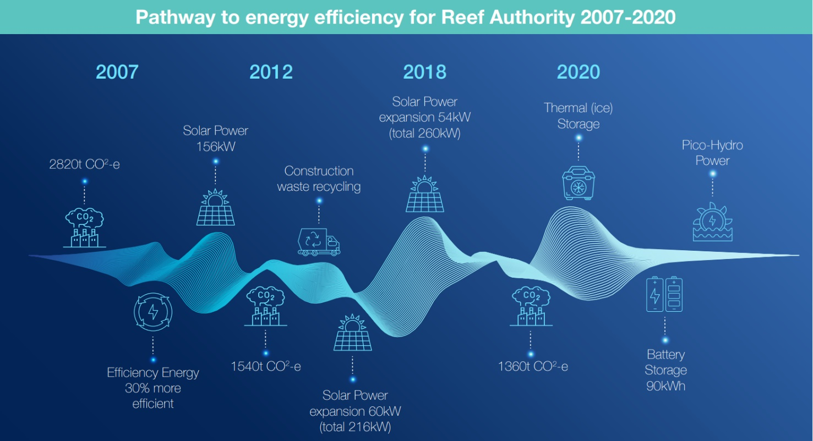
Starting with the Great Barrier Reef Aquarium over 15 years ago, the Reef Authority set ambitious energy use reduction targets that led to a 50% reduction in energy use for the facility. A suite of measures was used, including operational changes such as increasing the indoor air-conditioning set points and improving maintenance of energy using systems. Much larger energy efficiency retrofit actions included installing high efficiency chilling systems, using renewable energy systems and using thermal/electrical storage. A rooftop 260kW solar power station was installed at the aquarium in stages along with 20 tonnes of thermal water storage and 20 tonnes of ice storage that was part of the Australian Renewable Agency Advancing Renewables Project. The new thermal ice storage system included a carbon neutral refrigerant.
In recent years, the Reef Authority has put in place a Sustainability Strategy, including a roadmap to net zero, and systems to accurately track carbon emissions and waste. Recent procurements have included sustainability criteria to ensure that procurements align with the sustainability principles of the Reef Authority.
Recent achievements
In the last two years, the Reef Authority has implemented numerous key initiatives including:
- transitioning to 100% GreenPower for all properties it fully leases or owns
- transitioning 75% of its vehicle fleet to zero emissions vehicles
- moving to a 5 Star NABERS rated head office
- engaging with Green Star certification for its head office fit-out
- implementing a carbon accounting software tool
- aligning with the Reef Authority re-branding, choosing 100% natural fibre corporate uniforms that align to Nature Positive and Circular Economy principles
- investigating options for sustainable marine fuels and options for reducing emissions associated with aerial surveillance.
Looking ahead
The Reef Authority is finalising a sustainable procurement framework to assist staff to minimise emissions and waste through procurements. Priority areas in the short term are:
- improving its emissions data collection with a focus on scope 3 emissions
- investigating innovative techniques to collect waste data efficiently in the Reef Authority head office accommodation
- working with partners and stakeholders to find solutions for the hard-to-abate emissions, such as marine and aviation fuels, so the Reef Authority can deliver its services with the lowest possible impact.
Lessons learned
The Reef Authority has increased its understanding of sustainable options that are available, which allows it to be more specific in establishing performance criteria. The approach is to listen to internal and external stakeholder concerns and address these concerns whilst gaining an understanding of value for money beyond up-front cost and having evidence-based information to articulate non-financial and indirect benefits. Decision makers can then be provided with the justification they need to make sustainable choices. Further, re-configuration of its finance system to allow better collection of emissions data will be beneficial to prioritisation of emissions reduction initiatives.

Appendix A: Caveats

Annual report differences
Data in the Net Zero in Government Operations Annual Progress Report may vary from that in individual entity annual reports due to variations in internal deadlines to finalise annual reports for each entity. Data cleansing may have occurred after entity’s annual report deadlines, and, as such, data in the Annual Progress Report has been updated to better reflect actual emission data. Where this is the case, an updated Emissions Reporting Tool will be provided to entities with the expectation that updates will be reported in their annual report the following year.

Entity-specific caveats
Entity-specific caveats are outlined below to maintain transparency and accountability. These caveats may also be a factor in explaining discrepancies with future reporting.
Entity | Caveat
Anindilyakwa Land Council | Fleet data was not disaggregated.
Asbestos Safety and Eradication Agency | Electricity consumption data from 25 July 2022 to 31 January 2023 for a Canberra office was estimated based on consumption between 1 February 2023 to 30 June 2023.
Austrade | A portion of electricity consumption data was unable to be separated from landlord data and has not been included.
Australian Digital Health Agency | Electricity from three quarters missing due to errors in charging and invoicing.
Australian Hearing Services | Some electricity consumption data was unable to be separated from landlord data and has not been included.
Australian Institute of Health and Welfare | A portion of electricity consumption data for one building was unable to be separated from landlord data and has not been included.
Australian Pesticides and Veterinary Medicines Authority | Natural gas usage data was calculated for some properties/periods based on the amount paid, as itemised invoices were not available.
Australian Skills Quality Authority | A portion of electricity consumption data was extrapolated at a pro rata rate based on available data, due to billing period differences.
Commonwealth Grants Commissions | April and May 2023 electricity consumption data were available at the time of collection, the remaining 10 months were unavailable and were not included in reporting.
Commonwealth Scientific and Industrial Research Organisation | Electricity and natural gas consumption data incomplete due to billing cycle timing.
Department of Agriculture, Fisheries and Forestry | Fuel cards data not included.  For additional caveats see Annual report differences and Machinery of Government changes.
Department of Climate Change, Energy, Environment and the Water | See Annual report differences and Machinery of Government changes.
Department of Defence | Some emissions data were aggregated due to national security reasons, such as accelerated military preparedness, operational and capability requirements.
Department of Industry, Science and Resources | See Annual report differences and Machinery of Government changes.
Department of Infrastructure, Transport, Regional Development, Communications and the Arts | See Annual report differences and Machinery of Government changes.
Director of National Parks | Elements of office data are reported under the Department of Climate Change, Energy, the Environment and Water due to Memorandum of Understanding or Service Level Agreements.  For additional caveats see Annual report differences and Machinery of Government changes.
Fisheries Research and Development Corporation | Electricity consumption data from Adelaide office was unable to be separated from Landlord data and has not been included.
Murray-Darling Basin Authority | Electricity consumption data for offices in Adelaide, Albury-Wodonga and Toowoomba unable to be obtained. 29 total work points within these offices unable to be reported on.
National Indigenous Australians Agency | Electricity and natural gas consumption data incomplete due to billing cycle timing.
Office of the Fair Work Ombudsman | Electricity consumption data from Launceston office was unable to be separated from landlord data and has not been included
Office of the Special Investigator | A portion of electricity consumption data was unable to be separated from shared service provider data and has not been included.
The Office of the Australian Information Commissioner | Electricity consumption data from one tenancy (four-person office) was unable to be separated from shared service provider data and has not been included.
Productivity Commission | Electricity consumption data from a 6-month period in a small Adelaide office was unable to be separated from Landlord data and has not been included.
Services Australia | Electricity and natural gas consumption data incomplete due to billing cycle timing.  Elements of office data are reported under other entities due to Memorandum of Understanding/Service Level Agreements.

Machinery of Government changes

Domestic flights
Following Machinery of Government changes that took effect from 1 July 2022, many flights for the Department of Climate Change, Energy, the Environment and Water (DCCEEW) staff, and some from the Director of National Parks (DNP), were booked in 2022-23 using the systems of the Department of Agriculture, Fisheries and Forestry (DAFF); the Department of Industry, Science and Resources (DISR); and the Department of Infrastructure, Transport, Regional Development, Communications and the Arts (DITRDCA). In collaboration with all affected entities, DCCEEW and DNP flights were identified and separated from the other entities. Data reported from DCCEEW, DNP, DAFF, DISR and DITRDCA may contain some flights that were cancelled or not flown, and/or some flights that belong to another entity.

Entities reporting to the National Greenhouse and Energy Reporting (NGER) Scheme
The following seven Commonwealth entities and companies are obligated to report under the NGER Scheme. The table below details which year of data is included in this Annual Progress Report and will match the entities’ NGER reports, in the same year, for scope 1 and scope 2 emissions.
Entity | Required to report in 2022-23 for APS Net Zero | Year of data reported
Australian Postal Corporation | Yes | 2021-22
Airservices Australia | Yes | 2021-22
Australian National University | Yes | 2022-23
Australian Nuclear Science and Technology Organisation | Yes | 2022-23
Commonwealth Scientific and Industrial Research Organisation | Yes | 2022-23
Snowy Hydro Limited | No (Commonwealth company) | N/A
NBN Co Limited | No (Commonwealth company) | N/A

Appendix B: Methods
For entities that participate in whole-of-Australian-Government procurement arrangements led by the Department of Finance, data was sourced from the following, where available:
- natural gas and electricity from Property Service Providers
- fleet vehicles from the Motor Vehicle Fleet Management and Leasing Services
- flights from Whole-of-Australian-Government Travel Arrangements
Where Machinery of Government changes occurred or entities ceased operations within the reporting period, advice was sought from the appropriate entities to ensure that data was being attributed to the appropriate entity.
Although best efforts were made to cleanse and correctly assign the data to the relevant entity, it is possible that some errors remain. Efforts are underway to identify and disclose these issues, and processes are being developed to mitigate, to the best extent possible, these in the future. The quality of data is expected to improve over time as emissions reporting capability matures.
Each entity was provided with either a prefilled or blank Emissions Reporting Tool, depending on if they participated in whole-of-Australian-Government arrangements.
Entities were asked to review and update the Emissions Reporting Tool where required, including filling in any additional data that was missing, before returning the completed and endorsed tool to the Department of Finance. Entities were asked not to include any estimations of activity usage. The Emissions Reporting Tool pre-calculated the total emissions, in kg CO₂-e, for each entity using the methodology outlined below.
All returned Emissions Reporting Tools were checked for data entry errors or accidental deletion of formulas, and inspections were carried out to find data anomalies and outliers. When issues were identified, advice was provided to entities to correct the data if required. Entities are ultimately responsible for their data and its verification. Data that informed this report has been endorsed by entities.

Emission calculations
Greenhouse gas emissions are aggregated as kg of carbon dioxide equivalent (kg CO₂-e) using Global Warming Potentials. As greenhouse gases vary in their radiative forcing and in their atmospheric residence time, converting emissions into a carbon dioxide equivalent over a 100-year horizon allows the integrated effect of emissions of the various gases to be compared on an equivalent basis.
Emission factors are used to convert a unit of activity into its emissions equivalent. Greenhouse gas emissions are calculated by multiplying the relevant source-specific emission factor by the quantity of the activity, to give the emissions of different greenhouse gases for each source type. Throughout this work, emissions have been calculated using the formulas as published in the 2023 Australian National Greenhouse Accounts Factors, published by the Department of Climate Change, Energy, the Environment and Water. Emissions factors and sources are listed in Appendix C.

Greenhouse gas emissions calculation method:

$$kg {CO}_{2}\text{-}e=Q×EF$$

Where:
$kg {CO}_{2}e$ is the greenhouse gas emissions, in kg CO₂-e
$Q$ is the activity data, in gigajoules (GJ)
$EF$ is the source specific emissions factor, in kg CO₂-e per GJ, as in Appendix C
When an emission factor is given as kg CO₂-e /GJ but the activity data is not in GJ, then an energy content factor is also included in the calculation. The energy content factor is the amount of energy contained in fuel, measured in gross calorific value.
Greenhouse gas emissions calculation method using energy content factors:

$$kg {CO}_{2}\text{-}e=Q× EC×EF$$

Where:
$kg {CO}_{2}e$ is the greenhouse gas emissions, in kg CO₂-e
$Q$ is the activity data, in units other than gigajoules (e.g., kL)
$EC$ is the energy content factor of the fuel, e.g., GJ/kL, as in Appendix D
$EF$ is the source specific emissions factor, in kg CO₂-e per GJ, as in Appendix C
Emissions factors are activity-specific, and the type of activity determines the emission factor used. Emission factors for the APS Net Zero Emissions Reporting Tool are listed in Appendix C, and energy content factors are listed in Appendix D.
For each activity, if utilised by the entity, the following data was required to calculate emissions:
- Natural gas: State, Metro/Non-Metro, and Total Usage (in GJ)
- Electricity: State, Electricity Usage (kWh), and GreenPower Usage (kWh)
- Fleet vehicles: Asset Class, Unleaded Usage (L), or Ethanol Mix Usage (L), or Diesel Usage (L), or Liquid Petroleum Gas (LPG) Usage (L), or Biodiesel Usage (L)
- Flights: Departure Country, Arrival Country, Cabin Class, and Passenger kilometres
- Other energy: Emissions Category, Fuel Combusted, Fuel Type (liquid, solid or gas), Activity Data Unit, and Activity Data

Market-based method emissions calculations
While the methods above are used to calculate location-based electricity emissions, the following method is used for estimating scope 2 and scope 3 emissions released from electricity purchased or acquired and consumed using the market-based method:
Market-based method:
$${t CO}_{2}\text{-}e =\left(\left(Q-Q_{exempt}\right)×\left(1-\left(RPP+JRPP\right)\right)+\left(Q_{exempt}×\left(1-JRPP\right)\right)-\left({REC}_{surr}-{REC}_{onsite}\right)×1,000\right)×\frac{RMF1+RMF2}{1,000}$$

Where:
${t CO}_{2}e$ is the greenhouse gas emissions, in t CO₂-e
$Q$ is the quantity of electricity purchased or acquired, and consumed from the operation of the facility during the year, measured in kilowatt hours (kWh)
$Q_{exempt}$ is the quantity of electricity exempt from Renewable Energy Target (RET) liability, measured in kWh
$RPP$ is the RET Renewable Power Percentage for the applicable period, averaged across the previous and current calendar years, e.g., calendar years 2022 and 2023 are used for the calculation of the financial year 2023 RPP, see Appendix C
$JRPP$ is the jurisdictional RRP for the applicable period and activity state and is calculated as the number of eligible Renewable Energy Certificates (RECs) surrendered by or on behalf of the jurisdictional authority divided by total electricity consumption in the jurisdiction, see Appendix C
${REC}_{surr}$ is the number of eligible RECs voluntarily surrendered in the reporting year, equivalent to megawatt hours (MWh)
${REC}_{onsite}$ is the number of eligible RECs that have been or will be issued for electricity produced on-site during the year and consumed from the operation of the facility, equivalent to MWh
$RMF1$ is the scope 2 residual mix factor (RMF), in kg CO₂-e emissions per kWh or GJ, see Appendix C
$RMF2$ is the scope 3 RMF, in kg CO₂-e emissions per kWh or GJ, see Appendix C

Note: As the sum of $RMF1$ and $RMF2$ is given in kg CO₂-e emissions per kWh, it is necessary to divide by 1000 to convert to t CO₂-e

An eligible Renewable Energy Certificate (REC) is:
- a Large-scale Generation Certificate (LGC) that is voluntarily surrendered through the Renewable Energy Certificate Registry in the reporting year with a generation date of less than 36 months prior to the end of the reporting year; or
- a purchase of GreenPower electricity from an accredited GreenPower Provider.

Data post-processing
Total emissions were pre-calculated in kg CO₂-e, for each entity in the Emissions Reporting Tool. For the purposes of this report, emissions were converted to t CO₂-e by dividing the calculated emissions by 1000. Additionally, the data in this report has been presented as whole numbers. Emissions in t CO₂-e were rounded up to the nearest whole number, as is best practice in emissions accounting.

Time series consistency
Although 2022-23 is the first publication year of the Net Zero in Government Operations Annual Progress Report, subsequent years will expand reporting over time to track emissions trends and the effects of emission reduction strategies. Time series will show these historical trends. To ensure confidence in time-series consistency, that is, to ensure methods are traceable and equivalent over the years, approaches to emission calculation methodologies, data sources and caveats have been documented in this report.

Appendix C: Emission factors
Emission factors for the APS Net Zero Emissions Reporting Tool have been derived from the following sources, noting that all except flight emissions factors, are from an Australian source:
- Australian National Greenhouse Accounts Factors: 2022 document published by the Department of Climate Change, Energy, the Environment and Water (DCCEEW): National Greenhouse Accounts Factors 2022 - DCCEEW
- Australian National Greenhouse Accounts Factors: 2023 document published by the Department of Climate Change, Energy, the Environment and Water (DCCEEW): National Greenhouse Accounts Factors 2023 - DCCEEW
- Greenhouse Gas Reporting: Conversion Factors 2023 published by the government of the United Kingdom (UK): Conversion factors 2023: full set (for advanced users) - updated 28 June 2023

Natural gas emission factors
Natural gas distributed in a pipeline | Net scope 1 emission factor  kg CO₂-e/GJ | Net scope 2 emission factor  kg CO₂-e/GJ | Net scope 3 supply chain emission factor  kg CO₂-e/GJ
Natural gas NSW/ACT (metro) | 51.53 | - | 13.10
Natural gas NSW/ACT (non-metro) | 51.53 | - | 14.00
Natural gas QLD (metro) | 51.53 | - | 8.80
Natural gas QLD (non-metro) | 51.53 | - | 7.90
Natural gas SA (metro) | 51.53 | - | 10.70
Natural gas SA (non-metro) | 51.53 | - | 10.60
Natural gas VIC (metro) | 51.53 | - | 4.00
Natural gas VIC (non-metro) | 51.53 | - | 4.00
Natural gas WA (metro) | 51.53 | - | 4.10
Natural gas WA (non-metro) | 51.53 | - | 4.00
Natural gas Tasmania * | 51.53 | - | 8.10
Natural gas Northern Territory * | 51.53 | - | 8.10
Sources:
- Scope 1 - Natural gas distributed in a pipeline- The Australian National Greenhouse Accounts Factors: 2022 Page 13; table 4.
- Scope 3 - The Australian National Greenhouse Accounts Factors 2022 Page 14; table 5
Notes:
- * - Average of emission factors from other states non-metro from table 5
- Scope 1 emission factors are in CO₂-e and represents CO₂, CH₄ and N₂O.
- Scope 3 emission factors for most states and territories are different, therefore a compulsory drop down was added to the emissions reporting tool for the following:
  - State or territory and,
  - Metro or non-metro location.

Electricity emission factors

Location-based method emission factors
Location | Net scope 1 emission factor  kg CO₂-e/GJ | Net scope 2 emission factor  kg CO₂-e/GJ | Net scope 3 supply chain emission factor  kg CO₂-e/GJ
ACT - Australian Capital Territory | - | 202.78 | 16.67
NSW - New South Wales | - | 202.78 | 16.67
NT - Darwin Katherine Interconnected System (DKIS) in the Northern Territory | - | 150.00 | 19.45
QLD - Queensland | - | 202.78 | 41.67
SA - South Australia | - | 69.45 | 22.22
TAS - Tasmania | - | 47.22 | 2.78
VIC - Victoria | - | 236.11 | 19.45
WA - South West Interconnected System (SWIS) in Western Australia | - | 161.00 | 11.11
Source: The Australian National Greenhouse Accounts Factors: 2022 Page 7; table 1.
Note:
- Emissions factor is the kg CO₂-e /kWh emission factor as per table, which has been converted to GJ by multiplying it by 277.78.
- Emissions factors for most states and territories are different, therefore a compulsory drop down was added to the emissions reporting tool for State or Territory and electricity use.

Market-based method factors
The following factors are required to calculate the scope 2 and scope 3 emissions released from electricity purchased or acquired and consumed using the market-based method.

Residual mix factor (RMF)
Location | Scope 2 residual mix factor  kg CO₂-e/kWh | Scope 2 residual mix factor  kg CO₂-e/GJ | Scope 3 residual mix factor  kg CO₂-e/kWh | Scope 3 residual mix factor  kg CO₂-e/GJ
National | 0.81 | 226 | 0.10 | 29
Source: The Australian National Greenhouse Accounts Factors: 2023 Page 8.

Renewable power percentage (RPP)
Year | Renewable power percentage  %
2022 Calendar year | 18.64
2023 Calendar year | 18.96
2022-23 Financial year average | 18.80
Source: Clean Energy Regulator.

Jurisdictional renewable power percentage (JRPP)
Location | Year | Jurisdictional renewable power percentage  %
ACT | 2023 | 74.13
Source: The Australian National Greenhouse Accounts Factors (2023), page 10.
Note: As of 2023, the ACT is the only jurisdiction with a JRPP.

Fleet emission factors
Fuel types | Net scope 1 emission factor  kg CO₂-e/GJ | Net scope 2 emission factor  kg CO₂-e/GJ | Net scope 3 supply chain emission factor  kg CO₂-e/GJ
Diesel – Heavy trucks and buses | 70.50 | - | 17.30
Diesel – All other vehicles as per notes below | 70.41 | - | 17.30
Biodiesel | 2.50 | - | -
Ethanol mix (gasoline component) | 67.62 | - | 17.20
Ethanol mix (ethanol component) | 0.40 | - | -
Gasoline | 67.62 | - | 17.20
Liquid petroleum gas (LPG) | 61.00 | - | 20.20
Other biofuels | 2.50 | - | -
Source: The Australian National Greenhouse Accounts Factors 2022 Page 20; table 8
Notes:
- Scope 1 emission factors are in CO₂-e and represents CO₂, CH₄ and N₂O.
- Emission factors are based on drop downs for Asset Class and Fuel Use.
- These emission factors were used for the following vehicle types:
  - Cars, Light Duty Vehicles, Other Off-Road Vehicles, Domestic Marine, Motorcycles, Heavy Duty Trucks and Buses, with exceptions for:
    - Motorcycles, which do not use LPG, biodiesel, or diesel.
    - LPG which is not applicable domestic marine.
    - Diesel use in heavy trucks and buses, which uses the emission factor for Heavy duty vehicles - Diesel oil - Euro i.

Flights emission factors
Emission type | Location in Greenhouse Gas Reporting: Conversion Factors 2023 | Net scope 3 - indirect emission sources emission factor  kg CO₂-e/passenger km | Net scope 3 supply chain emission factor  kg CO₂-e/passenger km
Long business class flights (>3,700km) | Tab: business travel – air  Table: without RF- Cell: I30 | 0.34
 | Tab: WTT - business travel – air  Table: without RF- Cell: F27 |  | 0.07
International Aviation - Long economy class flights (>3,700km) | Tab: Business travel – air  Table: without RF - Cell: I28 | 0.12
 | Tab: WTT - business travel – air  Table: without RF-Cell: F25 |  | 0.02
Long first class flights (>3,700km) | Tab: Business travel – air  Table: without RF-Cell: I31 | 0.47
 | Tab: WTT - business travel – air  Table: without RF-Cell: F28 |  | 0.10
Long premium economy class flights (>3,700km) | Tab: Business travel – air  Table: without RF-Cells: I29 | 0.19
 | Tab: WTT - business travel – air  Table: without RF-Cell: F26 |  | 0.04
Short business class flights (>400km, ≤3,700km) | Tab: Business travel – air  Table: without RF-Cell: I26 | 0.16
 | Tab: WTT - business travel – air  Table: without RF-Cell: F23 |  | 0.03
Short economy class flights (>400km, ≤3,700km) | Tab: business travel – air  Table: without RF-Cell: I25 | 0.11
 | Tab: WTT - business travel – air  Table: without RF-Cell: F22 |  | 0.02
Very short flights (≤400km) | Tab: business travel – air  Table: without RF-Cells: I23 | 0.16
 | Tab: WTT - business travel – air  Table: without RF-Cell: F20 |  | 0.03
Source: Greenhouse Gas Reporting: Conversion Factors 2023, Government of the United Kingdom.
Greenhouse gas reporting: conversion factors 2023 - GOV.UK (www.gov.uk)
Notes:
- Net scope 3 - indirect emission sources emission factor is in CO₂-e and represents CO₂, CH₄ and N₂O.
- WTT is Well-to-Tank emission factor is an average of all the emissions released into the atmosphere from the production, processing and delivery of a fuel to the point where it is put into an aircraft.
- RF is Radiative Forcing, which is not included in the emission factors used by APS Net Zero.
- These emission factors are used for both International and Domestic flights.
- Compulsory drop downs for the flight emissions are Cabin Class, Passenger Kms, Departure and Arrival City, Departure and Arrival Country

Other energy tab

Stationary combustion - solid fuels
 | Net scope 1 emission factor  kg CO₂-e/GJ | Net scope 2 emission factor  kg CO₂-e/GJ | Net scope 3 supply chain emission factor  kg CO₂-e/GJ
Biomass, municipal and industrial materials, if combusted to produce heat or electricity | 1.80 | - | -
Dry wood | 1.20 | - | -
Green and air-dried wood | 1.20 | - | -
Primary solid biomass fuels other than those mentioned in the items above | 1.80 | - | -
Source: The Australian National Greenhouse Accounts Factors: 2022 Page 10; table 3
Notes: Scope 1 emission factors are in CO₂-e and represents CO₂, CH₄ and N₂O.

Stationary combustion - gaseous fuels
 | Net scope 1 emission factor  kg CO₂-e/GJ | Net scope 2 emission factor  kg CO₂-e/GJ | Net scope 3 supply chain emission factor  kg CO₂-e/GJ
A biogas that is captured for combustion, other than those mentioned. | 6.43 | - | -
Biomethane | 0.13 | - | -
Compressed natural gas (reverting to standard conditions) | 51.53 | - | 18.00
Gaseous fossil fuels other than those mentioned in the items above | 51.53 | - | -
Landfill biogas that is captured for combustion (methane only) | 6.43 | - | -
Source: The Australian National Greenhouse Accounts Factors: 2022 Page 13; table 4
Notes: Scope 1 emission factors are in CO₂-e and represents CO₂, CH₄ and N₂O.

Stationary combustion - liquid fuels
 | Net scope 1 emission factor  kg CO₂-e/GJ | Net scope 2 emission factor  kg CO₂-e/GJ | Net scope 3 supply chain emission factor  kg CO₂-e/GJ
Automotive gasoline/petrol (used as fuel for stationary energy) | 67.80 | - | 17.20
Biodiesel (used as fuel for stationary energy) | 0.28 | - | -
Diesel oil | 70.20 | - | 17.30
Other natural gas liquids | 61.28 | - | -
Petroleum based greases | 3.50 | - | 18.00
Petroleum based oils (other than petroleum-based oil used as fuel), e.g., lubricants | 13.90 | - | 18.00
Petroleum based products other than mentioned in the items above | 69.92 | - | 18.00
Source: The Australian National Greenhouse Accounts Factors: 2022 Page 17; table 7
Notes: Scope 1 emission factors are in CO₂-e and represents CO₂, CH₄ and N₂O.

Stationary combustion - liquid petroleum gas
 | Net scope 1 emission factor  kg CO₂-e/GJ | Net scope 2 emission factor  kg CO₂-e/GJ | Net scope 3 supply chain emission factor  kg CO₂-e/GJ
Liquid petroleum gas (LPG) (stationary) | 61.00 | - | 20.20
Source: The Australian National Greenhouse Accounts Factors: 2022 Page 20; table 8
Notes: Scope 1 emission factors are in CO₂-e and represents CO₂, CH₄ and N₂O.

Mobile combustion - aviation
 | Net scope 1 emission factor  kg CO₂-e/GJ | Net scope 2 emission factor  kg CO₂-e/GJ | Net scope 3 supply chain emission factor  kg CO₂-e/GJ
Gasoline for use as fuel in an aircraft-aviation | 67.66 | - | 18.00
Kerosene for use as fuel in an aircraft-aviation | 70.21 | - | 18.00
Source: The Australian National Greenhouse Accounts Factors: 2022 Page 20; table 8
Notes: Scope 1 emission factors are in CO₂-e and represents CO₂, CH₄ and N₂O.

Mobile combustion - cars and light commercial vehicles
 | Net scope 1 emission factor  kg CO₂-e/GJ | Net scope 2 emission factor  kg CO₂-e/GJ | Net scope 3 supply chain emission factor  kg CO₂-e/GJ
Biodiesel-cars and light commercial vehicles | 2.50 |  | -
Diesel oil-cars and light commercial vehicles | 70.41 |  | 17.30
Ethanol-cars and light commercial vehicles | 0.40 |  | -
Fuel oil-cars and light commercial vehicles | 74.18 |  | 18.00
Gasoline-cars and light commercial vehicles | 67.62 |  | 17.20
Liquid petroleum gas (LPG)-cars and light commercial vehicles | 61.00 |  | 20.20
Other biofuels-cars and light commercial vehicles | 2.50 |  | -
Source: The Australian National Greenhouse Accounts Factors: 2022 Page 20; table 8
Notes: Scope 1 emission factors are in CO₂-e and represents CO₂, CH₄ and N₂O.

Mobile combustion - heavy duty vehicles
 | Net scope 1 emission factor  kg CO₂-e/GJ | Net scope 2 emission factor  kg CO₂-e/GJ | Net scope 3 supply chain emission factor  kg CO₂-e/GJ
Compressed natural gas-heavy duty vehicles | 54.50 |  | 18.00
Diesel oil - Euro i-heavy duty vehicles | 70.50 |  | 17.30
Diesel oil - Euro iii-heavy duty vehicles | 70.40 |  | 17.30
Diesel oil - Euro iv or higher-heavy duty vehicles | 70.37 |  | 17.30
Source: The Australian National Greenhouse Accounts Factors: 2022 Page 20; table 8
Notes: Scope 1 emission factors are in CO₂-e and represents CO₂, CH₄ and N₂O.

Mobile combustion - light duty vehicles
 | Net scope 1 emission factor  kg CO₂-e/GJ | Net scope 2 emission factor  kg CO₂-e/GJ | Net scope 3 supply chain emission factor  kg CO₂-e/GJ
Compressed natural gas-light duty vehicles | 59.00 |  | 18.00
Liquefied natural gas-heavy duty vehicles | 54.50 |  | 18.00
Liquefied natural gas-light duty vehicles | 59.00 |  | 18.00
Source: The Australian National Greenhouse Accounts Factors: 2022 Page 20; table 8
Notes: Scope 1 emission factors are in CO₂-e and represents CO₂, CH₄ and N₂O.

Appendix D: Energy content factors
Energy content factors for the APS Net Zero Emissions Reporting Tool have been derived from the following:
- Australian National Greenhouse Accounts Factors: 2022 document published by the Department of Climate Change, Energy, the Environment and Water (DCCEEW): National Greenhouse Accounts Factors: 2022 – - DCCEEW
Emission source detail | Energy Content Factor | Unit
Electricity Generation | 0.004 | kWh/GJ
Ethanol mix - Gasoline component | 34.200 | kL/GJ
Ethanol mix - Ethanol component | 23.400 | kL/GJ
Unleaded | 34.200 | kL/GJ
Ethanol Mix | 23.400 | kL/GJ
Ultra-Premium Unleaded | 34.200 | kL/GJ
PULP Ethanol Blend | 23.400 | kL/GJ
Liquid Petroleum Gas (LPG) | 26.200 | kL/GJ
Diesel | 38.600 | kL/GJ
Biodiesel | 34.600 | kL/GJ
Gasoline | 34.200 | kL/GJ
Diesel - Euro i-Heavy duty vehicles | 38.600 | kL/GJ
Natural Gas | 0.039 | m³/GJ
Biodiesel-Cars and light commercial vehicles | 34.600 | kL/GJ
Compressed natural gas-Heavy duty vehicles | 0.039 | kL/GJ
Compressed natural gas-Light duty vehicles | 0.039 | kL/GJ
Diesel oil - Euro i-Heavy duty vehicles | 38.600 | kL/GJ
Diesel oil - Euro iii-Heavy duty vehicles | 38.600 | kL/GJ
Diesel oil - Euro iv or higher-Heavy duty vehicles | 38.600 | kL/GJ
Diesel oil-Cars and light commercial vehicles | 38.600 | kL/GJ
Ethanol-Cars and light commercial vehicles | 23.400 | kL/GJ
Fuel oil-Cars and light commercial vehicles | 39.700 | kL/GJ
Gasoline for use as fuel in an aircraft-Aviation | 33.100 | kL/GJ
Gasoline-Cars and light commercial vehicles | 34.200 | kL/GJ
Kerosene for use as fuel in an aircraft-Aviation | 36.800 | kL/GJ
Liquefied natural gas-Heavy duty vehicles | 25.300 | kL/GJ
Liquefied natural gas-Light duty vehicles | 25.300 | kL/GJ
Liquid Petroleum Gas (LPG)-Cars and light commercial vehicles | 26.200 | kL/GJ
Other biofuels-Cars and light commercial vehicles | 23.400 | kL/GJ
A biogas that is captured for combustion, other than those mentioned in the items above | 0.037 | m³/GJ
Biomethane | 0.039 | m³/GJ
Compressed natural gas (reverting to standard conditions) | 0.039 | m³/GJ
Gaseous fossil fuels other than those mentioned in the items above | 0.039 | m³/GJ
Landfill biogas that is captured for combustion (methane only) | 0.038 | m³/GJ
Automotive gasoline/petrol (used as fuel for stationary energy) | 34.200 | kL/GJ
Biodiesel (used as fuel for stationary energy) | 34.600 | kL/GJ
Diesel oil | 38.600 | kL/GJ
Liquid petroleum gas (LPG) (stationary) | 25.700 | kL/GJ
Other natural gas liquids | 46.500 | t/GJ
Petroleum based greases | 38.800 | kL/GJ
Petroleum based oils (other than petroleum-based oil used as fuel), e.g., lubricants | 38.800 | kL/GJ
Petroleum based products other than mentioned in the items above | 34.400 | kL/GJ
Biomass, municipal and industrial materials, if combusted to produce heat or electricity | 12.200 | t/GJ
Dry wood | 16.200 | t/GJ
Green and air-dried wood | 10.400 | t/GJ
Primary solid biomass fuels other than those mentioned in the items above | 12.200 | t/GJ



Non-corporate and corporate Commonwealth entities and Commonwealth companies are listed in the Public Governance, Performance and Accountability Act flipchart and list | Department of Finance.

