# Commentary on the

**Consolidated Financial Statements**

## Introduction

The 2022-23 Consolidated Financial Statements (CFS) for the Australian Government present the whole of government and general government sector (GGS) financial reports and are prepared in accordance with AASB 1049 *Whole of Government and General Government Sector Financial Reporting* (AASB 1049). They are required by section 48 of the *Public Governance, Performance and Accountability Act 2013* (PGPA Act).

The CFS includes the consolidated results for all Australian Government controlled entities as well as disaggregated information on government sectors (GGS, public non-financial corporations (PNFC) and public financial corporations (PFC))1. Unless explicitly stated, the financial results reported in this commentary comprise consolidated amounts for the Australian Government as a whole, inclusive of the GGS, PNFC and PFC sectors2. The GGS results in the 2022-23 CFS materially align with the 2022-23 Final Budget Outcome.

## At a glance

#### Table 1: Financial results for the year ended 30 June 2023

|  |  |  |  |
| --- | --- | --- | --- |
|  | 2022-23 | 2021-22 | Change Change |
|  | $b | $b | $b % |
| Revenue | 689.9 | 616.7 | 73.2 11.9 |
| Expenses | 665.0 | 637.2 | 27.7 4.4 |
| **Net operating balance(a)** | **24.9** | **(20.6)** | **45.5 221.4** |
| Per cent of GDP | 1.0 | (0.9) | - - |
| Net capital investment | 14.7 | 11.0 | 3.7 34.1 |
| **Fiscal balance(b)** | **10.2** | **(31.5)** | **41.8 132.4** |
| Per cent of GDP | 0.4 | (1.4) | - - |
| Total assets | 1,090.3 | 1,051.8 | 38.5 3.7 |
| Total liabilities | 1,660.6 | 1,660.5 | 0.0 0.0 |
| **Net worth(c)** | **(570.2)** | **(608.7)** | **38.5 6.3** |
| Per cent of GDP | (22.5) | (26.5) | - - |
| Net cash flows from operating activities | 42.8 | (6.0) | 48.8 813.1 |
| Net cash flows from investments in non- |  |  |  |
| financial assets | (24.8) | (23.8) | (1.0) 4.2 |
| **Cash surplus/(deficit)** | **18.0** | **(29.8)** | **47.8 160.3** |

1. Net operating balance equals total revenue minus total expenses.
2. Fiscal balance (or net lending/borrowing) is the net operating balance less net capital investment.
3. Net worth is calculated as total assets minus total liabilities.
   1. The institutional structure of the public sector is explained in Note 1 of the 2022-23 CFS. Note 14 of the 2022-23 CFS provides the list of Australian Government controlled reporting entities, including their sectoral classification.
   2. The balances and movements detailed in the commentary have been rounded to the nearest tenth of a billion. Discrepancies between totals and sums of components are due to rounding.

*Commentary on the financial statements*

#### Operating statement (net operating balance) Table 2: Operating statement

|  |  |  |  |
| --- | --- | --- | --- |
|  | 2022-23 | 2021-22 Change | Change |
|  | $b | $b $b | % |
| Revenue | 689.9 | 616.7 73.2 | 11.9 |
| Per cent of GDP | 27.3 | 26.9 - | - |
| Expenses | 665.0 | 637.2 27.7 | 4.4 |
| Per cent of GDP | 26.3 | 27.7 - | - |
| **Net operating balance** | **24.9** | **(20.6) 45.5** | **221.4** |
| Per cent of GDP | 1.0 | (0.9) - | - |
| Net capital investment | 14.7 | 11.0 3.7 | 34.1 |
| Per cent of GDP | 0.6 | 0.5 - | - |
| **Fiscal balance** | **10.2** | **(31.5) 41.8** | **132.4** |
| Per cent of GDP | 0.4 | (1.4) - | - |

**Chart 1: Operating statement (per cent of GDP) since 2013-14**

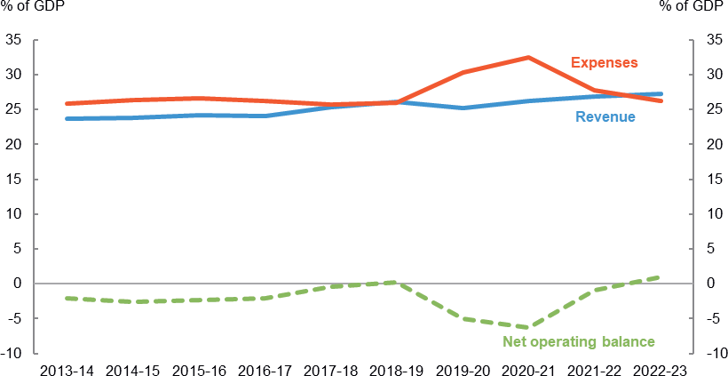

*Commentary on the financial statements*

#### Balance sheet (net worth)

**Table 3: Balance sheet**

|  |  |  |  |  |
| --- | --- | --- | --- | --- |
|  | 2022-23 | 2021-22 | Change | Change |
|  | $b | $b | $b | % |
| Financial assets | 807.7 | 787.8 | 19.9 | 2.5 |
| Non-financial assets | 282.6 | 264.0 | 18.6 | 7.0 |
| **Total assets** | **1,090.3** | **1,051.8** | **38.5** | **3.7** |
| **Total liabilities** | **1,660.6** | **1,660.5** | **0.0** | **0.0** |
| **Net worth** | **(570.2)** | **(608.7)** | **38.5** | **6.3** |
| Per cent of GDP | (22.5) | (26.5) | - | - |
| **Net financial worth(a)** | **(852.8)** | **(872.8)** | **19.9** | **2.3** |
| Per cent of GDP | (33.7) | (38.0) | - | - |
| **Net financial liabilities(b)** | **852.8** | **872.8 (19.9)** | | **2.3** |
| Per cent of GDP | 33.7 | 38.0 - | | - |
| **Net debt(c)** | 412.5 | 435.1 **(22.6)** | | **5.2** |
| Per cent of GDP | 16.3 | 18.9 - | | - |
| **Net interest payments** | **(14.9)** | **(9.5)** | **(5.4)** | **56.6** |
| Per cent of GDP | (0.5) | (0.4) | - | - |

1. Net financial worth equals total financial assets minus total liabilities.
2. Net financial liabilities equals total liabilities less financial assets other than investments in other public sector entities.
3. Net debt is the sum of deposits held, government securities, loans and lease liabilities less the sum of selected financial assets (cash and deposits, advances paid and investments, loans and placements).

#### Chart 2: Balance sheet (per cent of GDP) since 2013-14

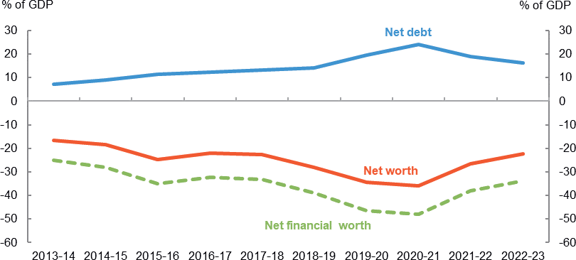

*Commentary on the financial statements*

## Discussion and Analysis

**Net operating balance**

The Australian Government’s net operating balance was a $24.9 billion surplus for the year ended 30 June 2023, an improvement of $45.5 billion against the 30 June 2022 result.

#### Table 4: Operating statement

|  |  |  |  |
| --- | --- | --- | --- |
|  | 2022-23 | 2021-22 | Change Change |
|  | $b | $b | $b % |
| Revenue | 689.9 | 616.7 | 73.2 11.9 |
| Expenses | 665.0 | 637.2 | 27.7 4.4 |
| **Net operating balance** | **24.9** | **(20.6)** | **45.5 221.4** |
| *Less* Net acquisitions of non-financial assets | 14.7 | 11.0 | 3.7 34.1 |
| **Fiscal balance** | **10.2** | **(31.5)** | **41.8 132.4** |

Chart 3 below shows the composition of the Australian Government’s net operating balance since 2013-14.

#### Chart 3: Operating statement since 2013-14

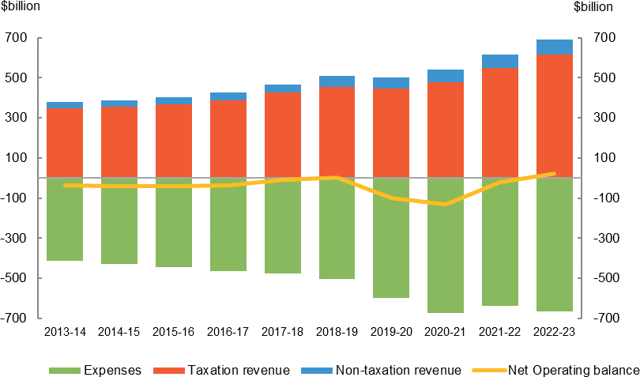

*Commentary on the financial statements*

#### Revenue

The Australian Government’s revenue increased by $73.2 billion (11.9 per cent) in 2022-23 to $689.9 billion.

#### Table 5: Revenue

|  |  |  |  |
| --- | --- | --- | --- |
|  | 2022-23 | 2021-22 | Change Change |
|  | $b | $b | $b % |
| Taxation revenue | 617.4 | 549.4 | 68.0 12.4 |
| Non-taxation revenue | 72.6 | 67.3 | 5.3 7.8 |
| **Total revenue** | **689.9** | **616.7** | **73.2 11.9** |

**Taxation revenue**

The Australian Government’s total taxation revenue for the year ended

30 June 2023 was $617.4 billion. The composition of taxation revenue is shown in Chart 4 below.

#### Chart 4: Composition of taxation revenue

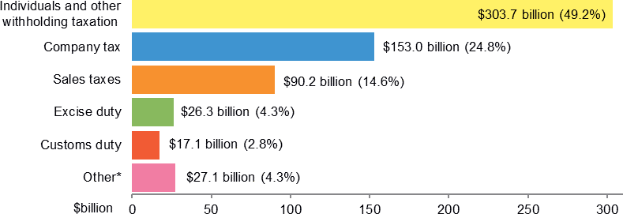

* Other includes: Other indirect taxation ($10.9 billion); Superannuation fund taxes ($10.4 billion); Fringe benefits tax ($4.1 billion) and Resource rent taxes ($1.7 billion).

*Commentary on the financial statements*

Taxation revenue increased by $68.0 billion (12.4 per cent) in comparison to 2021-22. This increase is primarily driven by:

* a $39.1 billion increase in **individuals and other withholding taxes** reflecting strong growth in employment and wages;
* a $27.4 billion increase in **company taxes**, as a result of sustained elevated commodity prices; and
* a $11.1 billion increase in **sales taxes**, resulting from increased consumption subject to GST; partially offset by
* a $16.2 billion decrease in **superannuation fund taxes** reflecting higher utilisation of franking credits.

Refer to Note 2A of the 2022-23 CFS for further information.

#### Non-taxation revenue

The Australian Government’s total non-taxation revenue for the year ended 30 June 2023 was $72.6 billion. For more information, refer to Notes 2B to 2D of the 2022-23 CFS.

*Commentary on the financial statements*

#### Expenses

The Australian Government’s total expenses as at 30 June 2023 were

$665.0 billion.

#### Table 6: Expenses

|  |  |  |  |
| --- | --- | --- | --- |
|  | 2022-23 | 2021-22 | Change Change |
|  | $b | $b | $b % |
| Gross operating expenses | 247.4 | 238.4 | 9.0 3.8 |
| Interest expense | 45.9 | 24.0 | 21.9 91.3 |
| Grants and capital transfers | 211.3 | 203.5 | 7.8 3.8 |
| Personal benefits | 142.8 | 154.5 | (11.7) 7.6 |
| Subsidies | 17.6 | 16.9 | 0.8 4.5 |
| **Total expenses** | **665.0** | **637.2** | **27.7 4.4** |

The Australian Government’s total expenses increased by $27.7 billion (4.4 per cent) since 30 June 2022. The composition of expenses is shown in Chart 5 below.

#### Chart 5: Composition of expenses

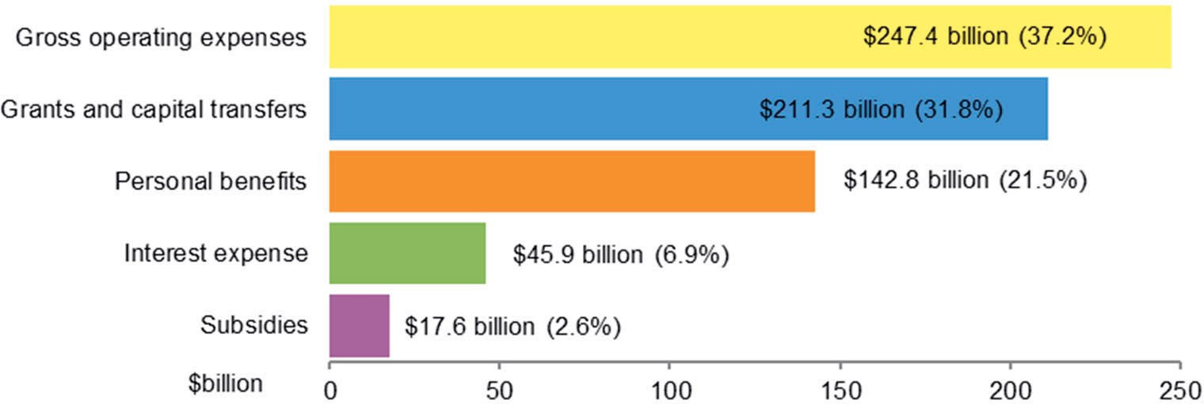

The key movements in **expenses** were:

* an increase in **interest expense** of $21.9 billion, primarily driven by higher exchange settlement balances for the Reserve Bank of Australia ($12.6 billion) and an increase in superannuation interest expense ($3.4 billion) due to a change in discount rates;
* an increase in **gross operating expenses** of $9.0 billion, driven by an increase in benefits to households in goods and services of $9.1 billion, primarily relating to an increase in participants under the National Disability Insurance Scheme ($6.6 billion);
* an increase of $7.8 billion in **grants and capital transfers**, primarily as a result of increased grants to state and territory governments ($6.7 billion); offset by

*Commentary on the financial statements*

* a decrease in **personal benefit expenses** of $11.7 billion, primarily reflecting the significant reduction in demand for payments relating to the COVID-19 pandemic.

Chart 6 below provides a presentation of total expenses based on how the Australian Government allocated resources across the range of functions. The chart highlights the relative cost of each function for 2022-23.

#### Chart 6: Total expenses by function

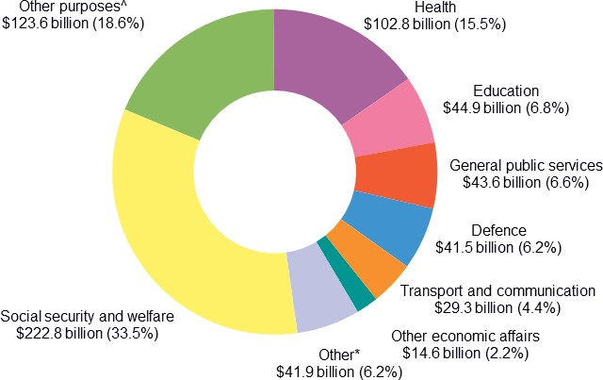

^ Other purposes includes public debt transactions, general purpose inter government transactions and natural disaster relief. Grants to and through state and territory governments are recorded against the ‘other purposes’ function.

**\*** Other includes: Fuel and energy ($12.8 billion); Housing and community amenities ($8.4 billion); Public order and safety ($7.5 billion); Mining, manufacturing and construction ($5.3 billion); Recreation and culture ($4.5 billion); and Agriculture, forestry and fishing ($3.4 billion).

Refer to Note 3 of the 2022-23 CFS for further information on expenses.

*Commentary on the financial statements*

## Net worth

The Australian Government’s net worth increased by $38.5 billion in 2022-23 to a negative net worth of $570.2 billion as at 30 June 2023.

#### Table 7: Balance sheet

|  |  |  |  |
| --- | --- | --- | --- |
|  | 2022-23 | 2021-22 | Change Change |
|  | $b | $b | $b % |
| Financial assets | 807.7 | 787.8 | 19.9 2.5 |
| Non-financial assets | 282.6 | 264.0 | 18.6 7.0 |
| **Total assets** | **1,090.3** | **1,051.8** | **38.5 3.7** |
| Interest bearing liabilities | 1,089.2 | 1,098.7 | (9.5) 0.9 |
| Provisions and payables | 571.4 | 561.8 | 9.6 1.7 |
| **Total liabilities** | **1,660.6** | **1,660.5** | **0.0 0.0** |
| **Net worth** | **(570.2)** | **(608.7)** | **38.5 6.3** |

Chart 7 below shows the composition of the Australian Government’s financial position since 2013-14.

#### Chart 7: Balance sheet since 2013-14

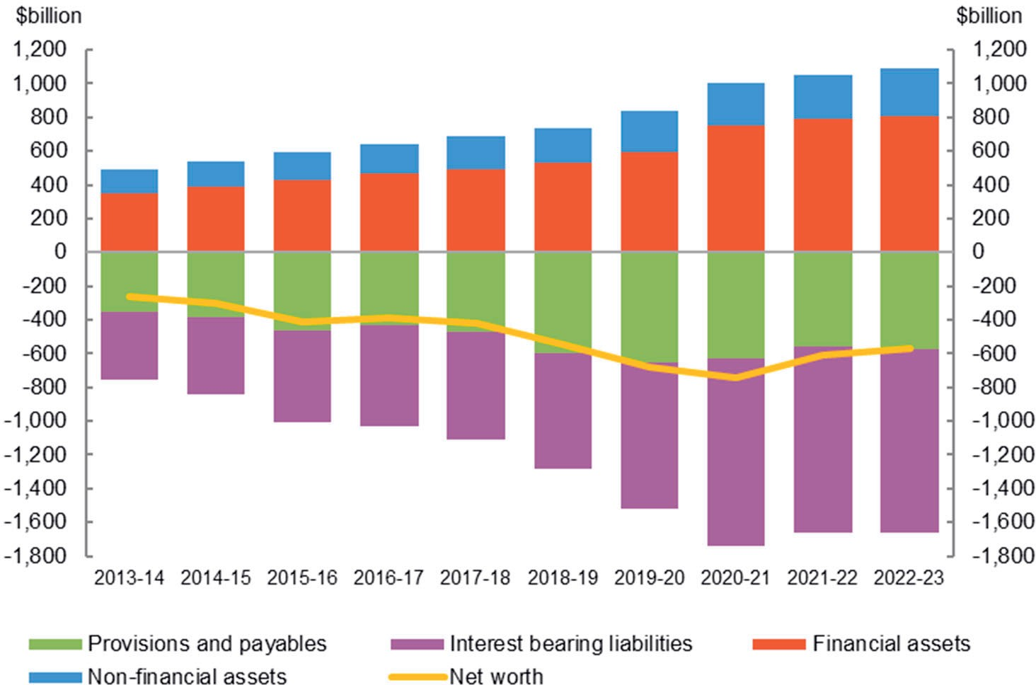

*Commentary on the financial statements*

#### Assets

The Australian Government’s total assets as at 30 June 2023 were $1,090.3 billion.

#### Table 8: Assets

|  |  |  |  |
| --- | --- | --- | --- |
|  | 2022-23 | 2021-22 | Change Change |
|  | $b | $b | $b % |
| Financial assets |  |  |  |
| Cash and deposits | 7.5 | 8.7 | (1.2) 14.2 |
| Advances paid | 73.1 | 70.6 | 2.5 3.6 |
| Other receivables and accrued revenue | 73.8 | 74.4 | (0.6) 0.8 |
| Investments, loans and placements | 569.3 | 558.2 | 11.1 2.0 |
| Equity investments | 84.1 | 75.9 | 8.2 10.8 |
| Total financial assets | 807.7 | 787.8 | 19.9 2.5 |
| Non-financial assets | 282.6 | 264.0 | 18.6 7.0 |
| **Total assets** | **1,090.3** | **1,051.8** | **38.5 3.7** |

The Australian Government’s total assets increased by $38.5 billion (3.7 per cent) since 30 June 2022. The composition of assets is shown in Chart 8 below.

#### Chart 8: Composition of assets

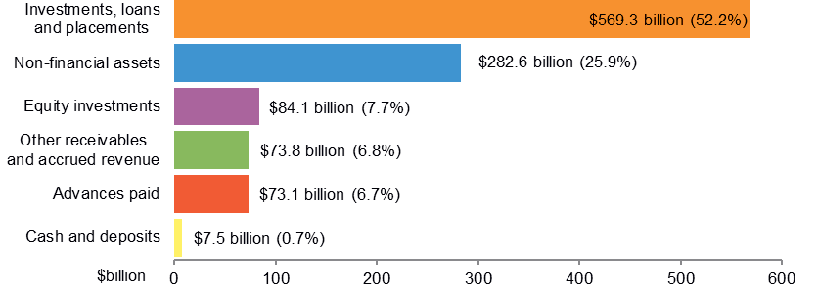

The key changes in **financial assets** were:

* an increase of $11.1 billion in **investments, loans and placements**, primarily driven by an increase in Government securities ($9.1 billion).
* an increase of $8.2 billion in **equity investments**, mainly due to a change in the composition of investments held by the Future Fund.

The key changes in **non-financial assets** were:

* increases in **other plant, equipment and infrastructure** ($7.9 billion), **specialist military equipment** ($3.4 billion), **buildings** ($3.1 billion), and land ($1.7 billion) as a result of additions and revaluation adjustments.

Note 5 of the 2022-23 CFS provides further information on assets.

*Commentary on the financial statements*

#### Liabilities

The Australian Government’s total liabilities were $1,660.6 billion as at 30 June 2023.

#### Table 9: Liabilities

|  |  |  |  |
| --- | --- | --- | --- |
|  | 2022-23 | 2021-22 | Change Change |
|  | $b | $b | $b % |
| Interest bearing liabilities | 1,089.2 | 1,098.7 | (9.5) 0.9 |
| Provisions and payables | 571.4 | 561.8 | 9.6 1.7 |
| **Total liabilities** | **1,660.6** | **1,660.5** | **0.0 0.0** |

The Australian Government’s liabilities balance remained consistent since 30 June 2022. The composition of liabilities is shown in Chart 9 below.

#### Chart 9: Composition of liabilities

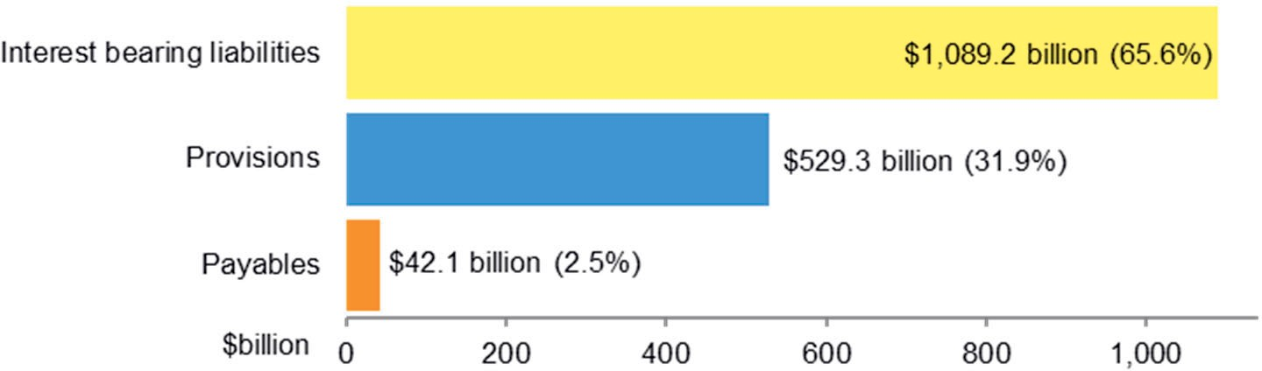

The decrease of $9.5 billion in **interest bearing liabilities** is primarily due to:

* a decrease in exchange settlement funds ($10.8 billion) and deposits held by foreign governments ($2.3 billion); partially offset by
* an increase of $3.9 billion in loans, primarily due to increased borrowings from NBN Co ($2.1 billion).

The increase in **provisions and payables** of $9.6 billion is primarily driven by:

* increases in the personal benefit military compensation ($8.9 billion) and health care military compensation ($4.7 billion) provisions, primarily due to actuarial revaluations;
* an increase in supplier payables of $6.8 billion primarily due to higher unsettled purchases of securities ($5.7 billion); partially offset by
* a decrease in unfunded superannuation provisions ($8.9 billion) primarily due to an actuarial revaluation (refer Note 9C for further information); and
* a decrease in swaps held by the Future Fund ($2.6 billion).

Note 6 of the 2022-23 CFS provides further information on liabilities.

*Commentary on the financial statements*

## Cash flows

The Australian Government’s cash balance was $7.5 billion at 30 June 2023. For the year ended 30 June 2023, the Australian Government recorded a cash surplus of $18.0 billion compared to a cash deficit of $30.0 billion for 2021-22.

#### Table 10: Cash flows

|  |  |  |  |
| --- | --- | --- | --- |
| Cash receipts Operating activities  Investing activities in non-financial assets  Investing activities in financial assets for policy purposes  Financing activities (net)  **Total cash receipts**  Cash payments Operating activities  Investing activities in non-financial assets  Investing activities in financial assets for policy purposes  Investing activities in financial assets for liquidity purposes (net)  Financing activities (net)  **Total cash payments Net movement in cash**  Cash at beginning of the year  **Cash at end of year Key fiscal aggregate**  Net cash flows from operating activities  Net cash flows from investments in non- financial assets  **Cash surplus/(deficit)** | 2022-23 | 2021-22 | Change Change |
| $b | $b | $b % |
| 670.9 | 600.1 | 70.7 11.8 |
| 0.4 | 0.6 | (0.2) 34.4 |
| 9.3 | 8.4 | 0.9 10.7 |
| 32.9 | 132.1 | (99.2) 75.1 |
| **713.4** | **741.1** | **(27.7) 3.7** |
| 628.1 | 606.1 | 22.0 3.6 |
| 25.2 | 24.4 | 0.8 3.3 |
| 13.2 | 13.9 | (0.7) 5.3 |
| 6.8 | 54.7 | (47.8) 87.5 |
| 41.4 | 41.1 | 0.3 0.7 |
| **714.7** | **740.2** | **(25.5) 3.4** |
| **(1.2)** | **1.0** | **(2.2) 228.0** |
| 8.7 | 7.7 | 1.0 12.5 |
| **7.5** | **8.7** | **(1.2) 14.2** |
| 42.8 | (6.0) | 48.8 813.1 |
| (24.8) | (23.8) | (1.0) 4.2 |
| **18.0** | **(29.8)** | **47.8 160.3** |

*Commentary on the financial statements*

#### Receipts and payments

The following charts provide a detailed breakdown of Australian Government receipts and payments for 2022-23, showing the relative composition of each dollar received and paid.

#### Chart 10: Composition of each dollar of cash received in 2022-23

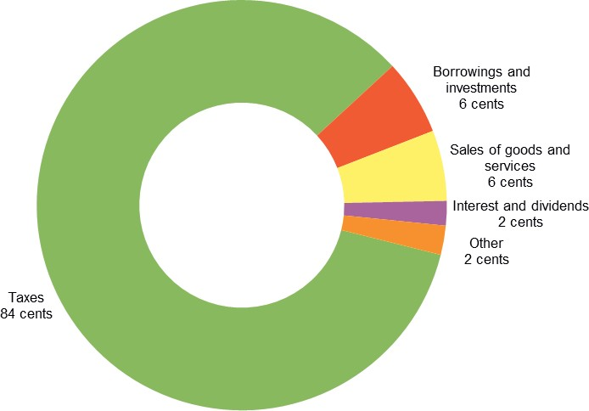

**Chart 11: Composition of each dollar of cash paid in 2022-23**

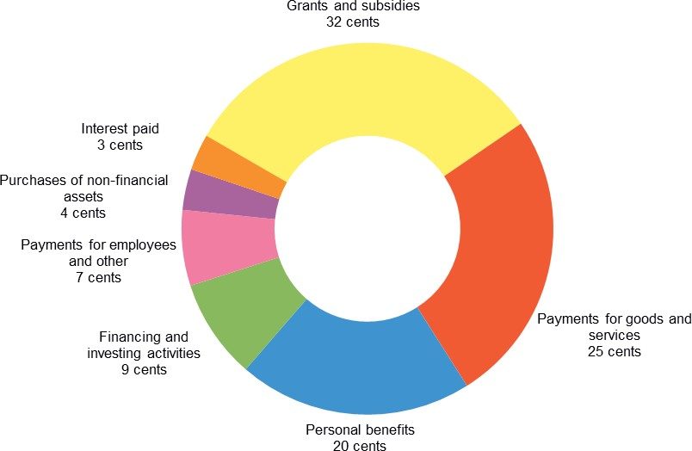

*Commentary on the financial statements*

## Previous years

**APPENDIX A**

The CFS since 1995-96 are available on the Department of Finance website at: <http://www.finance.gov.au/publications/commonwealth-consolidated-> financial-statements.

The historical series datasets are available in electronic format at: <http://data.gov.au/dataset/australian-government-consolidated-financial-> statements-tables-and-data.

## Links to other publications

The Australian Government publishes a range of information about its projected and actual financial position. Links to some of these documents are set out below. The information in the following documents has been prepared for different purposes and therefore does not form part of the CFS. Further, the documents listed below are not subject to audit.

#### 2022-23 Final Budget Outcome

The 2022-23 Final Budget Outcome (FBO) was prepared in a manner consistent with the *Charter of Budget Honesty Act 1998* (the Charter). The Charter requires that the Government provide the FBO no later than three months after the end of the financial year. Consistent with these requirements, the FBO encompasses Australian Government GGS fiscal outcomes for the 2022-23 financial year and is based on external reporting standards.

The 2022-23 FBO was released on the 22 September 2023 and is available on the Australian Government website at:

https://archive.budget.gov.au/2022-23-october/index.htm.

#### Australian Government Monthly Financial Statements

The Australian Government GGS monthly financial statements (MFS) are prepared on a basis consistent with the Budget as required under section 47 of the PGPA Act. The statements are prepared in accordance with AASB 1049.

The Australian Government GGS MFS are available on the website of the Minister for Finance as well as the Department of Finance website: https:[//w](http://www.finance.gov.au/publications/commonwealth-monthly-financial-)ww[.finance.gov.au/publications/commonwealth-monthly-financial-](http://www.finance.gov.au/publications/commonwealth-monthly-financial-) statements#20222023.

The historical series datasets are available in electronic format at: <http://data.gov.au/dataset/australian-government-general-government->

sector-monthly-financial-statements-tables-and-data.

*Commentary on the financial statements*

#### Budget Strategy and Outlook and Mid-Year Economic and Fiscal Outlook

The Budget Strategy and Outlook — Budget Paper No.1 — 2022-23, the Mid-Year Economic and Fiscal Outlook 2022-23, the Budget Strategy and Outlook — Budget Paper No.1 — 2023-24 have been prepared in accordance with the Charter.

These Budget papers are available on the Australian Government website at [http://www.budget.gov.au/.](http://www.budget.gov.au/)

#### Tax Benchmarks and Variations Statement 2021

The Tax Benchmarks and Variations Statement provides details of concessions, benefits, incentives and charges provided through the tax system (tax expenditures) to taxpayers by the Australian Government. Information is published on the Treasury website at: https://treasury.gov.au/publication/p2022-244177.