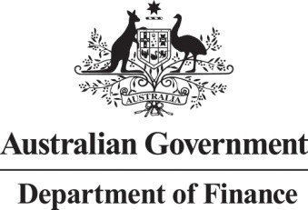

2022-2023 Annual Report

**Ministerial consultants engaged under the *Members of the Parliament (Staff) Act 1984***

# Introduction

The *Members of Parliament (Staff) Act 1984* (the MOP(S) Act) provides a legislative basis for, among other things, the engagement of ministerial consultants.

This report has been prepared to comply with section 31 of the MOP(S) Act, which requires that a report setting out certain details of ministerial consultants engaged under the MOP(S) Act be tabled each year in both Houses of the Parliament.

# Ministerial consultants

There were no ministerial consultants engaged under the MOP(S) Act in the year ending

30 June 2023, or before the commencement of the year ending 30 June 2023, who performed tasks ending 30 June 2023.