

Portfolio Charging Review Information Sheet and Templates

This resource should be read in conjunction with the RMG 302 Guidance to the Australian Government Charging Framework.
Overview
This document provides tools and resources to assist Department of States meet the requirements, timeframes and considerations in undertaking a Portfolio Charging Reviews (PCRs).
In this document you can find resources and tools for all PCR Stages:
- Attachment A: PCR Checklist
- Attachment B: PCR Activity Review Template
- Attachment C: PCR Terms of Reference Template
- Attachment D: PCR Report Structure Example
- Attachment E: Draft letter to Finance Minister
Departments of State must conduct reviews of all existing and potential charging activities within their portfolios at least every five years, in accordance with the published Schedule of Portfolio Charging Reviews or at other times agreed by the Finance Minister.
For each PCR, the Department of State must collect information from all Commonwealth entities in the general government sector within its portfolio, on activities in scope of the Australian Government Charging Framework. This includes all activities of a regulatory or non-regulatory (resource and commercial) nature.
Authority
- As part of the Charging Framework, PCRs provide an ongoing mechanism to review existing charging activities and to bring forward charging reforms, including new opportunities and changes to existing charging activities.
- For each Department of State, the Terms of Reference (ToR) for the PCR must be agreed between the responsible Minister and the Finance Minister via an exchange of letters.
- Entities are required to provide the Portfolio Minister information on the performance of the charging activities conducted across the portfolio and confirm they continue to be appropriate and consistent with the government’s policy intent.
- Where a PCR identifies an additional charging activity that requires Government agreement, new policy proposals may be brought forward as part of the relevant Portfolio Budget Submission for Cabinet consideration during the Budget process, without the Portfolio Minister being required to seek further policy authority.

Scope of PCRs
- Departments of State conduct the PCR to assess the performance of existing charging activities and to identify new charging opportunities.
- Departments of State should commence the PCR to allow sufficient time for: coordination with entities across the portfolio; the number and complexity of every in scope activity; and internal approval processes for completion ahead of Portfolio Budget Submissions deadlines.
- The PCR looks at a broader range of charges than just regulatory charges. Entities must include all activities in scope of the Charging Framework regardless of whether the activity is charged for or not charged for.
- For each PCR, entities are required to review existing information on activities: non-regulatory (resource and commercial) and regulatory, including:
- assess the extent of existing charging activities across the portfolio;
- compare and analyse different types of charging activities;
- evaluate the performance of regulatory charging activities;
- identify charging potential for new and/or existing activities not charged for;
- identify opportunities to amend or discontinue charging activities; and
- assess the effectiveness of stakeholder engagement strategies and opportunities for improvement.
- Approvals
- Departments of State are required to:
- develop and approve ToR for the PCR with the Portfolio Minister;
- coordinate information supplied by portfolio entities and prepare the PCR report; and
- obtain Portfolio Minister approval of the completed PCR report and recommendations.
- The Portfolio Minister is required to:
- seek agreement of ToR with the Finance Minister;
- send completed PCR report to the Finance Minister; and
- seek approval from the Australian Government for any significant policy recommendations identified in the PCR prior to implementing changes to activities.

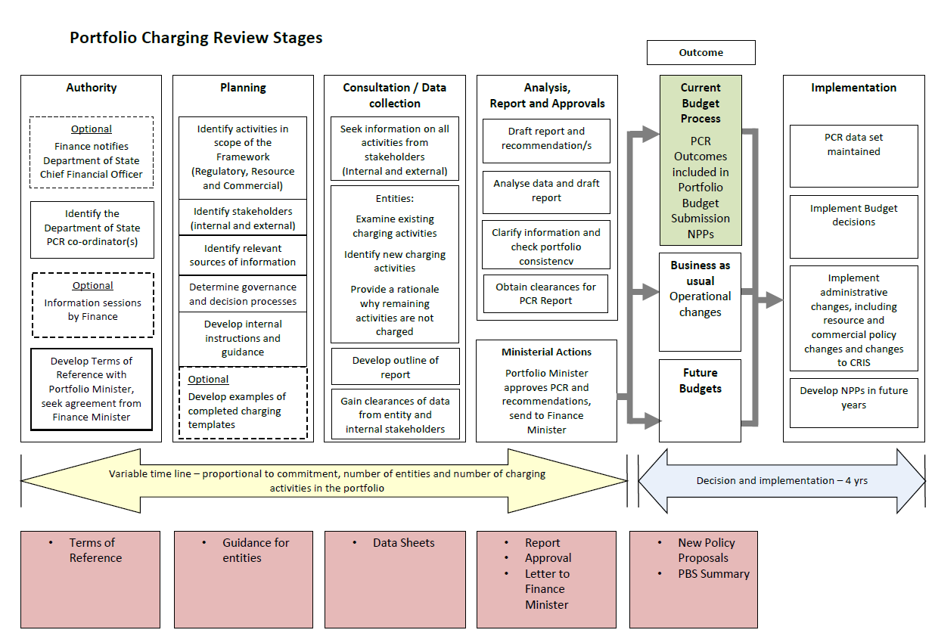

Attachment A: Portfolio Charging Review Checklist
Objective
For the responsible Department of State to review and assess the state of all activities undertaken in its portfolio (both those charged and not charged), within scope of the Charging Framework, and assess the potential for new or changes to existing activities.
Key processes
- Finance will engage with the responsible Department of State (the department) according to the schedule of portfolio charging reviews to support the planning and preparation
- The responsible Minister will agree via correspondence with the Finance Minister the terms of reference for the portfolio charging review
- The department plans and coordinates the portfolio charging review
- Portfolio entities provide information on all of their existing and potential charging activities to the department
- The department prepares the review report, submits it to the responsible Minister, who then provides a copy to the Finance Minister
- Where necessary, policy approval is sought to implement review report recommendations.
Key outputs
- Terms of reference agreed between the responsible Minister and the Finance Minister
- A portfolio charging review report
Charging Framework requirements
- Terms of reference agreed between the responsible Minister and the Finance Minister
- A portfolio charging review report

Attachment B: Activity Review Template

Instructions:
- The aim of this template is to collect information on all existing and potential charging activities in the portfolio (i.e. all activities delivered to the non-government sector by the Department of State and relevant portfolio entities). These activities may involve the provision of a good, service, regulation and/or access to a government asset.
- The information collected will inform a review of a broad range of charges, not just regulatory activities charges.
- Similar charging activities may be grouped together but should remain sufficiently disaggregated to understand the activity.
There are a number of considerations that entities take into account when developing advice on whether it is appropriate to charge for a government activity.
Figure 1: Charging decision making process
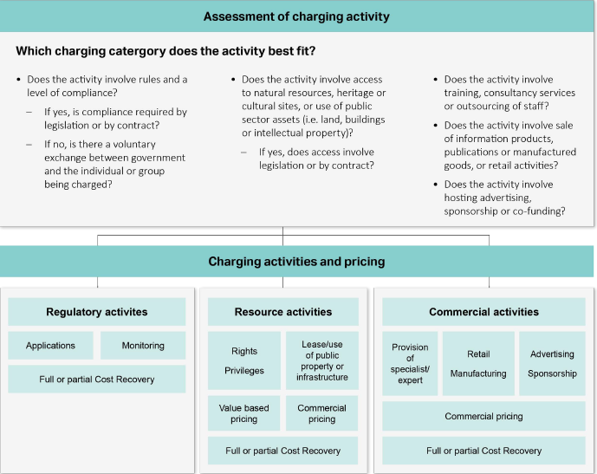
Section A – Description of activity
- Activity Name
Click or tap here to enter text.
Examples:
Regulatory activity – Application for registration, or ongoing monitoring and compliance
Resource example – Access to a national park
Commercial example – Commercial renting of building space
- Is the activity charged for?
☐Yes
☐No
- Nature of the activity?
☐Regulatory
☐Non-regulatory (charged as a resource)
☐Non-regulatory (charged on a commercial basis)
- What group/s causes the need for the activity?
☐Individuals
☐Organisations
☐Industry sector
☐Other
- Who provided the policy authority to charge, or not to charge?
☐Government (Cabinet)
☐Accountable Authority
Date (day/month/year if known): Click or tap here to enter text.
☐Unknown
- If charged for, what is the legal authority to charge?
☐ Legislation (including regulations)
☐ Contract
☐ Other
☐ Not applicable
Reference: Click or tap here to enter text.

- How are regulatory charges documented?
☐Cost Recovery Implementation Statement (CRIS)
☐Other Click or tap here to enter text.
☐Not documented
- In Table 1, complete data on expenses, revenue and any cumulative balance for the activity over the past five years (or another period for which data is available if the activity has been in place for less than five years).
Table 1: Financial outcomes*
 | 2022-23 | 2023-24 | 2024-25 | 2025-26 | 2026-27
 | $m OR exact
Expenses | Click or tap here to enter text. | Click or tap here to enter text. | Click or tap here to enter text. | Click or tap here to enter text. | Click or tap here to enter text.
Revenue (if charged for) | Click or tap here to enter text. | Click or tap here to enter text. | Click or tap here to enter text. | Click or tap here to enter text. | Click or tap here to enter text.
Balance (if charged for) | Click or tap here to enter text. | Click or tap here to enter text. | Click or tap here to enter text. | Click or tap here to enter text. | Click or tap here to enter text.
Variance (+ or - % if charged for) | Click or tap here to enter text.% | Click or tap here to enter text.% | Click or tap here to enter text.% | Click or tap here to enter text.% | Click or tap here to enter text.%
*Where there is no figure to provide, mark ‘-‘.
Comment on financial variance greater than 10%.
Click or tap here to enter text.
If activity is not charged for, proceed to Question 23.
Charging model (cost and price)
This section provides the opportunity to assess whether existing charging is undertaken consistent with the Charging Framework.
- What type of costing model has been used to determine costs?
☐Activity based costing model
☐Allocation of existing staffing effort
☐Unknown

- Is the price currently charged to reflect changes in actual costs?
☐Yes
☐No
  - If yes, how are price changes determined?
☐Annual review
☐Use of indexation
☐Other
  - If no, how will prices reflect cost changes into the future?
Click or tap here to enter text.
- When were the prices last reviewed or changed?
Choose an item.
- State the basis for the level of charging (e.g. at cost, below cost or above cost), including when and how this level was set (i.e. the authority, when, as a percentage, dollar amount or formula).
Click or tap here to enter text.
Section B – Non-financial performance
This section provides the opportunity to assess, compare and evaluate the non-financial performance of charging activities.
- What is the policy intent of the activity?
Click or tap here to enter text.
- How does charging contribute to the stated policy objective of the activity?
Click or tap here to enter text.
- How have stakeholder engagement mechanisms been used?
Click or tap here to enter text.
- How have stakeholders contributed to the performance of the activity?
Click or tap here to enter text.
- What stakeholder engagement mechanisms been used?
Click or tap here to enter text.
Ongoing risk management for activities charged for
This section provides the opportunity to assess risk management for the activity is appropriate. This could include risks such as policy (e.g. reform), legal (e.g. prices for charges laid out in primary legislation, sunsetting of regulations), operational (e.g. geographic location of regulator and provider) or other.
- Describe any risks for the charging activity.
☐Policy Click or tap here to enter text.
☐Legal Click or tap here to enter text.
☐Operational Click or tap here to enter text.
☐Other Click or tap here to enter text.
- What are the mitigating strategies for the identified risks?
☐Policy Click or tap here to enter text.
☐Legal Click or tap here to enter text.
☐Operational Click or tap here to enter text.
☐Other Click or tap here to enter text.
Consideration for activities NOT charged for
This section provides the opportunity to assess whether charging is appropriate for an activity or is contrary to intended policy outcomes. This includes an assessment of whether it would:
- impact the provision of community services or industry support
- impact on stakeholders (e.g. charging stakeholders for delivery of the activity would result in adverse outcomes)
- not be effective, or efficient to apply charging for the activity.
- Would charging impact on the policy outcomes and/or objectives of the activity?
☐Yes Click or tap here to enter text.
☐No Click or tap here to enter text.
- Please explain why it would/would not impact the policy outcomes?
Click or tap here to enter text.
- Would charging for the activity be efficient and effective? (i.e. would the proposed revenue generated meet the expenses of the activity? Are there existing points of contact between government and industry?)
☐Yes Click or tap here to enter text.
☐No Click or tap here to enter text.
- Please explain why it would/would not be efficient and effective to charge?
Click or tap here to enter text.
If relevant – impact of COVID-19 pandemic
The COVID-19 pandemic had an impact on a number of government policies, services and programs.
This section provides the opportunity to assess whether the COVID-19 pandemic had an impact on the activity in 2019-20. This includes an assessment of whether the COVID-19 pandemic:
- affected intended policy outcomes, such as the provision of community services or industry support.
- impacted on stakeholders, for example fee relief.
- Has the activity been impacted by COVID-19?
This may include changes in demand, changes in how the activity (goods or service) is undertaken or changes to how the activity is delivered.
☐Yes Click or tap here to enter text.
☐No Click or tap here to enter text.
- Did this activity provide any fee relief such as waiver of fees or acts of grace?
☐Yes Click or tap here to enter text.
☐No Click or tap here to enter text.
- Are there any learnings that can be taken from these experiences?
Click or tap here to enter text.
Section C – Proposed actions and timeframes
Existing Activity Charged For:

Identify and analyse whether to continue charging for the activity and if any changes are required. Areas to cover may include:
- Operational changes, such as price or cost model adjustments, to reflect the efficient costs of the activity.
- Policy changes, such as discontinuing the activity, or undertaking a further review, refreshing policy authority – identify the level of approval required for proposed actions: Cabinet, responsible Minister, accountable authority or Legislative changes needed.
- Subject to approval, indicate when the proposed action could be implemented.

Click or tap here to enter text.
Existing Activity NOT Charged For:

Identify and analyse whether to continue NOT to charge for the activity. Areas to cover may include:
- Justification to continue with current arrangements i.e. not charging
- Seek policy authority to charge – identify the required level of approval: Cabinet, responsible Minister or Accountable Authority.
- Identify if there are any legislative changes required.
- Subject to approval, indicate when the proposed charging could be implemented.

Click or tap here to enter text.

Attachment C: PCR Terms of Reference Template

Portfolio Charging Review
Terms of Reference
[portfolio name] Portfolio

Authority
A Portfolio Charging Review (PCR) is a requirement of the Australian Government Charging Framework (Charging Framework) agreed by the Government in 2015. Departments of State must conduct a periodic review of all activities within their portfolios at least every five years, in accordance with the published Schedule of PCRs.

Government agreed in September 2017 that ‘Terms of Reference’ must be agreed between the relevant Minister and the Finance Minister for each PCR to assist in appropriate focus and timely delivery.

Portfolio Charging Reviews
The PCR provides an opportunity to assess the extent of charging and bring greater consistency to charging across the portfolio. It will identify potential to charge for new and existing activities. It is also an opportunity to identify whether charging is still appropriate and efficient and assess the effectiveness of stakeholder engagement.

Scope and Objectives
The Department of the [insert name of Department of State] will collect information on all regulatory, resource and commercial activities in-scope of the Charging Framework. Information is to be collected from non-corporate and corporate entities within the [insert name of portfolio] Portfolio.
In-scope entities in the [insert name of portfolio] Portfolio include:
- [insert entity names]

Out-of-scope entities in the [insert name of portfolio] Portfolio include:
- [insert entity names]
All activities of the portfolio are in-scope, unless they are specifically excluded from the Charging Framework as detailed at Appendix A.
The PCR will:
- identify and analyse all activities in the portfolio, including activities that are currently not charged for
- for activities that are not charged for, determine whether there is a policy decision that charging is not appropriate
- assess consistency of all existing charging activities with the principles and requirements of the Australian Government Charging Framework
- compare and evaluate the performance of charging activities, using external and/or internal benchmarks
- develop indexation strategies for all charging activities
- identify new charging opportunities, including for existing budget funded activities, where appropriate
- identify opportunities to amend or discontinue charging activities
- assess the effectiveness of stakeholder engagement strategies
- identify opportunities to improve efficiency, transparency and accountability of charging in the portfolio

In addition to the above, the PCR will:
- [insert areas of focus for the PCR]
- include impacts of the COVID-19 pandemic on charging activities
- address issues identified from the [year] External Government Charging survey including:
  - [insert areas of focus].

Timeframe
The [insert name of portfolio] PCR will be completed and a copy provided to the Finance Minister, prior to reporting any PCR outcomes in [insert name of portfolio] [202XX-XX] Portfolio Budget Submission (PBS). This will allow for PCR outcomes to be reported in the PBS and the development of any New Policy Proposals (NPP) to implement PCR outcomes in the 202XX-XX Budget context.

Information sources
The PCR will utilise information from existing sources where possible, including statutory reviews, pricing reviews, charging surveys, previous PCRs, and other relevant sources.

Deliverables

Key deliverables for the PCR include:
- PCR report provided to the [insert name of relevant Minister] for consideration and agreement, and copied to the Finance Minister
- a summary of PCR outcomes for inclusion in the [insert name of portfolio] PBS
- any NPP/s for Government consideration to implement PCR outcomes.

Consultation
The Department of the [insert name of Department of State] or its portfolio entities will consult with relevant stakeholders (where appropriate) and Finance during the PCR process, especially where NPPs will be brought forward in the Budget context.

Appendix A Out-of-scope Activities for the PCR
A range of activities are out-of-scope of the Australian Government Charging Framework. These activities include:
- inter- and intra-government charges
- charging by Commonwealth companies
- investment returns, interest, dividends, debt charges and related charges
- repayments of loans to the Australian Government
- co-payments, co-funding, partnership activities or similar arrangements
- charges under the Freedom of Information Act 1982
- grants, donations or similar amounts paid to the Australian Government
- contractual penalties and settlements, court fees and similar fees
- receipts from asset sales, investments or similar activities
- general taxation.

Attachment D: Portfolio Charging Review Report Structure Example
- Executive summary
- Profile of charging activities across the portfolio, e.g. types of activities/revenue
- Key findings and recommendations
- Recommendations
By activity, the proposed changes, timing and justification
- detail activities that are likely to require Government policy approval, such as introducing charging for new activities
- identify changes that can be approved by accountable authorities or responsible Minister, such as increasing fees
- changes within the portfolio to better support charging
- Current state
Summary of activities across the portfolio
- Existing charging activities
- Existing activities not charged for
- New charging activities
- Charging activities to discontinue
Strengths and weaknesses
Identify specific clear examples of strengths and weaknesses in charging activities. What lessons learned or better practice could be shared within the portfolio?
Key risks and opportunities
Identify examples from those activities that are charged and not charged
- Indexation strategy
- Provide analysis of existing indexation arrangements
- Identify portfolio strategy to ensure prices reflect costs
- For new and existing activities, how will this be implemented?
- Stakeholder engagement mechanisms
- Assess their effectiveness, appropriateness and consistency with better practice principles
- Impact of the COVID-19 pandemic (if relevant)
- Improvement options
- Identify improvement options, including risks and benefits (e.g. options to share better practice within the portfolio)
- Recommendations based on analysis of improvement options
- Implementation Strategy
- Include timeline and options to inform the Minister of how PCR recommendations will be implemented
- Attachments – Terms of Reference for the PCR, completed templates for existing charging activity, existing activity not charged for, and new charging activity.

Attachment E: Draft letter to Finance Minister approval for Terms of Reference

Senator the Hon Katy Gallagher
Minister for Finance
Parliament House
CANBERRA ACT 2600

Dear Senator,

I am writing to seek your agreement to the attached Terms of Reference for the forthcoming [Entity] 20XX Portfolio Charging Review (PCR). I understand my Department has worked with the Department for Finance in drafting the Terms of Reference.

I will provide a copy of the final PCR report to you and a summary of the outcomes will be included in the [Entity] 20XX-XX Portfolio Budget Submission.

Yours sincerely

Responsible Minister

Intra-government and inter-government payments may be between entities from the Australian Government, state, territory, local or foreign governments, and usually involve may involve charging for specific goods or services. Where a government entity provides an activity to both the government and non-government stakeholders, charges should generally be set on the same basis for all stakeholders.
A flipchart of Commonwealth entities and companies can be found at http://www.finance.gov.au/flipchart.

