# Consolidated Financial Statements, including the Australian Government And General Government Sector Financial Reports

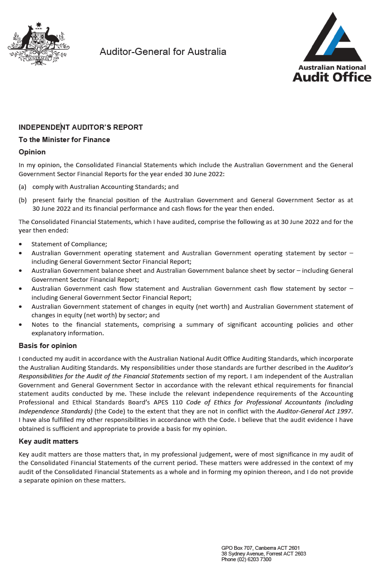

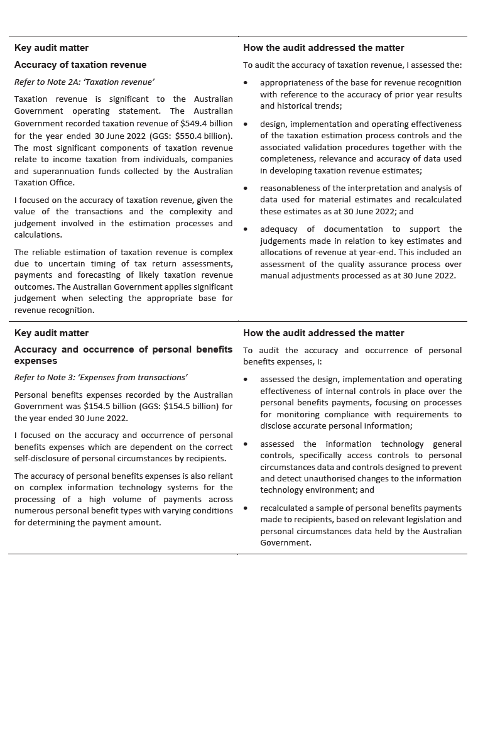

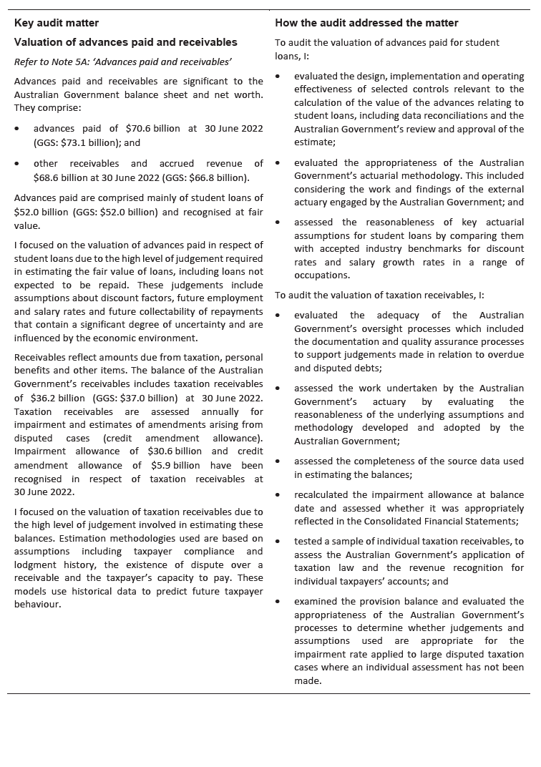

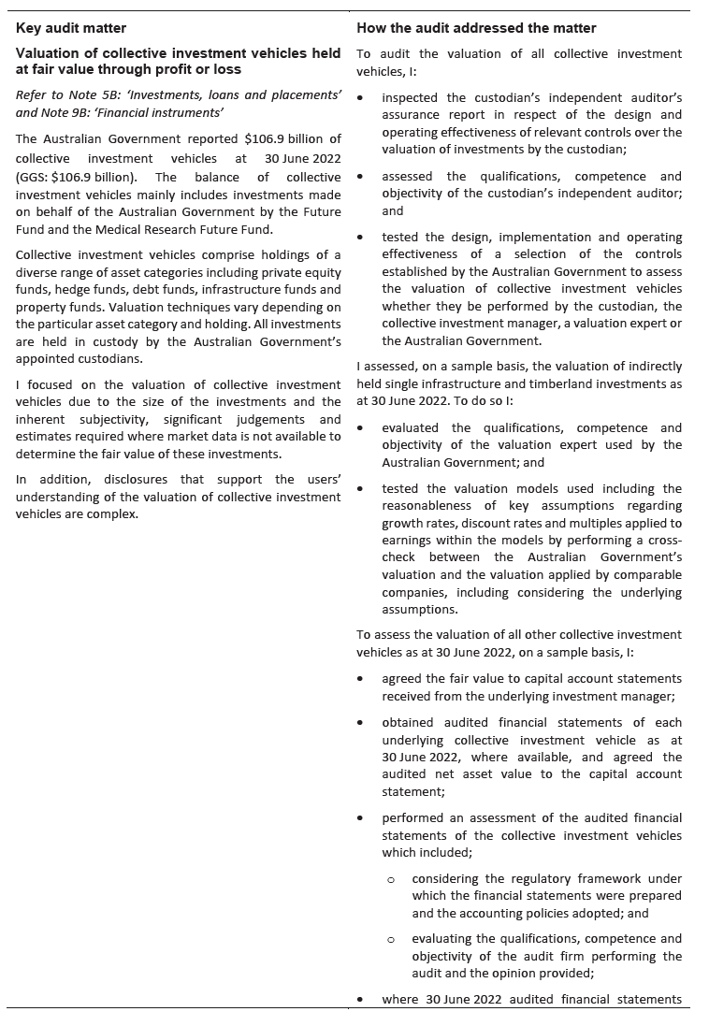

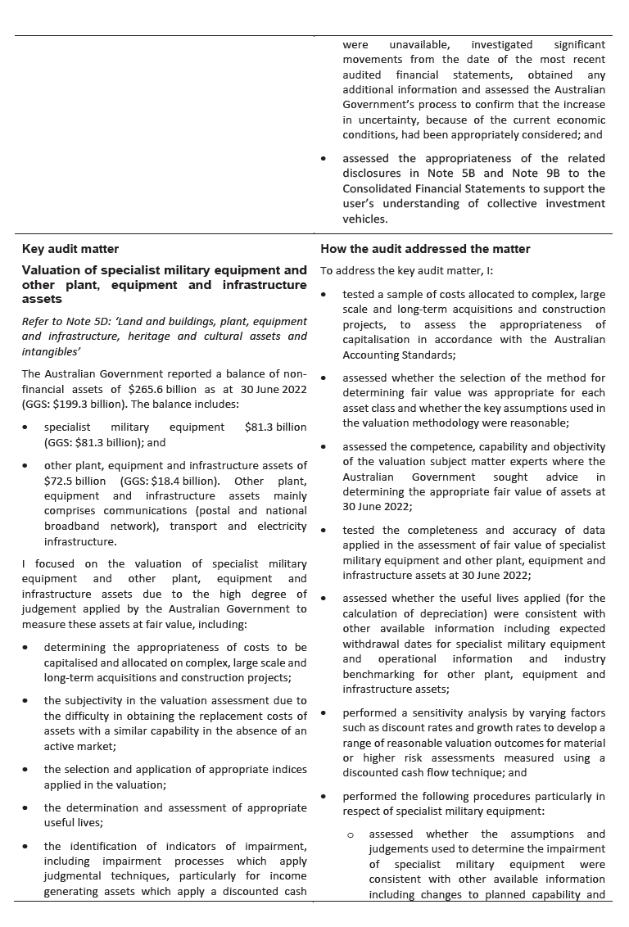

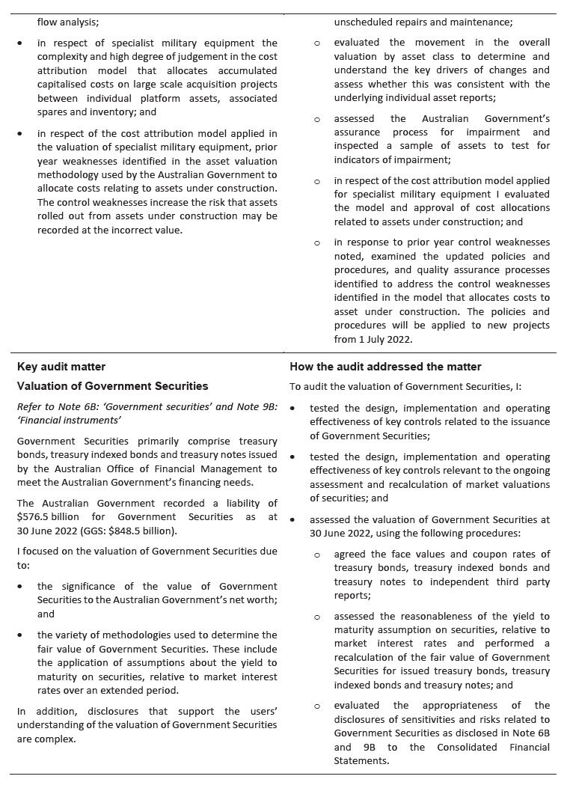

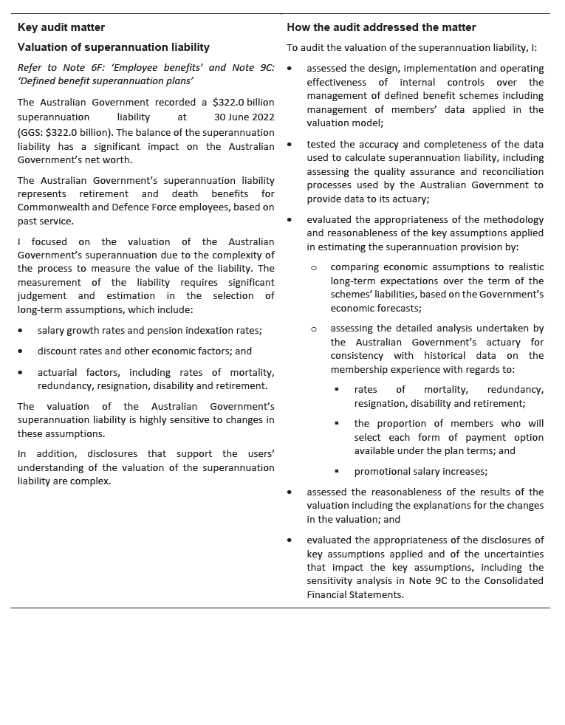

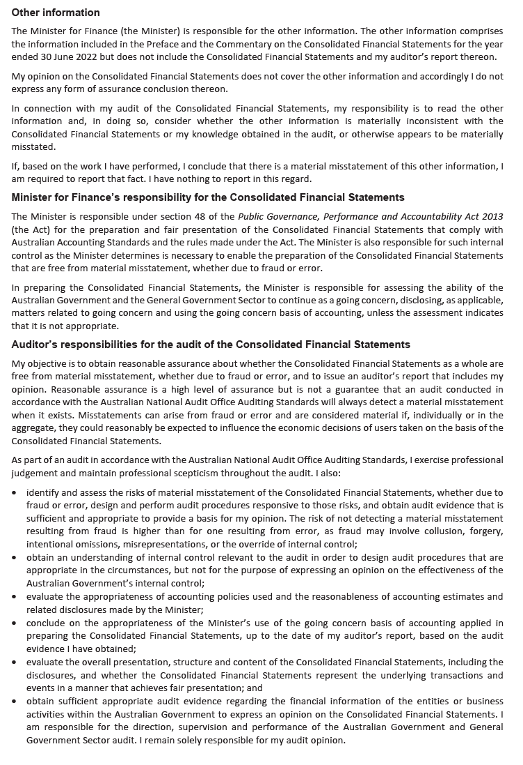

## 

## Statement of Compliance

The annual Consolidated Financial Statements of the Australian Government are required by section 48 of the *Public Governance, Performance and Accountability Act 2013.*

In my opinion, the attached annual Consolidated Financial Statements of the   
Australian Government, which includes the whole of government and general government sector financial statements:

1. comply with Australian Accounting Standards; and
2. present fairly the Australian Government’s financial position as at 30 June 2022 and its financial performance and cash flows for the year then ended.



Senator the Hon Katy Gallagher

Minister for Finance

16 November 2022

Australian Government operating statement

for the year ended 30 June 2022

|  |  |  |  |
| --- | --- | --- | --- |
|  |  | 2022 | 2021 |
|  | Note | $m | $m |
| **Revenue from transactions** |  |  |  |
| Taxation revenue | 2A | 549,394 | 479,916 |
| Sales of goods and services | 2B | 37,244 | 33,450 |
| Interest income | 2C | 12,974 | 6,723 |
| Dividend and distribution income | 2C | 8,846 | 7,620 |
| Other | 2D | 14,755 | 13,474 |
| **Total revenue** |  | **623,213** | **541,183** |
| **Expenses from transactions** |  |  |  |
| *Gross operating expenses* |  |  |  |
| Wages and salaries | 3A | 27,627 | 26,110 |
| Superannuation | 3A | 12,872 | 13,068 |
| Depreciation and amortisation | 3B | 16,266 | 16,695 |
| Supply of goods and services | 3C | 173,096 | 150,887 |
| Other operating expenses | 3A | 8,494 | 8,658 |
| *Total gross operating expenses* |  | *238,355* | *215,418* |
| Superannuation interest expense | 3A | 8,974 | 7,002 |
| Interest expense | 3D | 21,564 | 20,472 |
| *Current transfers* |  |  |  |
| Current grants | 3E | 184,534 | 166,930 |
| Subsidy expenses |  | 16,852 | 85,249 |
| Personal benefits |  | 154,452 | 160,485 |
| *Total current transfers* |  | *355,838* | *412,664* |
| *Capital transfers* |  |  |  |
| Mutually agreed write-downs | 3E | 2,884 | 2,792 |
| Other capital grants | 3E | 16,056 | 13,286 |
| *Total capital transfers* |  | *18,940* | *16,078* |
| **Total expenses** | 3F | **643,671** | **671,634** |
|  |  |  |  |
| **Net operating balance** |  | **(20,458)** | **(130,451)** |
| **Other economic flows - included in operating result** |  |  |  |
| Net write-down of assets (including bad and doubtful debts) | 4A | (12,270) | (12,005) |
| Net gains/(losses) from the sale of assets | 4B | (1,985) | 3,045 |
| Net foreign exchange gains/(losses) | 4C | 2,010 | (3,609) |
| Net interest on derivatives gains/(losses) | 4C | (409) | 1,235 |
| Net fair value gains/(losses) | 4C | 54,441 | 53,777 |
| Net other gains/(losses) | 4C | 7,082 | (9,902) |
| **Operating result(a)** |  | **28,411** | **(97,910)** |
| **Other economic flows - other non-owner movements in equity** |  |  |  |
| ***Items that will not be reclassified to operating result*** |  |  |  |
| Revaluation of non-financial assets | 7 | 10,149 | 1,327 |
| Actuarial revaluations of superannuation |  | 95,210 | 33,451 |
| Other economic revaluations |  | 1,751 | 26 |
| ***Items that may be reclassified subsequently to operating result*** |  |  |  |
| Revaluation of equity investments | 7 | 373 | (260) |
| **Comprehensive result - total change in net worth** |  | **135,894** | **(63,366)** |
| **Net operating balance** |  | **(20,458)** | **(130,451)** |
| ***less* Net acquisition of non-financial assets** |  |  |  |
| Purchases of non-financial assets |  | 26,351 | 23,167 |
| *less* Sales of non-financial assets |  | 1,388 | 320 |
| *less* Depreciation and amortisation |  | 16,266 | 16,695 |
| *plus* Change in inventories |  | 2,392 | 2,353 |
| *plus* Other movements in non-financial assets |  | (18) | 3 |
| **Total net acquisition of non-financial assets** |  | **11,071** | **8,508** |
| **Fiscal balance (Net lending/(borrowing))** |  | **(31,529)** | **(138,959)** |

1. Includes $101 million attributable to minority interests (2021: $83 million).

Australian Government balance sheet

as at 30 June 2022

|  |  |  |  |
| --- | --- | --- | --- |
|  |  | 2022 | 2021 |
|  | Note | $m | $m |
| **Assets** |  |  |  |
| *Financial assets* |  |  |  |
| Cash and deposits |  | 8,698 | 7,734 |
| Advances paid | 5A | 70,598 | 71,550 |
| Other receivables and accrued revenue | 5A | 68,639 | 59,288 |
| Investments, loans and placements | 5B | 563,957 | 526,186 |
| Equity investments | 5C | 75,891 | 87,334 |
| *Total financial assets* |  | *787,783* | *752,092* |
| *Non-financial assets(a)* |  |  |  |
| Land | 5D | 15,113 | 14,085 |
| Buildings | 5D | 50,731 | 47,749 |
| Specialist military equipment | 5D | 81,255 | 74,387 |
| Other plant, equipment and infrastructure | 5D | 72,469 | 69,481 |
| Intangibles | 5D | 15,008 | 13,674 |
| Investment property | 5D | 365 | 348 |
| Inventories | 5E | 11,979 | 10,850 |
| Heritage and cultural assets | 5D | 12,632 | 11,861 |
| Other non-financial assets | 5F | 6,036 | 5,620 |
| *Total non-financial assets* |  | *265,588* | *248,055* |
| **Total assets** | 5G | **1,053,371** | **1,000,147** |
|  |  |  |  |
| **Liabilities** |  |  |  |
| *Interest bearing liabilities* |  |  |  |
| Deposits held | 6A | 426,128 | 356,014 |
| Government securities | 6B | 576,517 | 683,915 |
| Loans | 6C | 38,125 | 28,566 |
| Leases | 6D | 31,783 | 31,964 |
| Other interest bearing liabilities | 6E | 36,354 | 11,398 |
| *Total interest bearing liabilities* |  | *1,108,907* | *1,111,857* |
| *Provisions and payables* |  |  |  |
| Superannuation liability | 6F | 321,998 | 407,506 |
| Other employee liabilities | 6F | 36,910 | 39,970 |
| Supplier payables | 6G | 14,011 | 13,868 |
| Personal benefits payable | 6G | 2,999 | 3,015 |
| Subsidies payable | 6G | 908 | 976 |
| Grants payable | 6G | 3,926 | 6,821 |
| Australian currency on issue | 6H | 102,345 | 95,485 |
| Other payables | 6G | 4,339 | 3,049 |
| Other provisions | 6H | 64,202 | 60,820 |
| *Total provisions and payables* |  | *551,638* | *631,510* |
| **Total liabilities** |  | **1,660,545** | **1,743,367** |
|  |  |  |  |
| **Net worth** |  |  |  |
| Accumulated results |  | (698,169) | (831,030) |
| Reserves |  | 90,365 | 87,436 |
| Minority interests |  | 630 | 374 |
| **Net worth** |  | **(607,174)** | **(743,220)** |

1. Right-of-use assets are included in the following line items: Land, Buildings and Other plant, equipment and infrastructure.

Australian Government cash flow statement

for the year ended 30 June 2022

|  |  |  |  |
| --- | --- | --- | --- |
|  |  | 2022 | 2021 |
|  | Note | $m | $m |
| **OPERATING ACTIVITIES** |  |  |  |
| **Operating cash received** |  |  |  |
| Taxes received |  | 536,053 | 473,763 |
| Receipts from sales of goods and services |  | 36,093 | 34,111 |
| Interest receipts |  | 10,462 | 5,858 |
| Dividend and distribution receipts |  | 8,621 | 7,238 |
| Other receipts |  | 15,435 | 16,438 |
| **Total cash received** |  | **606,664** | **537,408** |
| **Operating cash used** |  |  |  |
| Payments for employees |  | (42,236) | (39,358) |
| Payments for goods and services |  | (168,312) | (147,103) |
| Grants and subsidies paid |  | (217,850) | (276,147) |
| Interest paid |  | (17,818) | (17,588) |
| Interest payments on lease liabilities |  | (1,239) | (1,149) |
| Personal benefits paid |  | (156,276) | (163,747) |
| Other payments |  | (8,038) | (7,844) |
| **Total cash used** |  | **(611,769)** | **(652,936)** |
| **Net cash flows from operating activities** | 8 | **(5,105)** | **(115,528)** |
| **INVESTING ACTIVITIES** |  |  |  |
| **Investments in non-financial assets** |  |  |  |
| Sales of non-financial assets |  | 561 | 369 |
| Purchases of non-financial assets |  | (24,357) | (20,545) |
| **Net investments in non-financial assets** |  | **(23,796)** | **(20,176)** |
| **Investments in financial assets for policy purposes** |  |  |  |
| Receipts from policy investments |  | 8,378 | 7,599 |
| Payments for policy investments |  | (13,893) | (16,133) |
| **Net investments in financial assets for policy purposes** |  | **(5,515)** | **(8,534)** |
| **Investments in financial assets for liquidity purposes** |  | **(54,650)** | **(133,330)** |
| **Net cash from investing activities** |  | **(83,961)** | **(162,040)** |
| **FINANCING ACTIVITIES** |  |  |  |
| **Net financing cash received** |  |  |  |
| Borrowings |  | 20,117 | 1,064 |
| Contributed equity |  | 168 | 63 |
| Other financing |  | 110,881 | 287,866 |
| **Net cash received** |  | **131,166** | **288,993** |
| **Net financing cash used** |  |  |  |
| Distributions paid |  | (16) | (7) |
| Principal payments of lease liabilities |  | (2,947) | (2,969) |
| Other financing |  | (38,173) | (8,696) |
| **Net cash used** |  | **(41,136)** | **(11,672)** |
| **Net cash flows from financing activities** |  | **90,030** | **277,321** |
| **Net increase/(decrease) in cash held** |  | **964** | **(247)** |
| **Cash at beginning of year** |  | **7,734** | **7,981** |
| **Cash at end of year** |  | **8,698** | **7,734** |
| **Key fiscal aggregate** |  |  |  |
| Net cash flows from operating activities |  | (5,105) | (115,528) |
| Net cash flows from investments in non-financial assets |  | (23,796) | (20,176) |
| **Cash surplus/(deficit)** |  | **(28,901)** | **(135,704)** |

Australian Government statement of changes in equity (net worth)

for the year ended 30 June 2022

|  |  |  |  |  |  |  |  |  |  |
| --- | --- | --- | --- | --- | --- | --- | --- | --- | --- |
|  |  | Reserves | | | | | |  |  |
| Item | Accumulated results | Asset revaluation reserve | Foreign currency translation reserve | Investments reserve | Statutory funds | Other reserves | Total reserves | Contributed equity | **Total net worth** |
|  | $m | $m | $m | $m | $m | $m | $m | $m | **$m** |
| **Australian Government** |  |  |  |  |  |  |  |  |  |
|  |  |  |  |  |  |  |  |  |  |
| Adjusted opening balance as at 1 July 2020 | (773,507) | 61,649 | 145 | 13,756 | 8,514 | 9,333 | 93,397 | 207 | **(679,903)** |
| Contribution/(distribution) of equity | - | - | - | - | - | - | - | 56 | **56** |
| Dividends provided for or paid | (7) | - | - | - | - | - | - | - | **(7)** |
| Comprehensive result - change in net worth | (64,694) | 708 | (67) | 339 | - | 348 | 1,328 | - | **(63,366)** |
| Transfers to/(from)/between reserves | 7,288 | (10) | - | (339) | 1,247 | (8,186) | (7,288) | - | **-** |
| **Net worth as at 30 June 2021** | **(830,920)** | **62,347** | **78** | **13,756** | **9,761** | **1,495** | **87,437** | **263** | **(743,220)** |
| *less:* Minority interests | 110 | - | - | 1 | - | - | 1 | 263 | **374** |
| **Attributable to the Australian Government** |  |  |  |  |  |  |  |  |  |
| **Sector at 30 June 2021** | **(831,030)** | **62,347** | **78** | **13,755** | **9,761** | **1,495** | **87,436** | **-** | **(743,594)** |
| Contribution/(distribution) of equity | - | - | - | - | - | - | - | 168 | **168** |
| Dividends provided for or paid | (16) | - | - | - | - | - | - | - | **(16)** |
| Comprehensive result - change in net worth | 123,126 | 10,932 | (20) | (417) | - | 2,273 | 12,768 | - | **135,894** |
| Transfers to/(from)/between reserves | 9,839 | (11) | - | 417 | (9,761) | (484) | (9,839) | - | **-** |
| **Net worth as at 30 June 2022** | **(697,971)** | **73,268** | **58** | **13,756** | **-** | **3,284** | **90,366** | **431** | **(607,174)** |
| *less:* Minority interests | 198 | - | - | 1 | - | - | 1 | 431 | **630** |
| **Attributable to the Australian Government** |  |  |  |  |  |  |  |  |  |
| **Sector at 30 June 2022** | **(698,169)** | **73,268** | **58** | **13,755** | **-** | **3,284** | **90,365** | **-** | **(607,804)** |

The above statements should be read in conjunction with the accompanying notes.