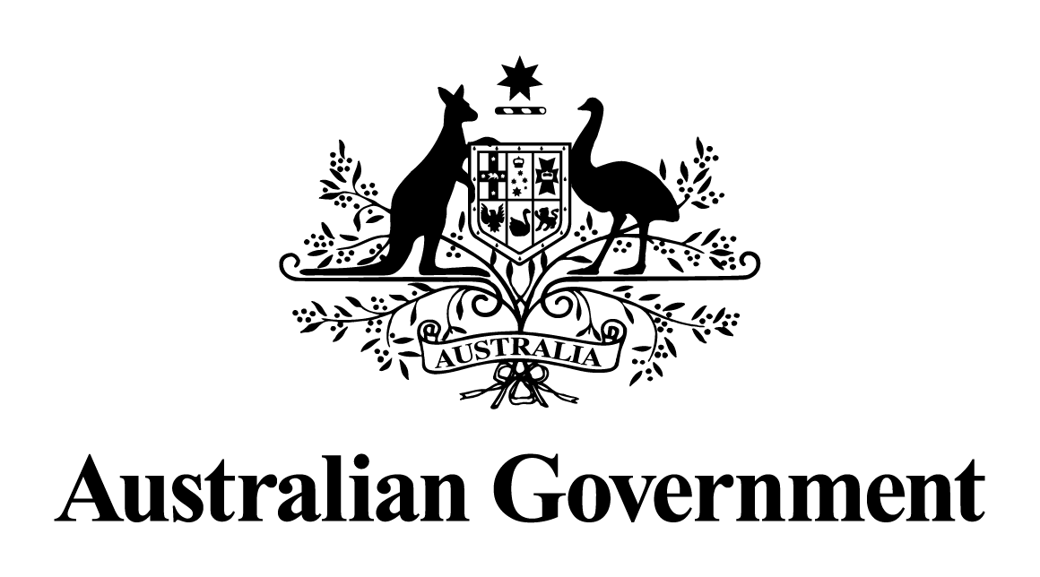

Australian Government response to the   
JOINT COMMITTEE OF PUBLIC ACCOUNTS AND AUDIT REPORT 492:

Governance in the Stewardship of Public Resources – Recommendation 12

November 2022

**Response to the Committee’s Recommendation**

**Recommendation 12:**

6.62 The Committee recommends that the Department of Finance (Finance):

* provide an update on its review of the Lands Acquisitions Act 1989 and how the findings of Auditor-General Report 9 (2020-21) and the Independent Review of the Leppington Triangle Acquisition (Sententia Consulting, May 2021) have informed Finance’s review, and subsequent guidance issued to Commonwealth entities;
* pending any systemic changes, adopt a clear default presumption that compulsory acquisition powers shall be used for land acquisition; and
* only permit ‘off-market’ voluntary acquisitions when carefully justified and thoroughly documented, in which case compulsory acquisition methodology should be used as a benchmark to help ensure that a situation like the Leppington Triangle purchase does not happen again.

***Not Agreed.***

The Report on the Review of the *Lands Acquisition Act 1989* was published in August 2021 on the Department of Finance website. The Review found the legislative framework of the LAA, coupled with the legislative requirements of the *Public Governance, Performance and Accountability Act 2013*, is appropriate and provides suitable safeguards to ensure appropriate conduct and outcomes.

The Review made 16 recommendations for targeted legislative, policy and administrative changes. This included additional guidance to provide better support and greater clarity and certainty to landholders and government officials. The Government agrees to all the recommendations, including those that were agreed and implemented by the previous Government.

The LAA Review recommendations were informed by the lessons from the Australian National Audit Office’s report into the Leppington Triangle purchase. The targeted legislative amendments are expected to be finalised by early 2023 and will provide greater rigour around acquisitions by agreement, including highlighting the requirement to ensure acquisitions represent value for money. Finance published a new *Resource Management Guide 501: Lands Acquisition Framework* in October 2021 to support best practice, which provides detailed guidance to officials to meet their obligations under the LAA and to encourage informed decision-making for acquisitions. This guidance addresses matters including probity, valuation, negotiation, ethical conduct, record keeping, acquisition strategy and approach, and determining price or compensation.

The Government does not support the Committee’s recommended default presumption that compulsory acquisition powers be used for land acquisition. The Government will continue to adopt the long-standing preference to pursue land acquisitions by mutual agreement, with a focus on market value as the foundation for offers. Under the LAA, an interest in land is defined broadly and the scope of acquisitions includes purchasing freehold or leasehold title, entering into a lease or licence (for example, leasing office accommodation) and acquiring access rights or easements. The LAA Review noted the vast majority of acquisitions under the LAA are lease agreements.

Acquisitions by agreement are usually simpler, faster and more cost-effective than compulsory acquisitions. The LAA Review heard from landholders who reported compulsory acquisition and subsequent compensation claim processes can be stressful and felt their lives were ‘on hold’ for several years. The Review also found lengthy compensation claims following compulsory acquisitions can result in significantly increased legal and compounding interest costs, which are paid by the Commonwealth.