Data sharing for data custodians fact sheet

The Intergovernmental Agreement on Data Sharing (IGA) commits all jurisdictions to share public sector data as a default position, where it can be done securely, safely, lawfully and ethically.

As demand for data for decision making and planning grows exponentially, Government agencies and their data custodians will receive increasing numbers of data requests.

This factsheet provides steps for data custodians to follow when considering data sharing requests. Where data cannot be shared because it is unlawful or not in the public interest, the IGA requires reasons for refusal to be communicated to the requester as soon as possible so other options can be considered.

For data requests sent to any or many Australian Government Data Custodians the Dataplace platform can be used to make and manage data requests.

[Dataplace](https://www.dataplace.gov.au/) is available to connect organisations seeking government data with Commonwealth agencies. Organisations using Dataplace can submit a data request and manage data sharing agreements with Commonwealth agencies, as well as obtain accreditation from the Office of the National Data Commissioner to support safer and more transparent data sharing practices using the [DATA Scheme](https://www.datacommissioner.gov.au/the-data-scheme)

## Step 1: Identify the purpose for the data request

* What problem is the requester trying to solve or understand?
* What is the intended outcome of the data project?
* What public benefit will occur as a result of the project?
* What are the consequences, costs and dis-benefits of not sharing the data?

The data requester may need assistance to refine their problem statement or understand what data is available. Open communication between the data custodian and requester will ensure available data is fit for purpose.

## Step 2: Can the data be lawfully shared?

Data custodians will only share data when it is lawful to so in accordance with any relevant legislation. Consideration needs to be given to Commonwealth legislation, state and territory legislation, and any legislation that governs specific data assets (for example, a data asset may have limits on approved uses). Privacy concerns are often cited as a reason not to share data, but it is usually possible to appropriately address these concerns and apply controls to maintain privacy.

Sharing of data needs to be in the public interest. Although it may be lawful to share data it may not be ethical to do so depending on the proposed use and purpose. Custodians may need to consider a data ethics impact assessment to inform their position.

## Step 3: Conduct due diligence

Appropriate data governance ensures custodians can oversee, monitor and control their data, even after it is shared. Data goverance is ‘the exercise of authority, control and shared decision-making (planning, monitoring and enforcement) over the management of data assets’. [1]

Data governance is a set of policies, processes, structures, roles and responsibilities that ensure data is managed effectively, stored and accessed securely, and that it can meet both current and future business requirements. Further guidance on data governance can be found at [NSW Government Data Governance Toolkit](https://data.nsw.gov.au/data-governance-toolkit-0).

Due dilligence requires the data custodian to communicate any data sensitivities and a data access pathway, including any required approvals. Data custodians may need to triage data requests based on their complexity, for example allowing additional development time for a multi-party data sharing agreement.

Managaging expectations of both parties by detailing the data sharing platform, key stakeholders and the ongoing engagement through the data lifecycle is important. Data matching protocols, privacy threshold assessments, privacy impact assessment and complexity assessment can be considered by both custodian and requester to ensure the community are aware of what data is being shared and how it will be used and protected. These considerations can be included in a Data Sharing Agreement.

Publishing the privacy assessment is considered best practice and helps to build trust and confidence by demonstrating transparency.

Dataplace’s data request service will prompt data requestors to provide information regarding step 1, 2 and 3 and provide a consistent assessment process which an Australian Government Data Custodian can use to inform their response.

## Step 4: Action Request

Negotiate a Data SharingAgreement. While agencies may have their own preferred Agreement templates, it is recommended agencies use the Data Sharing Agreement services offered on the Dataplace platform, which will assist organisations to complete a [Standard Data Sharing Agreement](https://www.datacommissioner.gov.au/data-management/data-sharing-agreement)  similar to the guide currently available by the Office of the National Data Commissioner.

When negotiating an Agreement:

* Confirm project scope, objectives and outcomes.
* Confirm data format, data variables, frequency and timeframe, and the platform or mechanism for data transfer or access.
* Agree an estimated timeframe for completion of the Data Sharing Agreement, building in time for internal reviews by legal officers, key stakeholders and decision-makers.
* Confirm whether any additional consultation is needed within or external to the agency before a Data Sharing Agreement can be finalised.
* Apply the Data Sharing Principles to ensure you have the appropriate controls in place to safely share data.

Each Government agency will have their own systems, business units and technology that impact how data requests are actioned. They can use the Dataplace platform to document the outcomes of these decisions and respond to requests. It is recommended that agencies visually document their specific agency systems and key decisions and approvals that are required for data sharing to take place.

## Step 5: Maintain engagement

Data custodians need to establish and maintain strategic relationships with other government agencies to maintain stewardship of data assets. Every time data is transmitted, used or analysed, it changes. That change may be a change in context, a change in the history of the data, a change in who knows the content of the data, or possibly a change in the data itself. At every step, these changes create metadata that describes the journey of the data. By consistently capturing metadata (data about data), governments can address some of the concerns data custodians have about use of shared data.

After a Data Sharing Agreement is in place, regular contact with the data recipient is a good practice to ensure the data received was fit-for-purpose and is being used for agreed purposes. Continued engagement also enables the custodian to measure the effectiveness of the data sharing against the cost, including benefits to the community. Dataplace’s data sharing agreement services will assist organsiations in monitoring and closing out data sharing if needed.

## More information

The Intergovernmental Agreement on Data Sharing is available online at <https://federation.gov.au/about/agreements/intergovernmental-agreement-data-sharing>.

Dataplace How to Guides – Data Users:

Dataplace How to Guides – Data Custodians:

If you have any questions about the Intergovernmental Agreement on Data Sharing, please contact the Department of the Prime Minister and Cabinet at [ddmm@finance.gov.au](mailto:ddmm@finance.gov.au).

*NOTE: The information in this fact sheet is to be used as a guide only. Advice should be sought in relation to individual circumstances.*

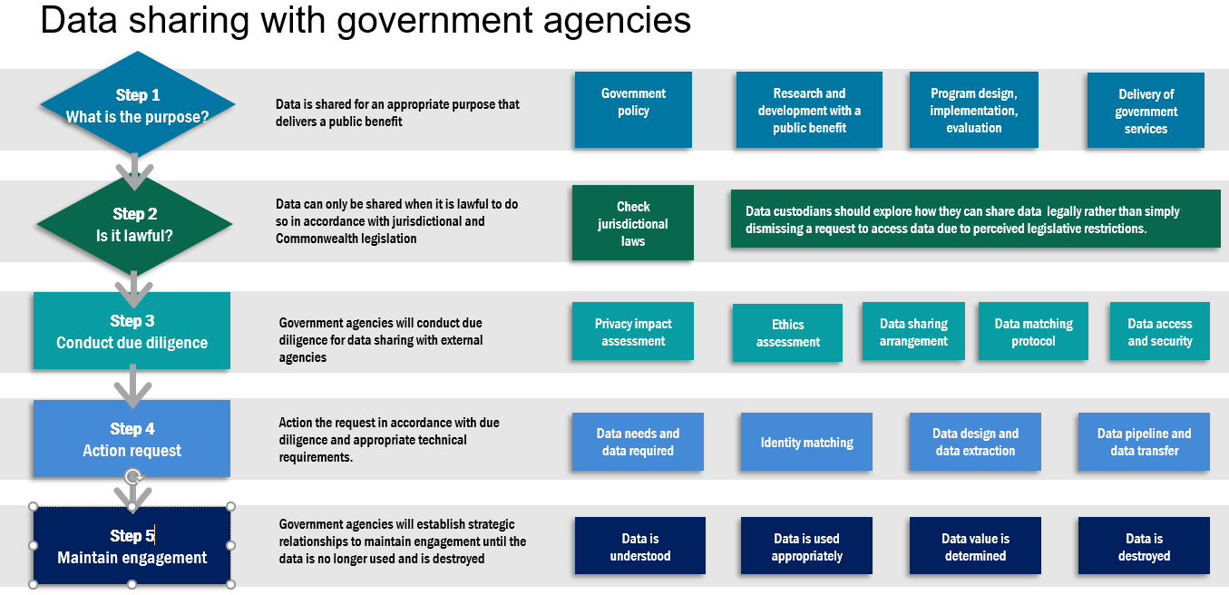

1. DAMA Guide to the Data Management Body of Knowledge