# Commentary on the Consolidated Financial Statements

## Introduction

The 2019-20 Consolidated Financial Statements (CFS) for the  
 Australian Government present the whole of government and general government sector (GGS) financial reports and are prepared in accordance with AASB 1049 *Whole of Government and General Government Sector Financial Reporting* (AASB 1049). They are required by section 48 of the *Public Governance, Performance and Accountability Act 2013* (PGPA Act).

The CFS includes the consolidated results for all Australian Government controlled entities as well as disaggregated information on the sectors of government (GGS, public non‑financial corporations (PNFC) and public financial corporations (PFC))[1]. Unless explicitly stated, the financial results reported in this commentary comprise consolidated amounts for the Australian Government as a whole, inclusive of the GGS and PNFC and PFC sectors[2]. The GGS results in the 2019-20 CFS materially align with the 2019-20 Final Budget Outcome.

At a glance

Table 1: Financial results for the year ended 30 June 2020



1. Net operating balance equals total revenue minus total expenses.
2. Fiscal balance (or net lending/borrowing) is the net operating balance less net capital investment.
3. Net worth is calculated as total assets minus total liabilities.

#### Operating statement (net operating balance)

Table 2: Operating statement



Chart 1: Operating statement (per cent of GDP) since 2010-11

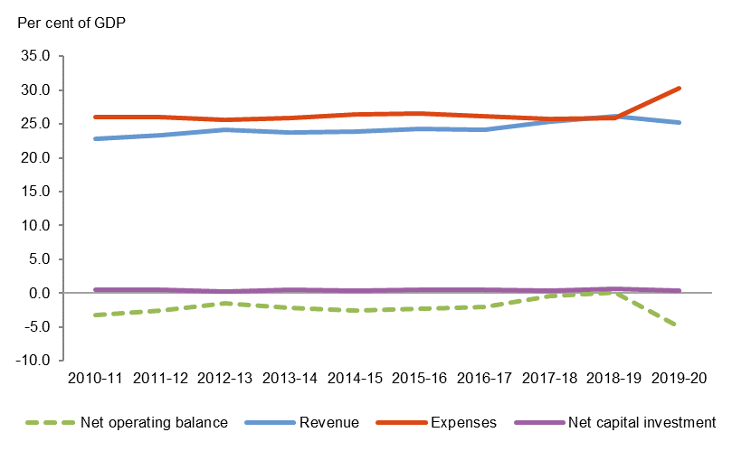

#### Balance sheet (net worth)

Table 3: Balance sheet



1. Net financial worth equals total financial assets minus total liabilities.
2. Net debt equals the sum of the deposits held, government securities, loans and other borrowing, minus the sum of the cash and deposits, advances paid and investments, loans and placements.

Chart 2: Balance sheet (per cent of GDP) since 2010-11

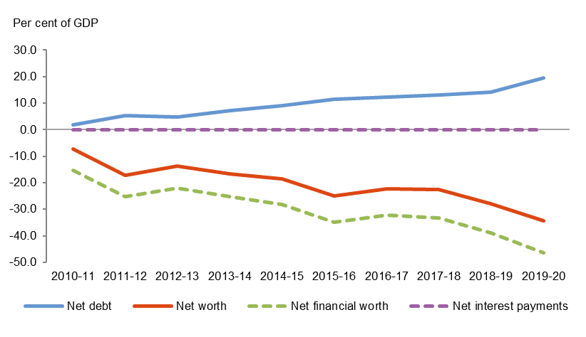

## Discussion and Analysis

### Net operating balance

The Australian Government’s net operating balance was a deficit of $99.7 billion for the year ended 30 June 2020, a deterioration of $102.9 billion against the 30 June 2019 result. The change in the net operating balance reflects the significant impact of the global COVID-19 pandemic and the scale of the Government’s economic response to support the Australian economy.

The COVID-19 pandemic has caused severe contractions in economic activity, resulting in lower taxation revenue and higher unemployment benefit payments.

As part of the Government’s response to COVID-19, economic support was provided to assist households and help businesses continue to operate through the economic downturn. This included the establishment of the time limited Coronavirus Supplement for income support recipients and the provision of the first $750 Economic Support Payment to pensioners and eligible recipients to manage the economic impact of COVID‑19. The Government also introduced the JobKeeper Payment to help businesses significantly impacted by COVID‑19 to cover the costs of their employees’ wages and provided temporary tax-free cash flow boosts to support eligible small and medium-sized businesses and not‑for‑profit organisations.

Table 4: Operating statement



Chart 3 below shows the composition of the Australian Government’s net operating balance since 2010-11.

Chart 3: Operating statement since 2010-11

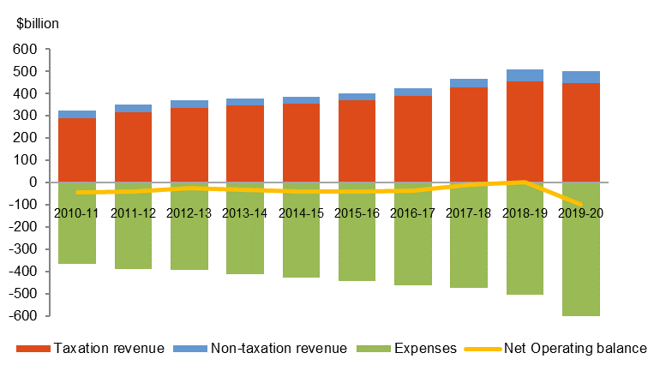

#### Revenue

The Australian Government’s revenue decreased by $7.5 billion (1.5 per cent) in 2019-20 to $500.3 billion.

Table 5: Revenue



#### Taxation revenue

The Australian Government’s total taxation revenue for the year ended 30 June 2020 was $447.1 billion. The composition of taxation revenue is shown in Chart 4 below.

Chart 4: Composition of taxation revenue

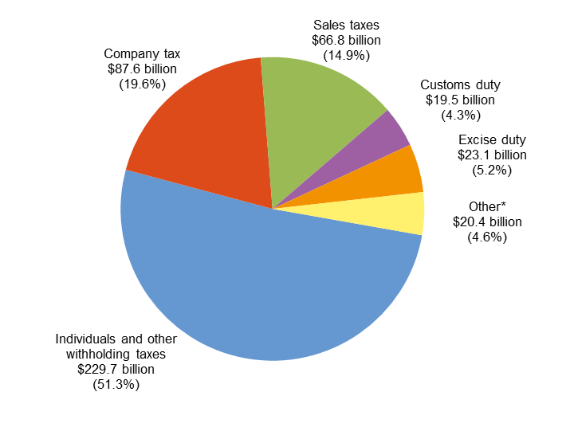

* Other includes: Other indirect taxation ($8.9 billion); Superannuation funds taxes ($6.6 billion); Fringe benefits tax ($3.9 billion); and Resource rent taxes ($0.9 billion).

Taxation revenue decreased by $8.8 billion (1.9 per cent) in comparison to 2018‑19. This is primarily a result of the impacts of the COVID-19 pandemic, driven by a decrease of $6.9 billion in company tax and a $4.3 billion decrease in superannuation fund taxes. This was partially offset by an increase in customs duties of $3.6 billion, particularly through tobacco duty.

Refer to Note 2A of the 2019-20 CFS for further information.

#### Non-taxation revenue

The Australian Government’s total non-taxation revenue for the year ended 30 June 2020 was $53.2 billion. For more information, refer to Notes 2B to 2D of the 2019‑20 CFS.

#### Expenses

The Australian Government’s total expenses for the year ended 30 June 2020 were $600.0 billion. The composition of expenses is shown in Chart 5 below.

Chart 5: Composition of expenses

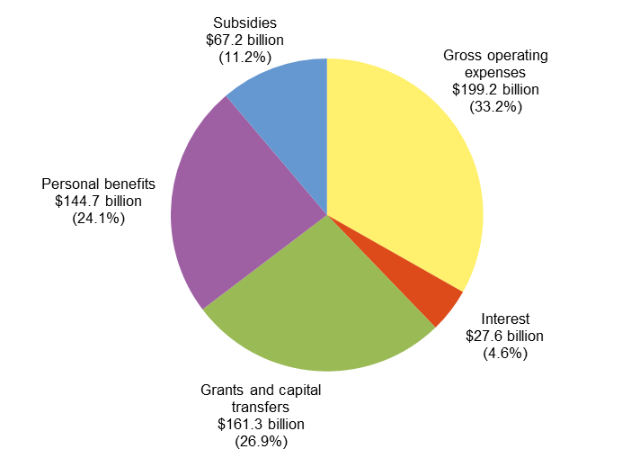

The Australian Government’s total expenses increased by $95.4 billion (18.9 per cent) in comparison to 2018-19. The key changes were:

* an increase in **subsidy expenses** of $55.9 billion, primarily reflecting JobKeeper Payments and the temporary tax-free cash flow boosts to support businesses as part of the Government’s economic response to the COVID‑19 pandemic ($55.2 billion);
* an increase in **personal benefits** of $19.4 billion, primarily reflecting the time limited Coronavirus Supplement and the first payment of the Economic Support Payment to assist households as part of the Government’s economic response to the COVID-19 pandemic, together with changes in recipient numbers and average payment rates of social welfare payments as a result of the impact of COVID-19 on the economy ($18.4 billion);
* an increase in **gross operating expenses** of $19.3 billion, driven by:
  + an increase in benefits to households in goods and services of $10.6 billion, primarily relating to an increase in participants under the National Disability Insurance Scheme ($6.6 billion) and increased spending in aged care, medical and pharmaceutical benefits ($3.0 billion);
  + an increase in depreciation and amortisation of $3.7 billion, largely due to the implementation of AASB 16 *Leases*; and
  + an increase in superannuation expense of $3.2 billion relating to the current employee service costs, which is calculated with reference to the valuation discount rate at the start of the reporting period.

Chart 6 below provides a presentation of total expenses based on how the Australian Government allocated resources across the range of policy areas. The chart highlights the relative cost of each function for 2019-20.

Chart 6: Total expenses by function

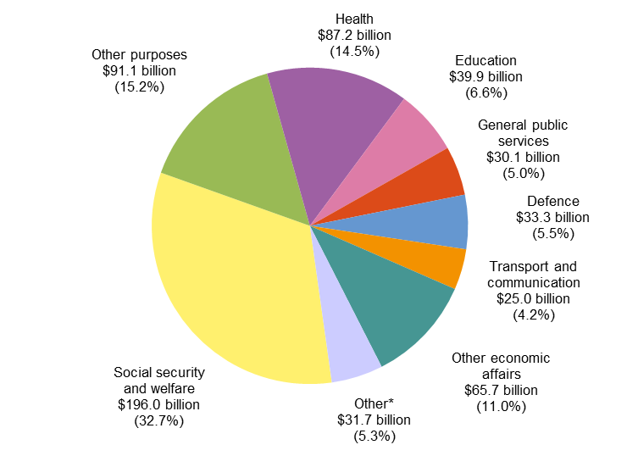

* Other includes: Fuel and energy ($10.6 billion); Public order and safety ($6.2 billion); Housing and community amenities ($5.4 billion); Recreation and culture ($4.0 billion); Mining, manufacturing and construction ($2.9 billion); and Agriculture, forestry and fishing ($2.6 billion).

Refer to Note 3 of the 2019-20 CFS for further information on expenses.

#### Net worth

The Australian Government’s net worth declined by $134.7 billion in 2019-20 to a negative net worth of $679.9 billion as at 30 June 2020.

Table 6: Balance sheet



Chart 7 below shows the composition of the Australian Government’s financial position since 2009-10.

Chart 7: Balance sheet since 2010-11



#### Assets

The Australian Government’s total assets as at 30 June 2020 were $838.6 billion.

Table 7: Assets



The Australian Government’s total assets increased by $101.3 billion (13.7 per cent) since 30 June 2019. The composition of assets is shown in Chart 8 below.

Chart 8: Composition of assets

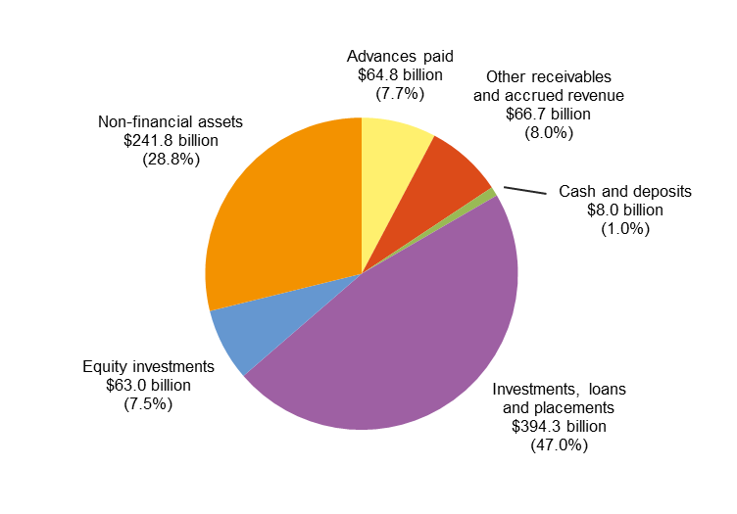

The key changes in **financial assets** were:

* an increase in **investments, loans and placements** of $60.8 billion, primarily driven by the increase in government securities held by the Reserve Bank of Australia from purchases in the secondary market, conducted as part of a range of monetary policy measures to lower funding costs across the economy in response to the COVID-19 pandemic ($57.2 billion); and
* an increase in **other receivables and accrued revenue** of $13.5 billion, primarily driven by an increase in net tax receivables relating to payment deferrals granted to taxpayers experiencing financial hardship as a result of the COVID-19 pandemic ($8.3 billion) and an increase in other receivables in respect of the advances that were paid to the states for GST during 2019-20 ($4.7 billion).

The key changes to **non-financial assets** were:

* an increase in **buildings** and **other plant, equipment and** **infrastructure** of $24.1 billion, reflecting the impact of the implementation of AASB 16 *Leases*;
* an increase in **specialist military equipment** of $5.1 billion, primarily as a result of additions and revaluation adjustments; and
* an increase in **inventories** of $1.0 billion, driven by the purchase of personal protective equipment and pharmaceuticals for the National Medical Stockpile as part of the Government’s response to the COVID-19 pandemic.

Note 5 of the 2019-20 CFS provides further information on assets.

#### Liabilities

The Australian Government’s total liabilities were $1,518.5 billion as at 30 June 2020.

Table 8: Liabilities



The Australian Government’s liabilities increased by $236.0 billion (18.4 per cent) since 30 June 2019. The composition of liabilities is shown in Chart 9 below.

**Chart 9: Composition of liabilities**

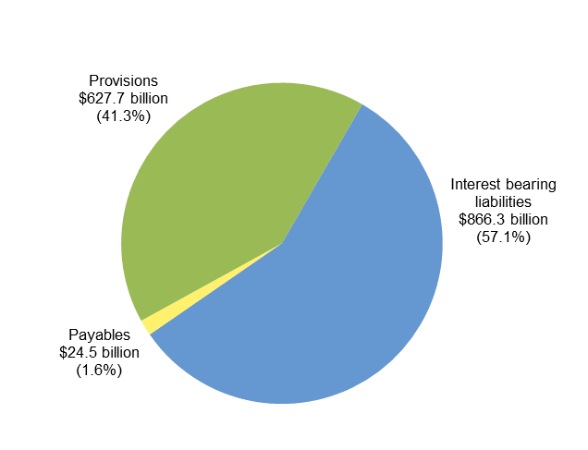

The increase of $177.2 billion in **interest bearing liabilities** is primarily due to:

* an increase in Australian Government Securities of $106.6 billion, primarily reflecting the Government’s increased borrowing requirements stemming from the response to, and impacts of, the COVID-19 pandemic;
* an increase in deposits held of $44.9 billion, primarily reflecting the increase in balances held in Exchange Settlement accounts, as a result of the enhanced liquidity operations of the Reserve Bank of Australia in response to the COVID‑19 pandemic ($44.0 billion); and
* an increase in leaseliabilities of $22.3 billion, reflecting the impact of the implementation of AASB 16 *Leases*.

The increase in **provision and payables** of $58.8 billion was driven by:

* an increase in provisions of $19.6 billion for JobKeeper and cash flow boost payments to businesses as part of the Government’s economic response to the COVID-19 pandemic;
* an increase in the superannuation liability of $15.0 billion, in part due to the change in actuarial revaluation for a decrease in the long-term discount rates;
* an increase to the actuarial revaluation of other employee liabilities and other provisions relating to military compensation of $10.8 billion; and
* an increase in Australian currency on issue of $10.1 billion.

Note 6 of the 2019-20 CFS provides further information on liabilities.

#### Cash flows

The Australian Government’s cash balance was $8.0 billion at 30 June 2020. For the year ended 30 June 2020, the Australian Government recorded a cash deficit of $87.5 billion compared to a cash deficit of $0.5 billion for 2018-19.

Table 9: Cash flows



#### Receipts and payments

The following charts provide a detailed breakdown of Australian Government receipts and payments for 2019-20, showing the relative composition of each dollar received and paid.

Chart 10: Composition of each dollar of cash received in 2019-20

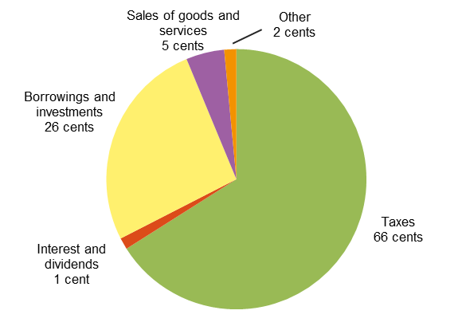

Chart 11: Composition of each dollar of cash paid in 2019-20

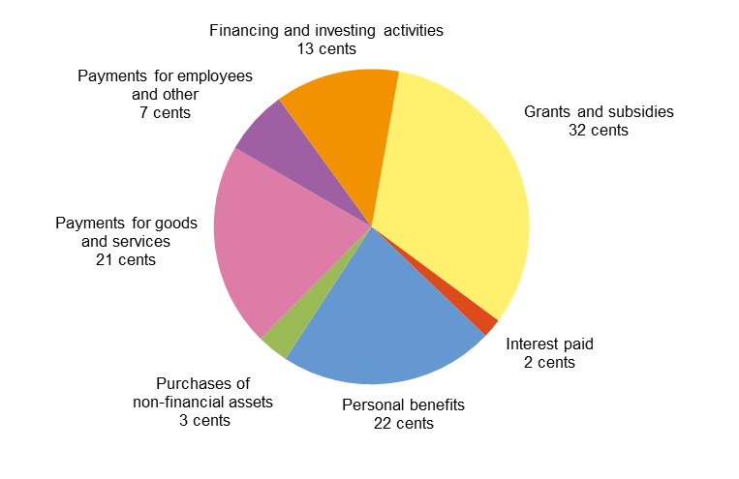

Chart 12 provides the trend of the Australian Government’s receipts and payments for operating activities and the sales and purchases of non-financial assets since 2010-11.

Chart 12: Receipts and payments – operating and non-financial assets

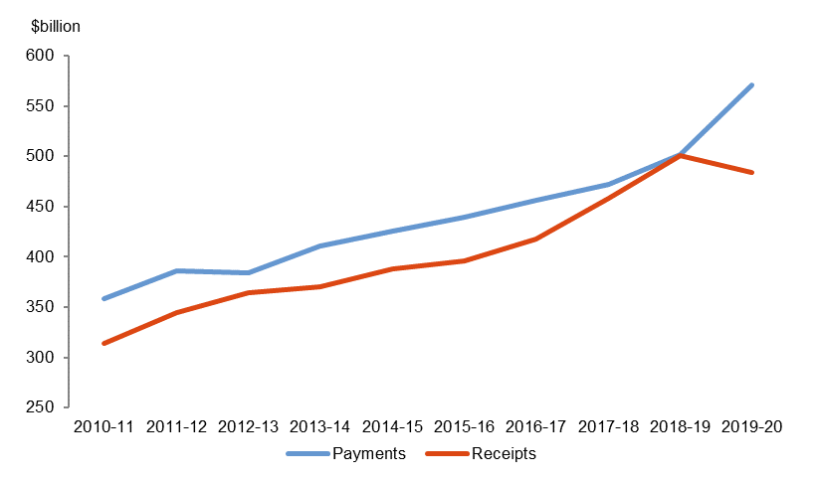

APPENDIX A

Previous years

The CFS since 1995-96 are available on the Department of Finance website at:   
<http://www.finance.gov.au/publications/commonwealth-consolidated-financial-statements>.

The historical series datasets are available in electronic format at:   
<http://data.gov.au/dataset/australian-government-consolidated-financial-statements-tables-and-data>.

Links to other publications

The Australian Government publishes a range of information about its projected and actual financial position. Links to some of these documents are set out below. The information in the following documents has been prepared for different purposes and therefore does not form part of the CFS. Further, the documents listed below are not subject to audit.

#### 2019-20 Final Budget Outcome

The 2019-20 Final Budget Outcome (FBO) was prepared in a manner consistent with the *Charter of Budget Honesty Act 1998* (the Charter). The Charter requires that the Government provide the FBO no later than three months after the end of the financial year. Consistent with these requirements, the FBO encompasses Australian Government GGS fiscal outcomes for the 2019-20 financial year and is based on external reporting standards.

The 2019-20 FBO was released on the 25 September 2020 and is available on the Australian Government website at:

https://www.budget.gov.au/2019-20/content/fbo/.

#### Australian Government Monthly Financial Statements

The Australian Government GGS monthly financial statements (MFS) are prepared on a basis consistent with the Budget as required under section 47 of the PGPA Act. The statements are prepared in accordance with AASB 1049.

The Australian Government GGS MFS are available on the website of the Minister for Finance as well as the Department of Finance website:

https://www.finance.gov.au/publications/commonwealth-monthly-financial-statements/ and http://www.financeminister.gov.au/media-releases/2020.

The historical series datasets are available in electronic format at: <http://data.gov.au/dataset/australian-government-general-government-sector-monthly-financial-statements-tables-and-data>.

.

#### Budget Strategy and Outlook and Mid-Year Economic and Fiscal Outlook

The Budget Strategy and Outlook — Budget Paper No.1 — 2019-20, the Mid-Year Economic and Fiscal Outlook 2019-20 and the Budget Strategy and Outlook — Budget Paper No.1 — 2020-21 have been prepared in accordance with the Charter.

These Budget papers and the July 2020 Economic and Fiscal Update are available on the Australian Government website at http://www.budget.gov.au/.

#### Tax Benchmarks and Variations Statement 2019

The Tax Benchmarks and Variations Statement provides details of concessions, benefits, incentives and charges provided through the tax system (tax expenditures) to taxpayers by the Australian Government. Information is published on the Treasury website at:

http://treasury.gov.au/publication/p2020-51153/.

1. The institutional structure of the public sector is explained in Note 1 of the 2019-20 CFS.   
   Note 14 of the 2019-20 CFS provides the list of Australian Government controlled reporting entities, including their sectoral classification.
2. The balances and movements detailed in the commentary have been rounded to the nearest tenth of a billion. Discrepancies between totals and sums of components are due to rounding.

   3 The 2018-19 comparatives include restatements. Refer to Note 1.5 of the 2019-20 CFS for further information.