Australian Government

Grants News – July 2018 Edition

***Great News!***

***Three grants related Resource Management Guides have been updated, and are now available on the Department of Finance website!***

The Department of Finance in consultation with 20 non-corporate Commonwealth entities have reviewed and revised the following grants related Resource Management Guides (RMGs):

* [***Resource Management Guide No. 411: Grants, Procurements and Other Financial Arrangements***](https://www.finance.gov.au/sites/default/files/rmg_411_0.pdf)
* ***[Resource Management Guide No. 412: Australian Government Grants – Briefing, Reporting, Evaluating and Election Commitments](https://www.finance.gov.au/sites/default/files/resource-management-guide-no-412.pdf)***
* [***Resource Management Guide No. 421: Publishing and Reporting Grants and GrantConnect***](https://www.finance.gov.au/sites/default/files/rmg421-grantconnect-publishing-grants.pdf)

The updated RMGs reflects best practice grants administration under the [*Commonwealth Grants Rules and Guidelines 2017* (CGRGs)](https://www.finance.gov.au/sites/default/files/commonwealth-grants-rules-and-guidelines.pdf).

The guides are designed to assist officials to operate in the Australian Government’s resource management framework by providing guidance on how officials can best implement the requirements under the CGRGs.

The RMGs are available from the Finance website at: <https://www.finance.gov.au/resource-management/grants/additional-guidance/>.

**For more information email:** [**grants@finance.gov.au**](mailto:grants@finance.gov.au)

***This July edition of Grants News provides a number of interesting articles on:***

* *GrantConnect;*
* *The Streamlining Government Grants Administration Program and Grants Hubs;*
* *Whole-of-government Grant Tools; and*
* *Grant-making charities;*

**GrantConnect –**

**the ‘GO-to’ place for grants**

GrantConnect has been the single point of discovery for all Australian Government Grant Opportunities since 30 April 2017, and Grants Awarded information since 31 December 2017.

During this time, entities and applicants have been making the most of the information available on GrantConnect. Some interesting statistics to date are:

* 13,500 public - Registered Users, 400 Entity Users
* 511,000 opportunity notifications emails have been sent to Registered Users
* 42 Forecast Opportunities published (28 linked to Grant Opportunities)
* 312 Grant Opportunities published with 23,000 downloads of grant guidelines
* Approx. 7,100 Grants Awards published with a total value $2.3 billion.

The next phase of the project will provide secure application submission. More information will become available once testing activities and acceptance is finalised.

**For more information about GrantConnect, visit** [**www.grants.gov.au**](http://www.grants.gov.au) **or watch the informational video on** [**YouTube**](https://www.youtube.com/watch?v=XttF5BL1D7c)**.**

**Streamlining Government Grants Administration (SGGA)**

The SGGA initiative, led by the Department of Finance, is part of the Government’s vision to drive a smarter and more productive public sector.

For 14 participating entities, grants administration is being consolidated into two specialist grants hubs - the Business Grants Hub and Community Grants Hub. This standardised and streamlined approach to the administration of government grants is a key part of the SGGA Program.

Changing the public service approach to grants delivery, improving discoverability and delivering effective digital solutions, will reduce red tape for grant applicants and provide the Government with accurate and helpful data.

**It’s all happening in the Hubs!**

**Since 1 July 2016, the** [**Community Grants Hub**](https://www.communitygrants.gov.au/) **(CGH) has been busy transitioning, designing and delivering Australian Government grants programs.**

The CGH now delivers end-to-end grants administration to over 21,000 community grants across government worth about $7.8 billion in grant recipient payments.

**Two new Hub digital platforms** will improve the grant experience for CGH’s client agencies and recipients – **a Grant Recipient Portal and a Hub Portal.**

The **Grant Recipient Portal** will provide a single entry point for grants management and administration, eliminating the need for grant recipients to access multiple agency websites to meet grant agreement conditions.

The **Hub Portal** is an online system for client agencies to self-manage their business transactions with the Hub. It includes reporting, templates, contact information, performance management and financial management processes.

For more information on any of the Hub’s new developments, email Hub Communications at [communications@communitygrants.gov.au](mailto:communications@communitygrants.gov.au).

**The Department of Industry, Innovation and Science, has been the government’s chief conduit to business for more than 20 years, delivering over 200 programs worth more than $20 billion to Australian businesses and customers.**

Building on the department’s strong history of program delivery, the [Business Grants Hub](https://www.business.gov.au/for-government/business-grants-hub) (BGH) was established on 1 July 2016 under the Streamlining Government Grants Administration Program for design and delivery of of grants.

Since then, the BGH has launched over 65 grant opportunities worth in excess of $1.5 billion, across 32 programs, for eight government entities.

Over time, the BGH has evolved to better meet the needs of our policy partners and build on lessons learned, as more programs come through the Hub.

To meet the government’s renewed focus on streamlining and simplifying the administration of grants through the Budget Process Operational Rules and grants policy guidance from the Department of Finance, the BGH has also updated their service offering to better simplify and streamline the administration of grants.

**The new service offering was launched in January 2018.**

To achieve an improved experience for grant applicants and recipients, lower the delivery costs and provide greater visibility of programs to government, the BGH provide a standard service offering.

To allow some configurability, services are outlined across three levels of complexity: simple, moderate and complex.

Some services may be restricted depending on the complexity of the program.

**For more information on the BGH and their services, email:** [**engage@industry.gov.au**](mailto:engage@industry.gov.au)**.**

**Whole of Government Grants Tools Update**

**The Department of Finance (Finance) has developed a suite of whole-of-government standardised grant templates in consultation with entities, in particular for grant opportunity guidelines and grant agreements.**

Commonwealth entities tested the grant guidelines templates with stakeholders for six months in 2017, and provided their feedback to Finance. Following the success of the pilot, entities have endorsed the guidelines templates. In the coming months, Finance will take the endorsed guidelines templates suite to Government for consideration.

Entities are currently testing a suite of Grant Agreement templates, which consist of a letter of agreement; simple grant agreement (previously the low-risk grant agreement template); standard grant agreement with clause bank; and a letter and deed of variations templates.

Finance has been holding focus group meetings with entities to discuss how the templates are working and whether any significant issues have arisen. Entities have received some favourable feedback on both the grant guidelines and grant agreement templates from their non-government stakeholders.

The templates seek to improve and streamline grant guidelines and grant agreements across Commonwealth entities for grant recipients, and make it easier and more efficient for grant recipients to engage with the Commonwealth.

**For more information about the templates, contact the Grants Policy team at the Department of Finance:** [**grants@finance.gov.au**](mailto:grants@finance.gov.au)

**Reminder! It’s almost time for government entities to lodge their first Taxable payments annual reports** **for the 2017-18 financial year.**

The Taxable payments annual report is due by 28 August 2018. Visit the ATO website for more information: [**www.ato.gov.au/tpargov**](http://www.ato.gov.au/tpargov)

**The ACNC - Grant-making charities provide billions in grants and donations**

Grant-making charities provide more than $4 billion annually in grants and donations, and hold more than $56 billion in assets, according to new research by the Australian Charities and Not-for-profits Commission (ACNC).

*Australia’s Grant-making Charities in 2016*, a sub-report of the Australian Charities Report, examined the activities of over 10,000 grant-making charities in 2016.

The research found these charities had a combined total revenue of $16.5 billion in 2016 and employed more than 100,000 people. However, more than 80 per cent of grant-making charities operated with no paid staff, and were supported by over 300,000 volunteers.

The research also found that more than 37 per cent of funding was distributed to organisations through public or open processes, and 14 per cent of grants were issued to rural and regional recipients.

The sub-report was produced by the ACNC in partnership with the Centre for Social Impact and the Social Policy Research Centre at the University of New South Wales.

**The Australia’s Grant-making Charities in 2016 sub-report, and the full report, are available to download on the Australian Charities Report microsite:** [**australiancharities.acnc.gov.au.**](http://australiancharities.acnc.gov.au/download/special-interest-reports/)**.**

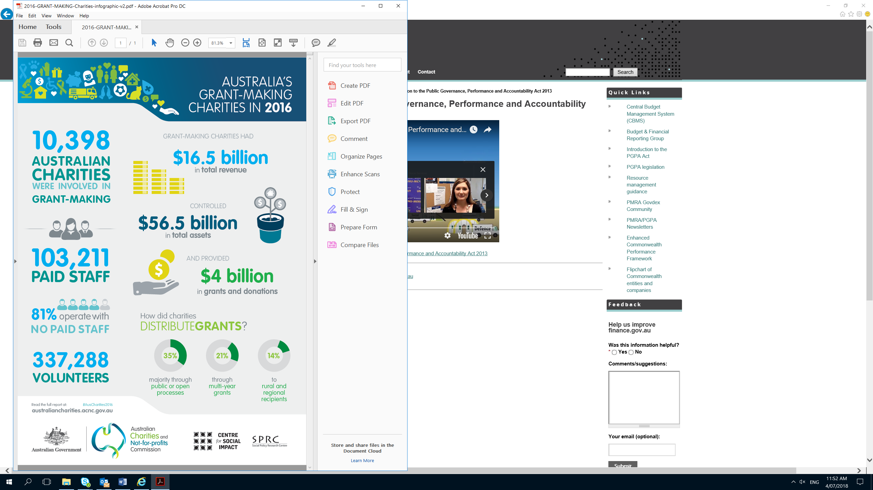

### Subscribe to Grants News: <http://www.finance.gov.au/financial-framework/financial-management-policy-guidance/grants/news.htm>

### Submit an article: [grants@finance.gov.au](mailto:grants@finance.gov.au)