**Commentary on the  
consolidated financial statements**

**Introduction**

The 2017-18 Consolidated Financial Statements (CFS) for the Australian Government present the whole of government and general government sector (GGS) financial reports and are prepared in accordance with AASB 1049 *Whole of Government and General Government Sector Financial Reporting* (AASB 1049). They are required by section 48 of the *Public Governance, Performance and Accountability Act 2013* (PGPA Act).

The CFS includes the consolidated results for all Australian Government controlled entities as well as disaggregated information on the sectors of government (GGS, public non‑financial corporations (PNFC) and public financial corporations (PFC))[1]. Unless explicitly stated, the financial results reported in this commentary comprise consolidated amounts for the Australian Government as a whole, inclusive of the GGS, and PNFC and PFC sectors[2]. The GGS results in the 2017-18 CFS materially align with the 2017-18 Final Budget Outcome.

**At a glance**

**Table 1: Financial results for the year ended 30 June 2018[3]**

|  |  |  |  |
| --- | --- | --- | --- |
|  | 2017-18 $b | 2016-17 $b | Change $b |
| Revenue | 467.9 | 425.2 | 42.7 |
| Expenses | 476.2 | 462.1 | 14.2 |
| **Net operating balance(a)** | **(8.4)** | **(36.9)** | **28.5** |
| Per cent of GDP | 0.5 | 2.1 |  |
| Net capital investment | 6.7 | 8.7 | (2.0) |
| **Fiscal balance(b)** | **(15.1)** | **(45.6)** | **30.5** |
| Per cent of GDP | 0.8 | 2.6 |  |
| Total assets | 688.9 | 642.6 | 46.3 |
| Total liabilities | 1,106.6 | 1,034.3 | 72.3 |
| **Net worth(c)** | **(417.8)** | **(391.7)** | **(26.0)** |
| Per cent of GDP | 22.7 | 22.3 |  |
| Net cash flows from operating activities | 4.4 | (23.9) | 28.3 |
| Net cash flows from investments in non-financial assets | (18.2) | (15.0) | (3.2) |
| **Cash surplus/(deficit)** | **(13.7)** | **(38.9)** | **25.1** |

1. Net operating balance equals total revenue minus total expenses.
2. Fiscal balance (or net lending/borrowing) is the net operating balance less net capital investment.
3. Net worth is calculated as total assets minus total liabilities.

**Operating statement (net operating balance)**

**Table 2: Operating statement**



Chart 1: Operating statement (per cent of GDP) since 2007-08

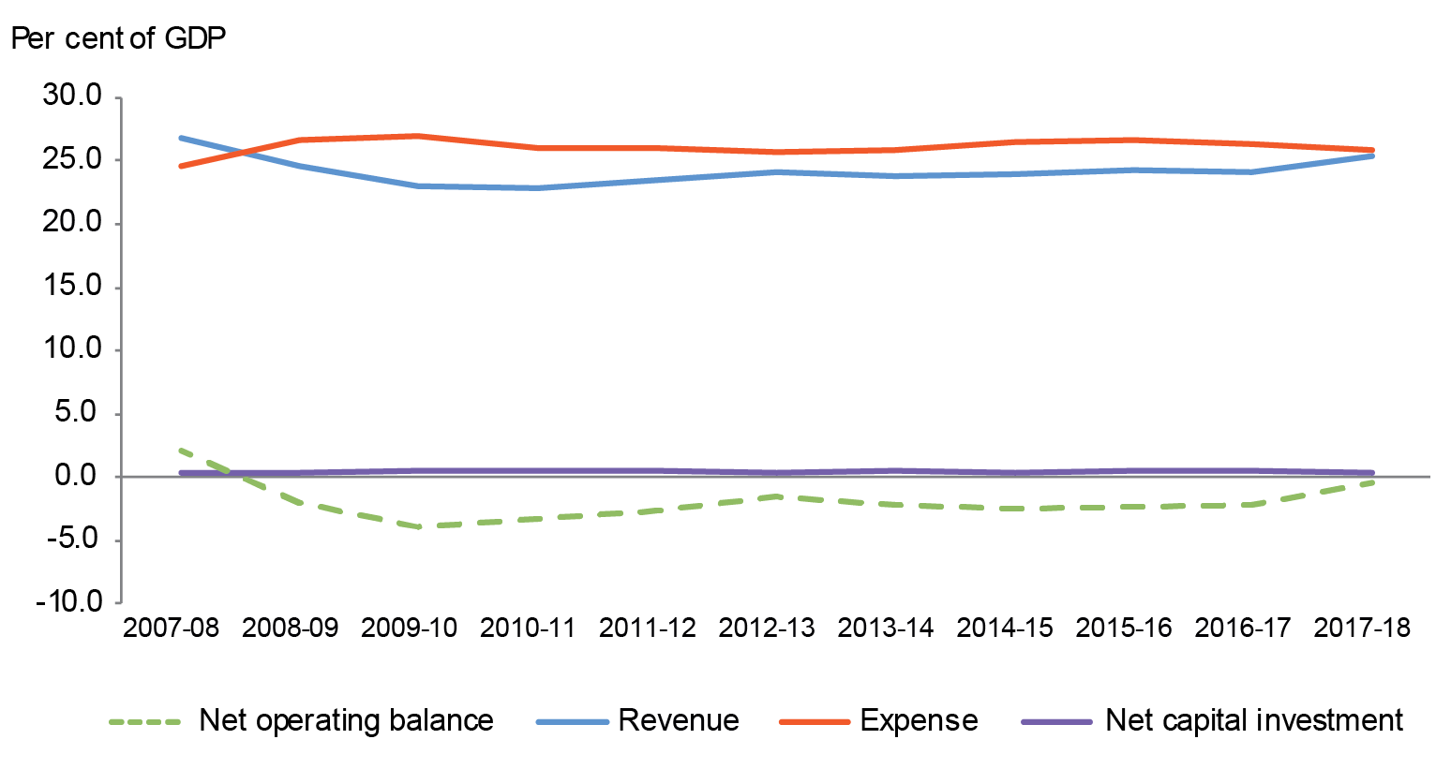

**Balance sheet (net worth)**

**Table 3: Balance sheet**



1. Net financial worth equals total financial assets minus total liabilities.
2. Net debt equals the sum of the deposits held, government securities, loans and other borrowing, minus the sum of the cash and deposits, advances paid and investments, loans and placements.

**Chart 2: Balance sheet (per cent of GDP) since 2007-08**

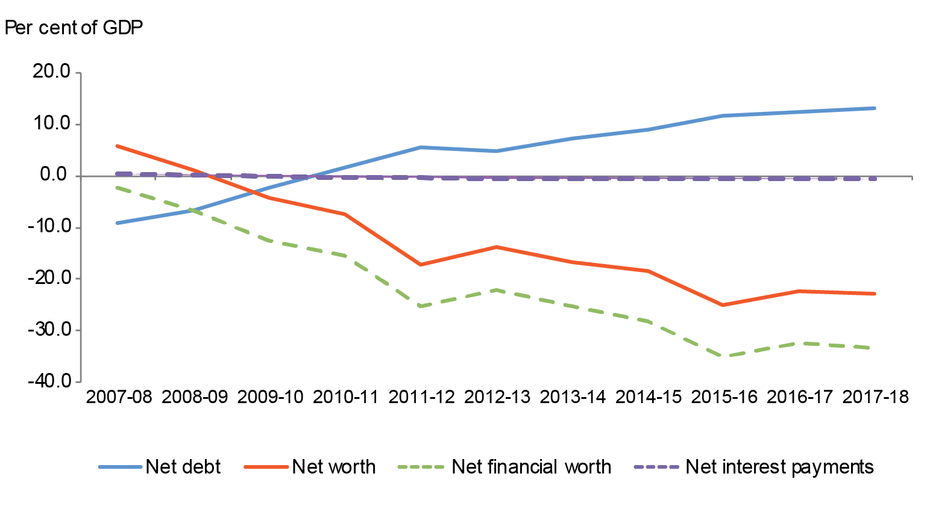

**Discussion and analysis**

**Net operating balance**

The Australian Government’s net operating balance was a deficit of $8.4 billion for the year ended 30 June 2018, an improvement of $28.5 billion (77.3 per cent) against the 30 June 2017 result.

Table 4: Operating statement



Chart 3 below shows the composition of the Australian Government’s net operating balance since 2007-08.

Chart 3: Operating statement since 2007-08

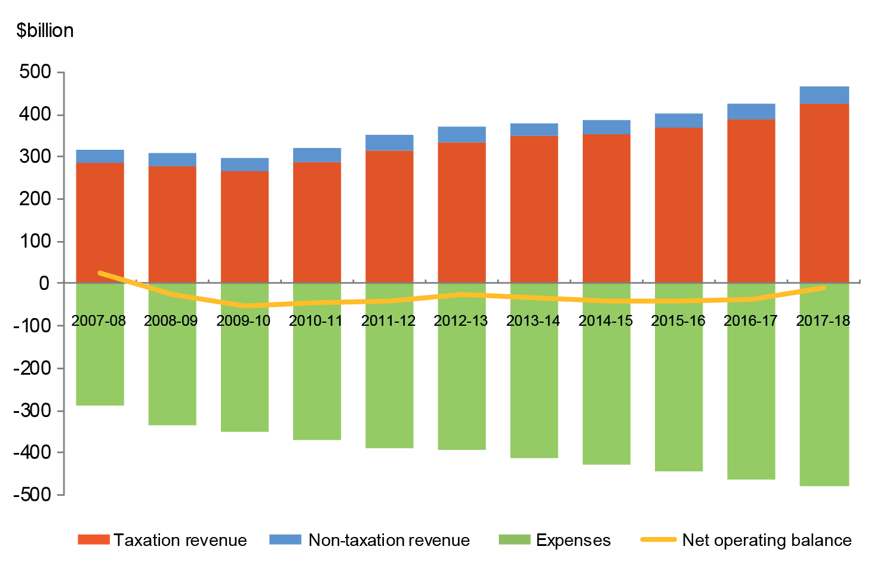

**Revenue**

The Australian Government’s revenue increased by $42.7 billion (10.0 per cent) in   
2017-18 to $467.9 billion.

**Table 5: Revenue[4]**

**Taxation revenue**

The Australian Government’s total taxation revenue for the year ended 30 June 2018 was $427.2 billion. The composition of taxation revenue is shown in Chart 4 below.

Chart 4: Composition of taxation revenue

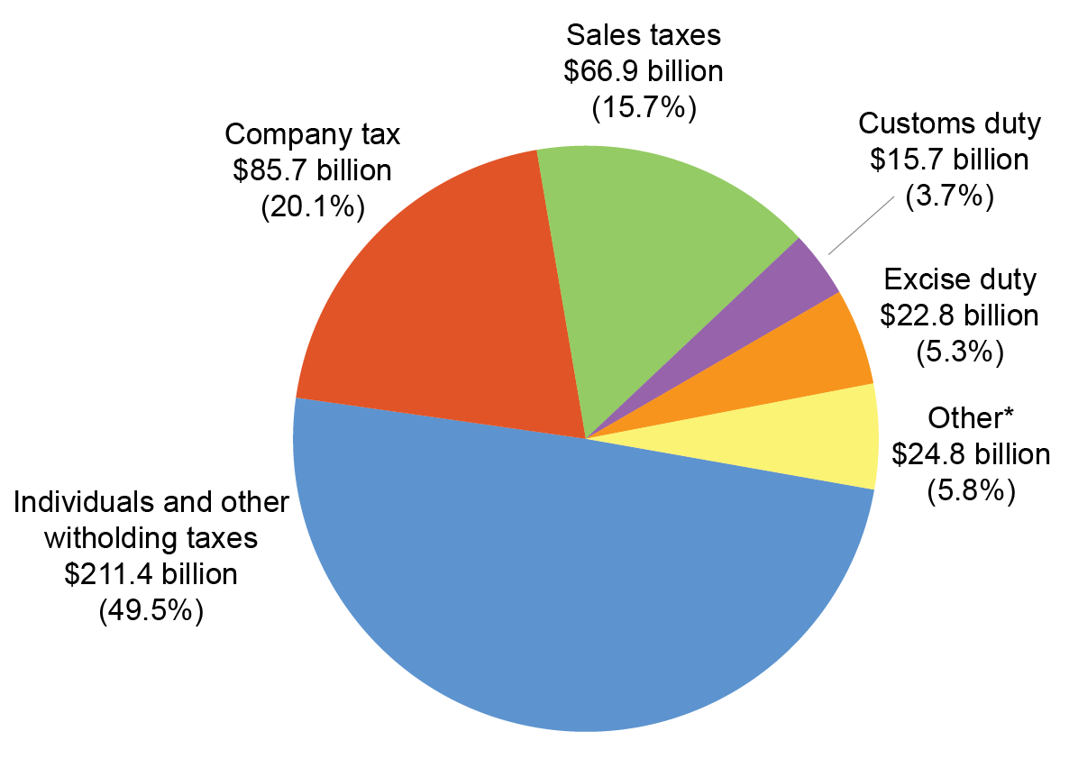

* Other includes: Superannuation fund taxes ($10.9 billion); Other indirect taxation ($9.1 billion);  
 Fringe benefits tax ($3.8 billion); and Resource rent taxes ($1.0 billion).

Taxation revenue increased by $38.9 billion (10.0 per cent) in comparison to 2016-17. The key changes were:

* an increase of $14.9 billion (21.0 per cent) in **company tax** due to stronger corporate profitability and stronger compliance outcomes;
* an increase of $14.0 billion (7.1 per cent) in **individuals and other withholding taxes** consistent with stronger employment growth;
* an increase of $2.7 billion (4.2 per cent) in **sales taxes** predominantly attributable to the goods and services tax (GST). The increase in GST is consistent with growth in household consumption;
* an increase of $2.7 billion (32.8 per cent) in **superannuation fund taxes**, mainly due to higher profits from net capital gains;
* an increase of $2.4 billion (36.5 per cent) in **other** **indirect taxes**, primarily as a result of the introduction of the bank levy in the 2017-18 financial year; and
* an increase of $1.5 billion (10.5 per cent) in **customs duty** driven by higher collections for tobacco and alcohol.

Refer to Note 2A of the 2017-18 CFS for further information.

**Non-taxation revenue**

The Australian Government’s total non-taxation revenue for the year ended 30 June 2018 was $40.6 billion. For more information, refer to Notes 2B to 2D of the 2017‑18 CFS.

**Expenses**

The Australian Government’s total expenses for the year ended 30 June 2018 were $476.2 billion. The composition of expenses is shown in Chart 5 below.

**Chart 5: Composition of expenses**

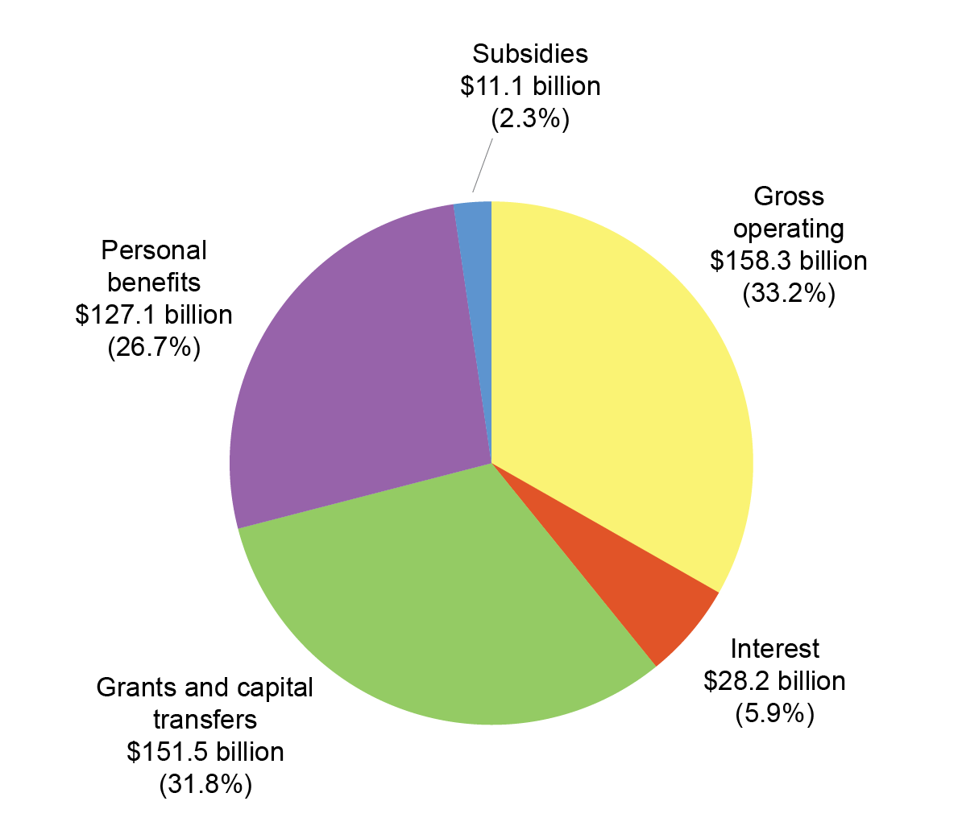

The Australian Government’s total expenses increased by $14.2 billion (3.1 per cent) in comparison to 2016-17. The key changes were:

* an increase in **gross operating expenses** of $6.8 billion (4.5 per cent). This was driven by an increase of $6.8 billion in the supply of goods and services expense, mainly due to:
  + an increase in benefits to households in goods and services of $5.2 billion, primarily relating to the National Disability Insurance Scheme ($3.2 billion), home support and care benefits ($1.2 billion) and medical benefits ($1.1 billion);
  + an increase in the supply of goods and services of $1.4 billion, primarily relating to the National Broadband Network ($0.6 billion);
* an increase of $5.9 billion (4.1 per cent) in **current and capital grants**, primarily as a result of an increase in grants to state and territory governments relating to GST payments ($4.1 billion);
* an increase of $1.4 billion (8.2 per cent) in **interest expense**, reflecting a higher Australian Government Securities balance (in face value terms) compared to last financial year; and
* a decrease of $1.0 billion (0.8 per cent) in **personal benefits expense**, primarily as a result of compliance measures for child care activities.

Chart 6 below provides a presentation of total expenses based on how the Australian Government allocated resources across the range of policy areas. The chart highlights the relative cost of each function for 2017-18.

**Chart 6: Total expenses by function**

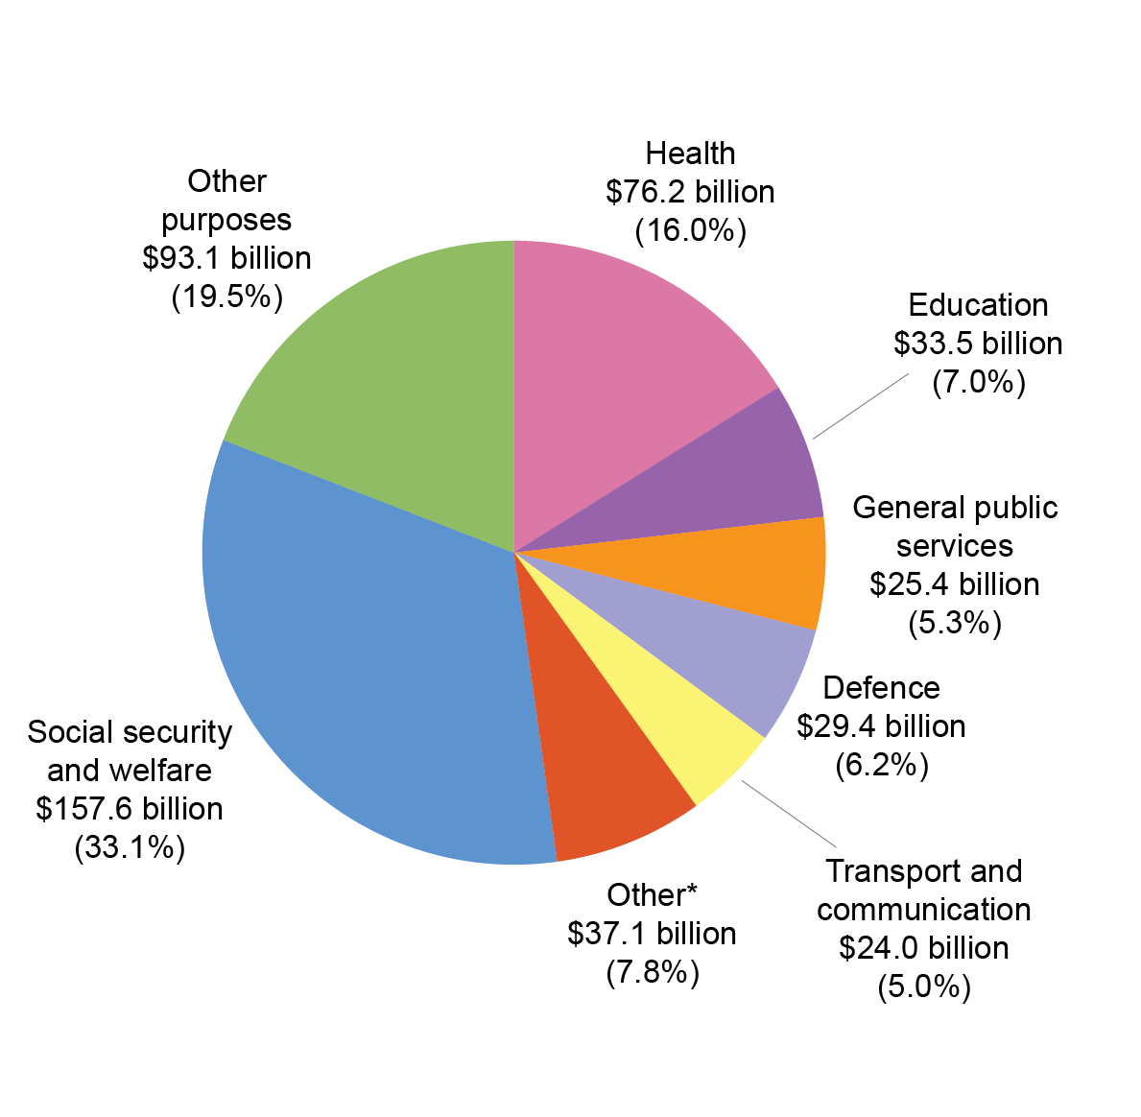

* Other includes: Other economic affairs ($10.0 billion); Fuel and energy ($7.4 billion); Housing   
and community amenities ($5.4 billion); Public order and safety ($5.3 billion); Recreation and   
culture ($3.7 billion); Agriculture, forestry and fishing ($2.6 billion); and Mining, manufacturing and construction ($2.7 billion).

Refer to Note 3 of the 2017-18 CFS for further information on expenses.

**Net worth**

The Australian Government’s net worth declined by $26.0 billion in 2017-18 to a negative net worth of $417.8 billion as at 30 June 2018.

**Table 6: Balance sheet**



Chart 7 below shows the composition of the Australian Government’s financial position since 2007-08.

**Chart 7: Balance sheet since 2007-08**

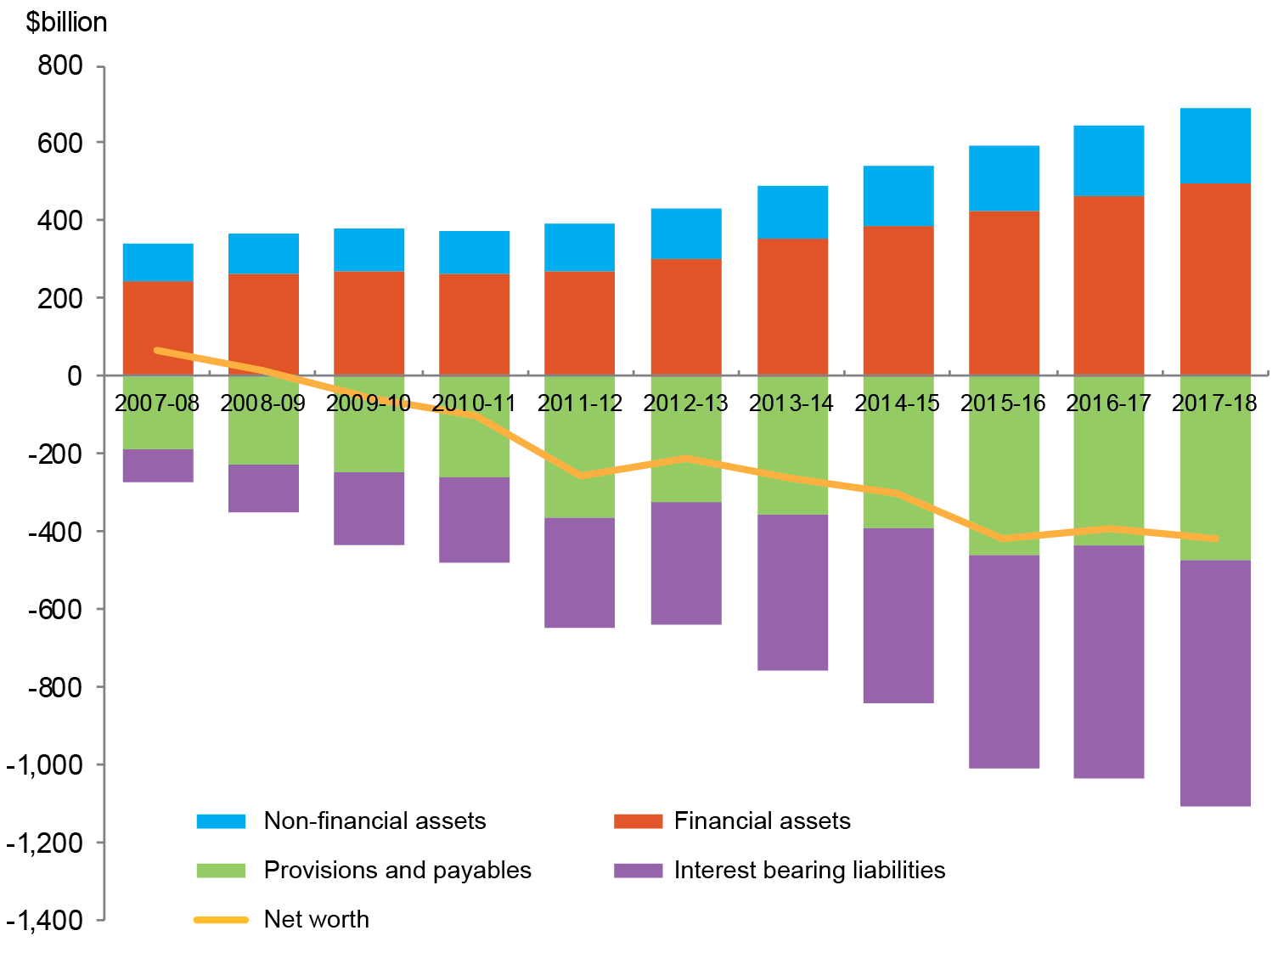

**Assets**

The Australian Government’s total assets as at 30 June 2018 were $688.9 billion. The composition of assets is shown in Chart 8 below.

**Chart 8: Composition of assets**

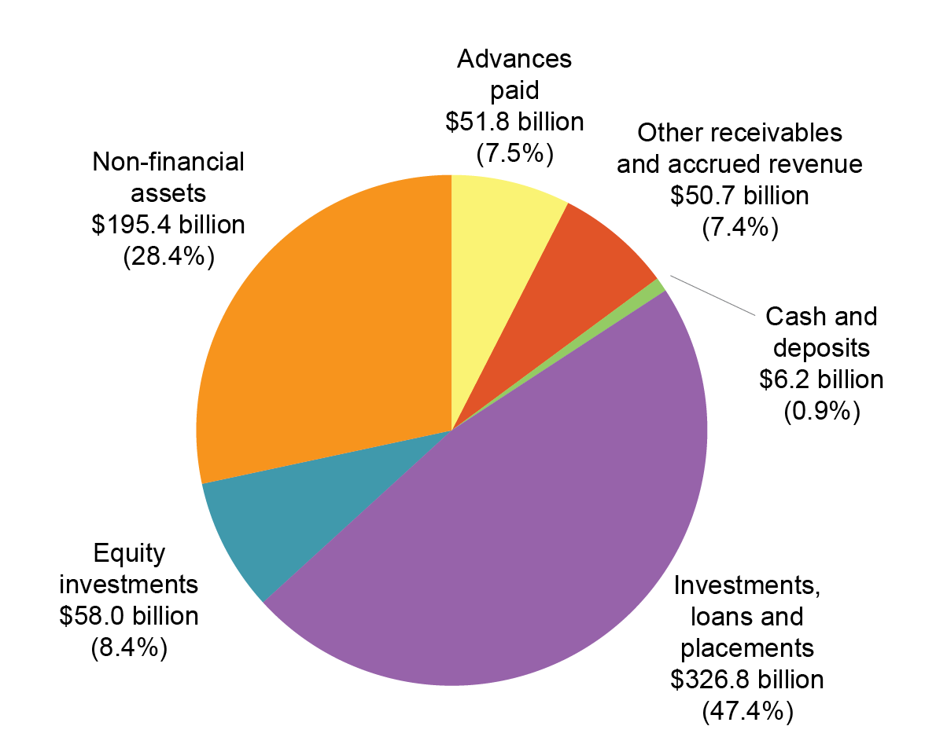

**Table 7: Assets**



The Australian Government’s total assets increased by $46.3 billion (7.2 per cent) since 30 June 2017.

The key changes in **financial assets** were:

* an increase of $11.4 billion in **equity investments**, mainly due to an increase in share investments held by the Future Fund;
* an increase of $5.9 billion in **investments, loans and placements**, primarily consisting of:
  + a $7.2 billion increase in non-equity investments held in Australian Government investment funds;
  + a $3.1 billion increase in non-equity investments held by the Future Fund; partially offset by:
  + a $4.0 billion decrease in foreign exchange holdings held by the Reserve Bank of Australia;
* an increase of $5.7 billion in **advances paid**, mainly due to an increase to the   
  Higher Education Loan Program scheme (HELP) driven by an increase in loans as well as a result of the yield curve movement based on the 2017-18 actuarial assessment;
* an increase of $4.5 billion in **other receivables and accrued revenue**, driven by:
  + an increase in net taxes receivable of $2.7 billion; and
  + an increase in goods, services and other receivables of $1.9 billion, mainly relating to the Pharmaceutical Benefits Scheme (PBS).

The key changes in **non-financial assets** between 30 June 2017 and 30 June 2018 included the following:

* an increase of $12.2 billion for **other plant, equipment and infrastructure**,primarily driven by:
  + an increase of $4.5 billion in network assets for the continued investment in the deployment of the National Broadband Network;
  + initial recognition of $7.0 billion plant, equipment and infrastructure for   
    Snowy Hydro Limited (SHL) as a result of the Australian Government assuming full ownership of the company on 29 June 2018;
* an increase of $4.5 billion for **specialist military equipment** ($3.4 billion) and  
  **land** ($1.1 billion) primarily as a result of additions and upward revaluation adjustments from the Department of Defence; and
* an increase of $1.2 billion for **intangibles**, in part driven by the initial recognition of net assets resulting from the Australian Government’s full acquisition of SHL.

Refer to Note 5 of the 2017-18 CFS for further information on assets.

**Liabilities**

The Australian Government’s total liabilities were $1,106.6 billion as at 30 June 2018. The composition of liabilities is shown in Chart 9 below.

**Chart 9: Composition of liabilities**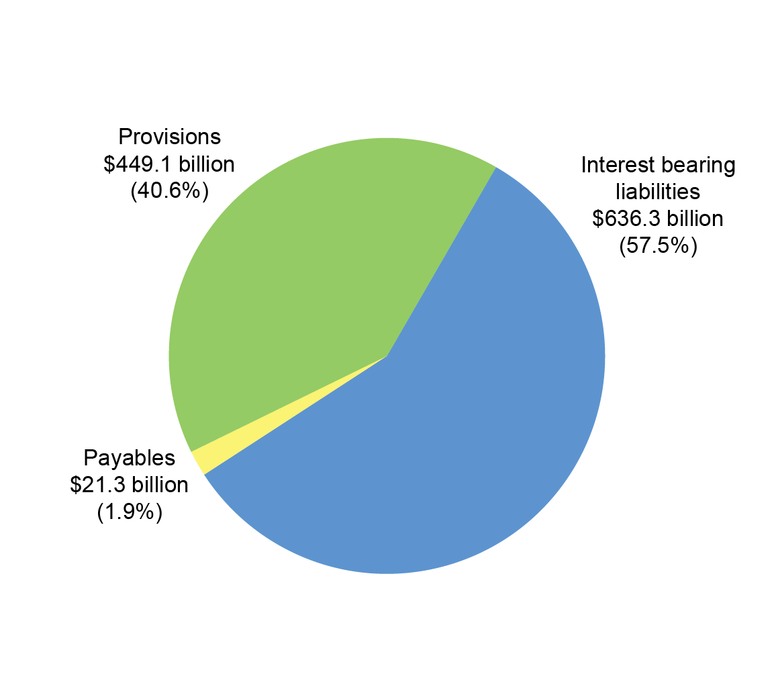

**Table 8: Liabilities**



The Australian Government’s liabilities increased by $72.3 billion (7.0 per cent) since 30 June 2017.

The increase of $33.5 billion in **interest bearing liabilities** was primarily as a result of:

* an increase of $32.2 billion in the issuance volume and market value of Australian Government Securities held by the Australian Office of Financial Management;
* an increase of $1.3 billion in other borrowings, mainly relating to access network infrastructure for the National Broadband Network; and
* an increase of $1.1 billion in loans predominantly driven by the initial recognition of liabilities resulting from the Australian Government’s full acquisition of SHL.

The increase in **provisions and payables** of $38.7 billion was primarily as a result of:

* an increase of $34.1 billion in the superannuation liability, predominantly due to the decrease in the long-term government bond rate used to discount expected future superannuation payments (refer to Note 10C of the 2017-18 CFS for further information); and
* an increase of $1.9 billion in Australian currency (notes) on issue.

Note 6 of 2017-18 CFS provides further information on liabilities.

**Cash flows**

**Table 9: Cash flows**



The Australian Government’s cash balance was $6.2 billion at 30 June 2018. For the year ended 30 June 2018, the Australian Government recorded a cash deficit of $13.7 billion, an improvement of $25.1 billion compared to a cash deficit of $38.9 billion for 2016-17.

**Receipts and payments**

The following charts provide a detailed breakdown of Australian Government receipts and payments for 2017-18, showing the relative composition of each dollar received and paid.

**Chart 10: Composition of each dollar of cash received in 2017-18**

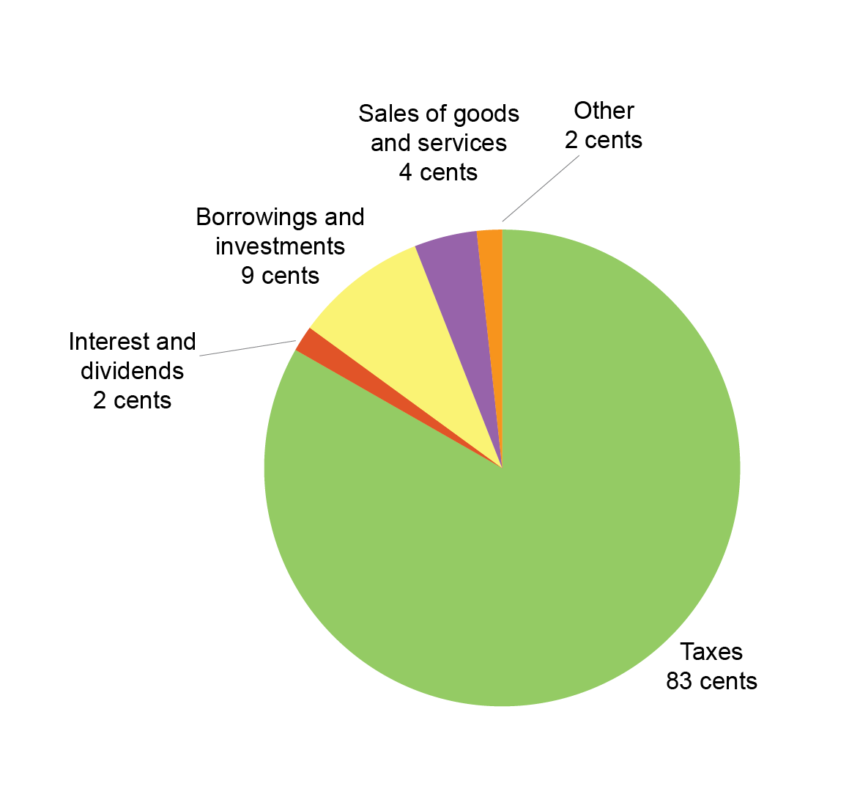

**Chart 11: Composition of each dollar of cash paid in 2017-18**

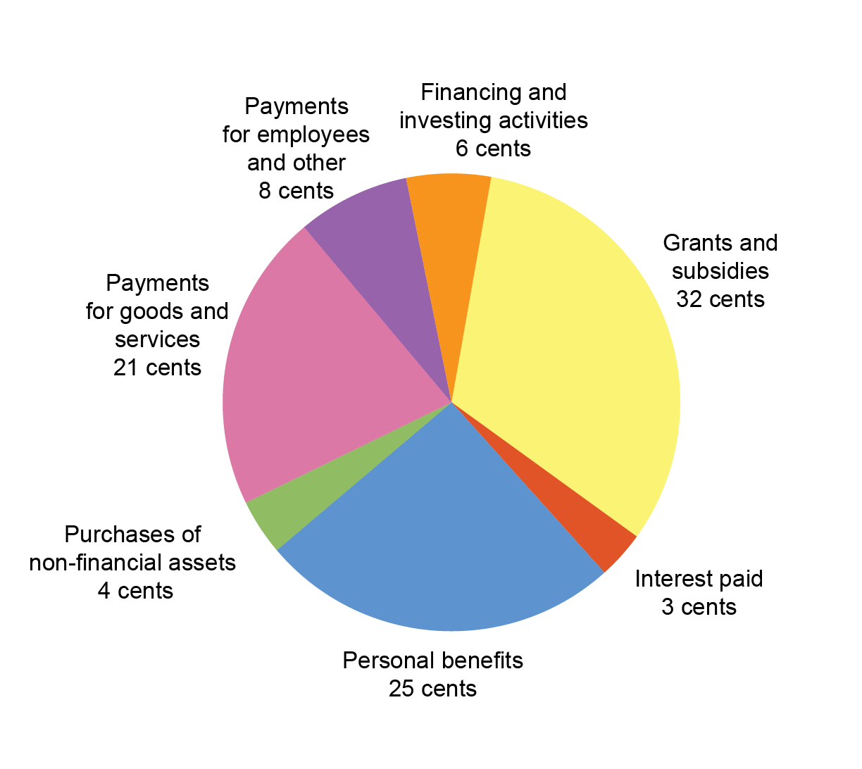

Chart 12 provides the trend of the Australian Government’s receipts and payments for operating activities and the sales and purchases of non-financial assets since 2007-08.

**Chart 12: Receipts and payments – operating and non-financial assets**

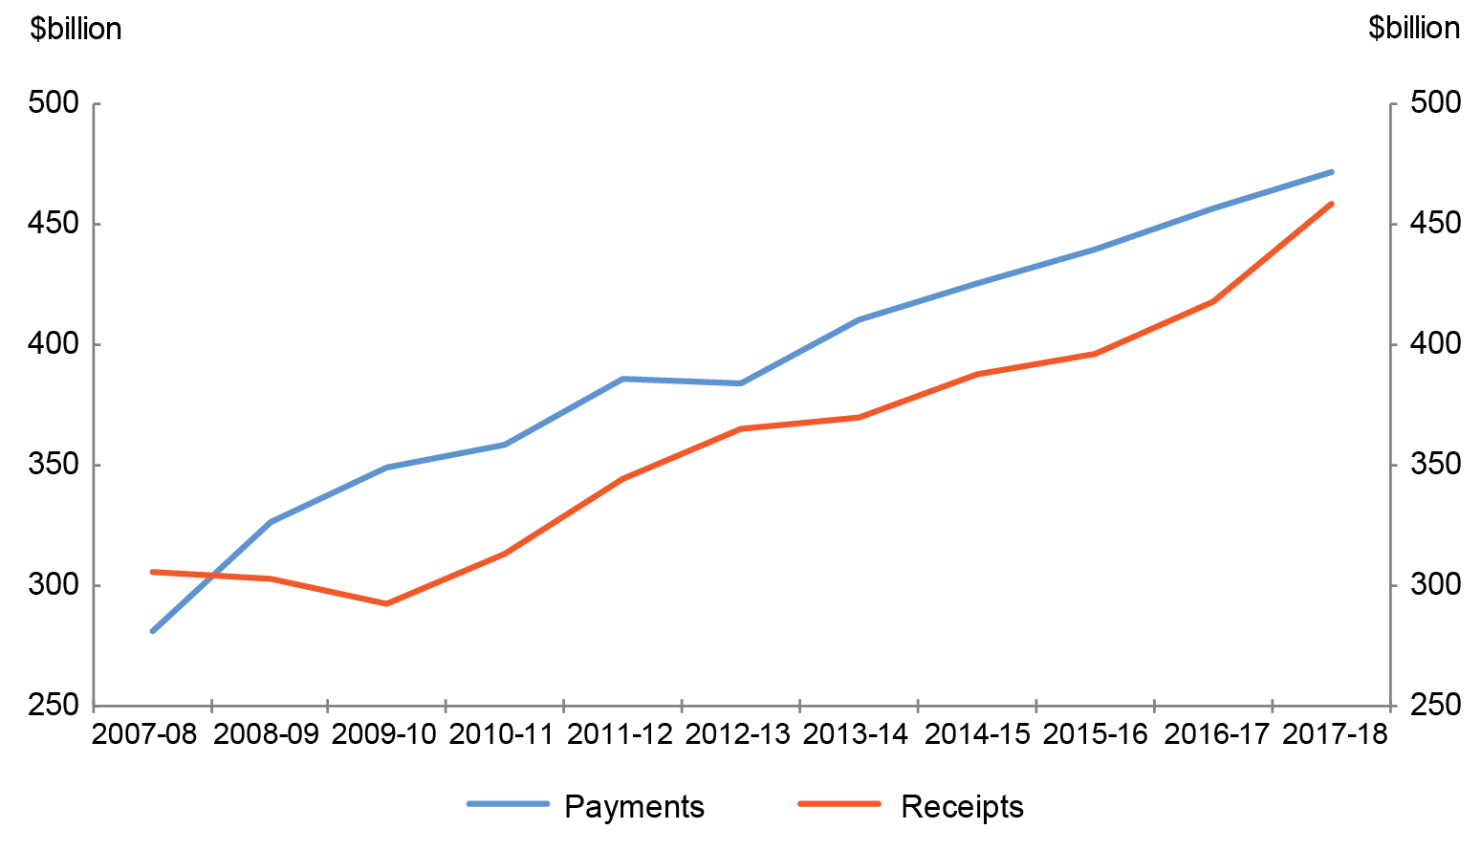

**APPENDIX A**

**Previous years**

The CFS since 1995-96 are available on the Department of Finance website at:   
<http://www.finance.gov.au/publications/commonwealth-consolidated-financial-statements>.

The historical series datasets are available in electronic format at:

<http://data.gov.au/dataset/australian-government-consolidated-financial-statements-tables-and-data>.

**Links to other publications**

The Australian Government publishes a range of information about its projected and actual financial position. Links to some of these documents are set out below. The information in the following documents has been prepared for different purposes and therefore does not form part of the CFS. Further, the documents listed below are not subject to audit.

**2017-18 Final Budget Outcome**

The 2017-18 Final Budget Outcome (FBO) was prepared in a manner consistent with the *Charter of Budget Honesty Act 1998* (the Charter). The Charter requires that the Government provide the FBO no later than three months after the end of the financial year. Consistent with these requirements, the FBO encompasses Australian Government GGS fiscal outcomes for the 2017-18 financial year and is based on external reporting standards.

The FBO is available on the Australian Government website at:

<http://www.budget.gov.au/2017-18/content/fbo/html>.

**Australian Government Monthly Financial Statements**

The Australian Government GGS Monthly Financial Statements are prepared on a basis consistent with the Budget as required under section 47 of the PGPA Act. The statements are prepared in accordance with AASB 1049.

The Australian Government GGS Monthly Financial Statements are available on the website of the Minister for Finance and the Public Service as well as the Department of Finance website:

http://www.finance.gov.au/publications/commonwealth-monthly-financial statements and http://www.financeminister.gov.au/media-releases.

The historical series datasets are available in electronic format at: <http://data.gov.au/dataset/australian-government-general-government-sector-monthly-financial-statements-tables-and-data>.

**Budget Strategy and Outlook and Mid-Year Economic and Fiscal Outlook**

The *Budget Strategy and Outlook — Budget Paper No.1 — 2017-18*, the *Mid‑Year Economic and Fiscal Outlook 2017-18* and the *Budget Strategy and Outlook — Budget Paper No.1 — 2018-19* have been prepared in accordance with the Charter.

These Budget papers are available on the Australian Government website at <http://www.budget.gov.au/>.

**Tax Expenditures Statement 2017**

The *Tax Expenditures Statement* (TES) provides details of concessions, benefits, incentives and charges provided through the tax system (tax expenditures) to taxpayers by the Australian Government. Information is published on the Treasury website at:

<http://treasury.gov.au/publication/2017-tax-expenditures-statement/.>

1. The institutional structure of the public sector is explained in Note 1 of the 2017-18 CFS.   
   Note 15 of the 2017-18 CFS provides the list of Australian Government controlled reporting entities, including their sectoral classification.
2. The balances and movements detailed in the commentary have been rounded to the nearest tenth of a billion. Discrepancies between totals and sums of components are due to rounding.
3. The 2016-17 comparatives include adjustments to revenue ($0.3 billion decrease) and liabilities ($0.5 billion increase). Refer to Note 1.5 of the 2017-18 CFS for further information.
4. The 2016-17 comparatives include an adjustment that reclassified $0.3 billion from taxation revenue to receivables (refer to Note 1.5 of the 2017-18 CFS for further information).