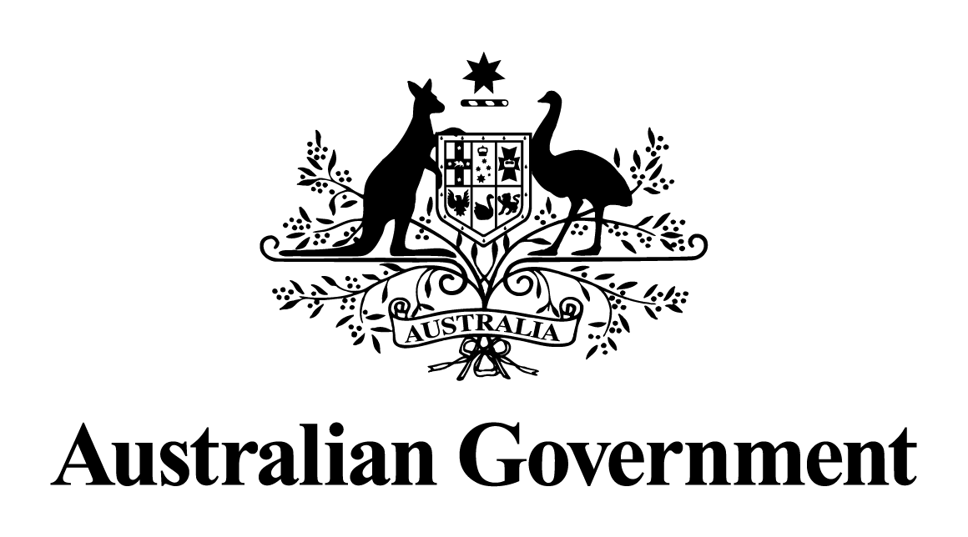

Australian Government response to the   
Senate Finance and Public Administration References Committee

Report on the Arrangements for the postal survey

June 2018

**Government Response to the Senate Finance and Public Administration References Committee: Report on the Arrangements for the postal survey**

The Australian Government thanks the Senate Finance and Public Administration References Committee for their work on the Report.

The Australian Marriage Law Postal Survey (Marriage Survey) fulfilled the Government’s election commitment to allow every eligible Australian to have their say on the issue of same-sex marriage. The Marriage Survey was a success. It was designed and conducted in fewer than 100 days and comprised a single question, asked of just over 16 million eligible Australians. Particular effort was made to ensure the survey was simple and could be completed by those travelling or living overseas, those in remote communities, people with a disability, and those who speak different languages.

**Recommendation 1**

**The committee recommends that questions of human rights for minority groups should not be resolved by a public vote.**

**Response**

The Government notes the recommendation. The Government commissioned the Marriage Survey to honour the commitment it made prior to the 2016 election to give the community a say on whether same-sex marriage should be legalised.

The Marriage Survey did not itself amend the law, rather it provided an undisputable public mandate for change that helped ensure the passage of legislation, after previous attempts to legislate change had failed. The exceptional level of public participation in the Marriage Survey showed both a strong public endorsement for the process of the survey itself as well as endorsement for social change. Other significant changes have been previously introduced through processes that included asking the views of the Australian public. This included the 1974 national anthem survey and the 1967 referendum that removed discriminatory references to Indigenous people in the constitution.

**Recommendation 2**

**The committee recommends that the Australian Government consider how further funding and support could be offered to mental health and LGBTIQ organisations to help address the consequences of the postal survey.**

**Response**

The Government supports and recognises the importance of ongoing funding for mental health treatment for all Australians. The Government also recognises the impact of mental health issues and suicide in the LGBTIQ community and funds a number of programs specific to their needs, including providing funding to the National LGBTI Health Alliance to deliver programs to support the ongoing mental health requirements of LGBTIQ Australians.

The Government also funds a number of other mental health services that provide a range of support, from telephone crisis support through to online peer forums, with many addressing LGBTIQ specific issues. These include QLife, Qheadspace, Lifeline, Kids Helpline, and ReachOut.

The 2017-18 Federal Budget provided $15 million in additional funding for mental health research, $9.1 million to improve access to psychological services through telehealth in regional, rural and remote Australia, and $11.1 million for suicide prevention programs. In January 2018, the Government also announced a further $110 million to extend and expand mental health programs for young Australians.

The Government recently launched Head to Health, a digital gateway which aims to support people to more easily access online and phone mental health and wellbeing advice provided by a range of trusted organisations. This provides a further avenue of support for vulnerable people, including those in the LGBTIQ community.

**Recommendation 3**

**The committee recommends that the Australian Electoral Commission actively engage with remote communities and Indigenous peak bodies to increase the number of enrolled people in remote electorates and to increase the participation of enrolled people in local, state and federal elections.**

**Response**

The Government supports this recommendation, noting that the Australian Electoral Commission (AEC) is responsible for conducting federal elections, including maintaining the Commonwealth electoral roll. Increasing the participation of enrolled people in local and state elections is a matter for state and territory governments.

The Government recognises the importance of assisting disadvantaged communities in participating in the electoral process, and supports the Indigenous Electoral Participation Program (IEPP) which aims to help close the gap in Indigenous disadvantage in electoral participation: <http://www.aec.gov.au/Indigenous/>.

The AEC is currently reviewing the IEPP as part of its commitment to continuously educate, improve enrolments and increase participation in federal elections.