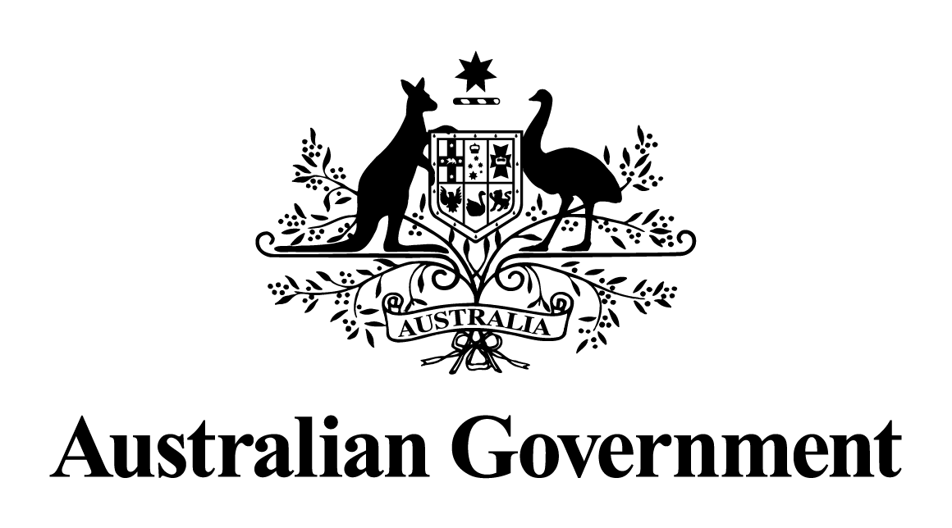

Australian Government response to the   
Senate Select Committee into the Abbott Government’s Commission of Audit

Final Report – June 2014

October 2018

**Government Response to the Senate Select Committee into the Abbott Government’s Commission of Audit Final Report**

**Recommendation 1**

**The Committee recommends greater transparency and scrutiny be given to tax expenditure by including the Tax Expenditure Statement alongside direct expenditure measures in Budget Paper 2.**

**Response**

Disagree.

The purpose of *Budget Paper No. 2* is to outline new revenue and expense measures taken since the previous Mid-Year Economic and Fiscal Outlook, rather than report on revenue and expenses more broadly. The *Charter of Budget Honesty Act 1*9*98* requires that the Budget include an overview of Australian Government tax expenditures. This is most appropriately included in the revenue statement in Budget Paper No. 1.  In the 2018-19 Budget it was located in Statement 5, Appendix A: Tax Benchmarks and Variations.

**Recommendation 2**

**The Committee recommends the government white paper on tax reform include a review of all government tax expenditures and concessions.**

**Response**

Noted.

As part of the 2016-17 Budget, the Government released a tax reform package aimed at creating jobs, driving growth, sustainability and integrity. This involved a comprehensive review of Australia's tax system and wide consultation with key stakeholders.

The Government is focussed on delivering lower, fairer and simpler taxes. Lower tax is not an expenditure. It is not the Government’s money. Unlike the opposition, the Government considers that your money is your money.

**Recommendation 3**

**The Committee recommends that the government release the costings and evidence base for each recommendation from the National Commission of Audit.**

**Response**

Noted.

The National Commission of Audit was given a broad remit to examine the scope for efficiency and productivity improvements across all areas of Commonwealth expenditure. The Commission was also asked to identify other savings or matters that the Commission considers should be brought to the Government’s attention. The Commission released its detailed report, including appendices, which present key findings and supporting arguments.

**Recommendation 4**

**The Committee recommends that by 31 December 2014, the government provide a response to each of the recommendations made by the National Commission of Audit. The response should indicate whether the recommendation has been accepted by government and when it will be implemented and where a recommendation has not been accepted, the government should provide reasons.**

**Response**

Noted.

On 13 May 2014, the Minister for Finance issued a media release responding to each of the National Commission of Audit's recommendations

(see <https://www.financeminister.gov.au/media-release/2014/05/13/our-response-national-commission-audit-report>).