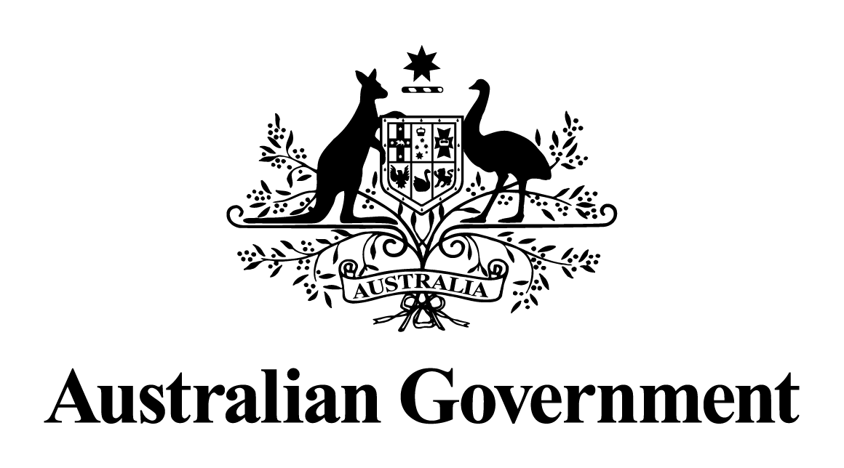

# Australian Government response to the Joint Committee of Public Accounts and Audit Report 441:

# Inquiry into Public Governance, Performance and Accountability Act 2013 Rules Development

September 2014

## Inquiry into Public Governance, Performance and Accountability Act 2013 Rules development (No. 441 of 2014)

## Recommendation 1

The Committee recommends that the Department of Finance review all *Public Governance, Performance and Accountability Act 2013* guidance material to improve consistency in:

* context provided
* document structure
* distinguishing between mandatory requirements and good practice terminology.

## Response

The Government agrees.

Since the JCPAA inquiry, Finance has revised all guidance material and engaged an independent technical expert whom has assessed the guidance for overall comprehensiveness, coverage and clarity. Finance has also engaged professional editors to check the guidance for consistency and clarity. Final guidance, which clarifies mandatory requirements and matters that can be considered as good practice, has been progressively released on the Finance Public Management Reform Agenda website.

## Recommendation 2

The Committee recommends that the following additional guiding principle be included as one of the guiding principles for the Public Management Reform Agenda:

* The financial framework, including the rules and supporting policy and guidance, should support the legitimate requirements of the Government and the Parliament in discharging their respective responsibilities.

## Response

The Government agrees.

The additional guiding principle has been adopted and will be reflected in future reforms. For example, the submission from the Department of Finance to the Senate Finance and Public Administration Legislation Committee inquiry into the *Public Governance, Performance and Accountability Amendment Bill 2014* (PGPA Amendment Bill), on 6 June 2014, adopted this additional guiding principle on page 3, as did the Government’s second reading speeches in both chambers in relation to this Bill.

## Recommendation 3

The Committee recommends that the Department of Finance work to ensure that any necessary amendments are made to the *Auditor-General’s Act 1997* such that the Australian National Audit Office has the power to audit the full planning, performance and accountability framework under the *Public Governance, Performance and Accountability Act 2013*.

## Response

The Government agrees.

The *PGPA Amendment Act 2014* modified the PGPA Act to add a note to Section 40 to put beyond doubt the continuing powers of the Auditor-General to conduct a performance audit of a Commonwealth entity at any time.

## Recommendation 4

The Committee does not recommend a change to the *Public Governance, Performance and Accountability Act 2013* (PGPA Act) at this time, to address the potential confusion from dual coverage with the *Public Service Act 1999* (PS Act). Instead, the Committee recommends that the Department of Finance and the Australian Public Service Commission work together to draft the necessary amendments to the PGPA Act and/or the PS Act to remove overlaps and reduce potential confusion from dual coverage, and that amendment proposals be put to the Parliament.

## Response

The Government agrees.

Finance has worked with the APSC and the Department of Parliamentary Services to draft amendments to the PGPA Act, PS Act and *Parliamentary Service Act 1999* to achieve greater alignment in the duties of officials and to reduce the potential for confusion.

The PGPA *Amendment Act 2014* made the necessary changes to the PGPA Act. Reciprocal changes to the PS Act and the Parliamentary Services Act were made through the *PGPA Consequential and Transitional Provisions Act 2014*. This suite of changes, taken together, brings about closer alignment between these pieces of legislation.

Finance will continue to work with the APSC and the parliamentary departments to consider the need for any future changes or guidance to address the JCPAA’s concerns.

## Recommendation 5

The Committee recommends that the Department of Finance (Finance) amend the draft guidance to s17 and s28 of the draft *Public Governance, Performance and Accountability Rule 2014* to emphasise that nothing in the draft rule precludes the chair, chief executive officer and chief financial officer of a Commonwealth body from attending audit committee meetings as an observer. Finance should also widely communicate this point.

## Response

The Government agrees.

Finance has amended the guidance for audit committees (*RMG 202 – Audit Committees for Commonwealth entities and Commonwealth companies*) to emphasise that the chair, CEO and CFO of a Commonwealth entity can attend audit committee meetings as an observer (for example, see paragraph 14 of that guidance).

The final guidance is available from the Finance website.

## Recommendation 6

The Committee recommends that draft rule s18 (Approving commitments of relevant money) of the *Public Governance, Performance and Accountability Rule 2014* be amended to explicitly place an obligation on all individual officials to consider proper use and management of public resources before approving commitments of relevant money.

## Response

The Government agrees in part.

Both Section 18 of the PGPA Rule and the guide to the section have been amended in response to this recommendation.

Section 18(2) of the Rule now reads that an “official must approve ...[a] commitment [of relevant money], and record the approval, consistently with any written requirements (including any requirements relating to the proposer use of that money and spending limits) specified by the accountable authority ...”.

The accountable authority can impose conditions, give directions or give instructions to officials about proper use, and may, by written instrument, issue instructions under section 20A that in and of themselves becomes part of “finance law’ (as defined in section 8).

All officials must act in accordance with instructions pertaining to finance law, by virtue of their general duties under the PGPA Act—section 25 requires officials to act with care and diligence and section 26 requires that they act honestly, in good faith and for a proper purpose.

## Recommendation 7

The Committee recommends that the issue of commitments of relevant money, and the appropriateness of spending limits and associated documentation requirements set by accountable authorities, be included by the Department of Finance in the first independent review of the *Public Governance, Performance and Accountability Act 2013*.

## Response

The Government agrees.

The PGPA Act requires the Finance Minister, in consultation with the JCPAA, to undertake an independent review of the operation of the Act and the Rules (section 112). This issue will be considered as part of that review.

## Recommendation 8

The Committee recommends that the draft guidance material supporting s18 (Approving commitments of relevant money) of the Public Governance, Performance and Accountability Rule 2014 be amended to include discussion of the reasonable use of, and the risks involved in, officials approving aggregate expenditure proposals.

## Response

The Government agrees.

Finance has amended its resource management guidance RMG 400: Approving commitments of relevant money. The guidance now includes discussion of the reasonable use of, and the risks involved in, officials approving aggregate expenditure proposals (refer to part 3).

## Recommendation 9

The Committee recommends that the Department of Finance continue its consultation process with stakeholders on the Public Governance, Performance and Accountability Act 2013 rules development for the post July 2014 rules and the broader Public Management Reform Agenda, based on the comprehensive consultation approach taken to date.

## Response

The Government agrees.

Finance will continue its consultation process with stakeholders post July 2014. To give one example, since the JCPAA hearings in April 2014, the cross-agency Planning and Reporting steering committee met on 17 June 2014 to consider the Commonwealth Performance Framework project and the Rules for Financial Reporting project.

## Recommendation 10

The Committee recommends that the Department of Finance prepare and communicate a plan clearly outlining the anticipated dates for development and consultation of all future rules and guidance materials under the Public Governance, Performance and Accountability Act 2013, and the broader Public Management Reform Agenda.

## Response

The Government agrees.

Finance will communicate the plan relating to future elements of the Public Management Reform Agenda.

For example, a plan on the development of the Commonwealth Performance Framework was circulated on 19 June 2014—it is available through the PMRA website.